
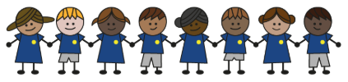
What is my child learning about in Summer Term 2 (June-July)?
Year group: Year 5/6
Our topic is:
Food and Farming
Writing  Adventure Story Writing  Explanation: How to survive Camp Green Lake/Detention Centre | Reading  Holes by Louis Sachar  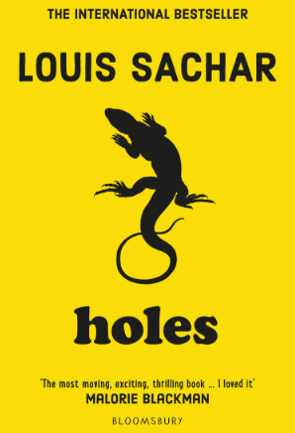 | Maths  Year 5: Decimals, Negative Numbers, Converting Units and Volume  Year 6: Themed projects and consolidation of learning  Lessons are adapted from White Rose Maths
Science  Making connections: Does the size of an asteroid affect the diameter of its impact crater?  Children will recall and use knowledge from previous science topics. They will apply what they know in new situations. They will plan and carry out a full scientific enquiry, including asking questions, making predictions, conducting experiments, and drawing conclusions. | Computing  Sensing: Microbit – step counter  Children will create a program that is able to run on a controllable device and design a project that uses inputs and outputs on a controllable device. | Geography  Food and Farming  Children will learn where food comes from, how it is grown or produced, and how it reaches our homes. They will also explore the choices we make about food and the impact on health, the environment, farmers, and animals.
DT  Mechanical systems (Option 1: Gears and pulleys)  Children will learn about machines, including examples that use gears and pulleys, and understand how they work. They will design and make their own gear and pulley systems, write problem statements, carry out market research, provide feedback, and analyse competitors. They will evaluate products against design criteria, suggest improvements, and make changes. | Music  Keyboard and Musical Notation  Year 6 Production | PE  Speed, Distance, Strength  Lend, Move, Score  Swimming (2 weeks)
RE  What does it mean to be a Muslim?  Children will learn about the five pillars and how they affect the lives of Muslims today. Children will also explore why Muslims go on pilgrimages. | Spanish  Weekend  Children will learn vocabulary for them to have a conversation about what they get up to on weekends | Trips/Workshops  Chessington (Year 6)  Sports Day

Home reading: Children must read daily at home with an adult or independently. Reading records must be signed with a comment about what your child has read that evening, for how long and how many pages.
Homework: A homework takeaway menu is sent home every half term with activities based on the various subject topics. Children are to complete at least two of these activities. Every Friday, spellings are posted on Class Dojo for children to learn. They are tested every Wednesday afternoon on these spellings.

