
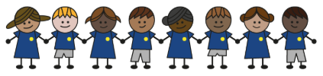
What is my child learning about in Spring Term 2 (February-April)?
Year group: Year 5/6
Our topic is:
South America
Writing  Setting description  Non-Chronological Report: Amazon or South America | Reading  Journey to the River Sea by Eva Ibbotson  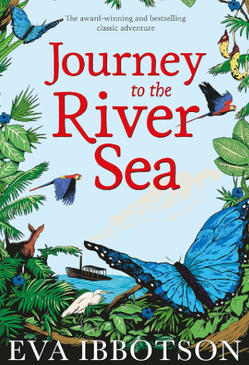 | Maths  Year 5: Decimals & Percentages, Perimeter & Area and Statistics  Year 6: Fractions, Percentages & Decimals, Area, Perimeter & Volume and Statistics  Lessons are adapted from White Rose Maths
Science  Materials: Mixtures and Separation  Children learn about mixtures and solutions and how different separation methods work. They explore techniques such as sieving, filtering, and evaporating, investigate what affects how quickly substances dissolve, and learn when to use each method to separate different types of mixtures and solutions. | Computing  Data and Information: Flat-file databases  Children will build a data set in a spreadsheet, explain formulas can create calculated data and how to apply these formulas. They will create a spreadsheet of their own to plan an event and choose a way to present their data. | Geography  South America  Children learn about the location of South America, its major features, and the countries within it. They explore similarities and differences between Brazil and the UK, discover what daily life is like in Rio de Janeiro, investigate southeast Brazil’s trade links, and consider the benefits and drawbacks for Brazil of hosting the Olympic Games.
DT  Electrical systems: Steady hand game  Children explore how toys are designed by looking at a product’s form (its shape) and function (how it works). They evaluate existing toys, investigate the skills toys help develop, and then design and build their own steady hand game—creating detailed drawings, constructing a secure base, and making a working electrical circuit to bring their design to life. | Music  Music Technology 2 | PE  Serve, Set, Slam  Explore, Solve, Challenge
RE  What matters most to humanists and Christians?  Children explore why we have rules. They explore what a humanist is and learn what guidelines non-religious people use. They explore Christianity and what values matter most in this religion. | Spanish  Olympics  Children will learn key vocabulary about the Olympics and the different sporting events. | Trips/Workshops

Home reading: Children must read daily at home with an adult or independently. Reading records must be signed with a comment about what your child has read that evening, for how long and how many pages.
Homework: A homework takeaway menu is sent home every half term with activities based on the various subject topics. Children are to complete at least two of these activities. Every Friday, spellings are posted on Class Dojo for children to learn. They are tested every Wednesday afternoon on these spellings.

