
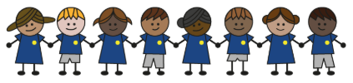
What is my child learning about in Spring Term 1 (January-February)?
Year group: Year 5/6
Our topic is:
London
Writing  Narrative (with a focus on dialogue)  Letter: persuasive writing  Poetry: (Visual) Blackout Poetry | Reading  Kick by Mitch Johnson  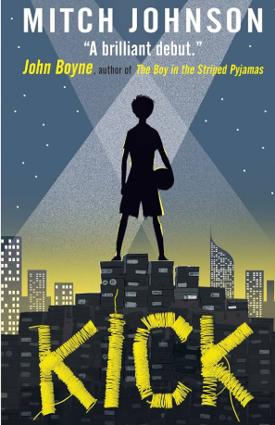 | Maths  Year 5: Multiplication & Division, Fractions, Decimals and Percentages  Year 6: Ratio, Algebra and Decimals  Lessons are adapted from White Rose Maths
Science  Light & Reflection  Children learn how light travels, how we see objects, and how to stay safe by protecting the eyes from bright light. They investigate shadows, reflection and mirror use, create and explain a periscope using ray diagrams, and explore how the size and shape of shadows change based on an object’s position. | Computing  Creating Media – 3D modelling tinkercad  Children will use a computer to create 3D digital objects. They look and modifying and combining models, as well as creating a 3D model for a given purpose. | History  What can the census tell us about local areas?  Children learn how to use census data and other historical sources to understand what life was like in the past. They explore how people’s jobs and living conditions changed over time, investigate Victorian working life, study the updates seen in the 1921 census, and use these skills to plan their own local history enquiry.
Art  Drawing: Depth, emotion and movement  Children explore how artists use line, colour, and tone to express emotion and movement in their work. They design and create their own prints, carefully considering composition and depth, and reflect on their process to improve their final pieces. | Music  Classroom Jazz | PE  Cricket  Symmetry, Balance, Travel  Dodgeball
PSHE  Mental health and emotional wellbeing: Healthy minds  Children learn what mental health means, what can affect it, and practical ways to look after their wellbeing each day. They also discuss stigma and discrimination related to mental health, helping them understand the importance of speaking openly and seeking support when needed.  Drug, alcohol and tobacco education: Weighing up risk  Children learn about the risks linked to different drugs: including tobacco and nicotine products, alcohol, solvents, medicines, and other legal and illegal substances. They also learn how to assess risk in situations involving drug use and explore safe, responsible ways to manage or avoid these risks. | Spanish  What is the weather?  Children learn key vocabulary around the weather types, how to explain what the weather is like and translation to English too. | Trips/Workshops  Tower of London  TfL Citizenship Workshop (Y6)

Home reading: Children must read daily at home with an adult or independently. Reading records must be signed with a comment about what your child has read that evening, for how long and how many pages.
Homework: A homework takeaway menu is sent home every half term with activities based on the various subject topics. Children are to complete at least two of these activities. Every Friday, spellings are posted on Class Dojo for children to learn. They are tested every Wednesday afternoon on these spellings.

