
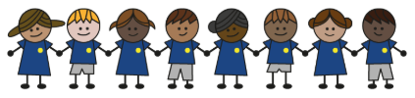
What is my child learning about in Autumn Term 2 (November-December)?
Year group: Year 5/6
Our topic is:
Marvellous Maps
Writing  Narrative: Suspense (based on book)  Instructions: Journeys | Reading  A Girl of Ink and Stars by Karen Millwood Hargrave  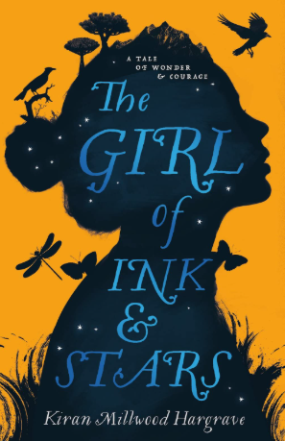 | Maths  Year 5: Multiplication & Division and Fractions  Year 6: Fractions and Converting Units  Lessons are adapted from White Rose Maths
Science  Earth & Space  Children will look at key astronomy ideas, including models of the Solar System, the shapes and orbits of celestial bodies, Moon phases, the causes of day/night and seasons, how sundials work, and the roles and risks related to satellites. | Computing  Web Page Design  Children look at what makes a good website by navigating a website to answer questions. They will design their own website and learn what ownership and privacy means. | Geography  Our Local Area  Children explore the local area through fieldwork, starting by locating it on different maps and understanding how it connects to the wider region. They then investigate key features within a fifty-mile radius and gather fieldwork data to see how the area meets people’s needs, finally presenting their findings as a newspaper-style pull-out with an annotated Ordnance Survey map.
DT  Monitoring Devices: Microbit  Children will look at monitoring devices - what they are, why they’re useful, and how they’ve evolved from early thermoscopes to modern digital thermometers. Pupils research an animal to design a suitable monitoring device, learn basic programming with a temperature-alert system (including how to debug code), and build and evaluate simple prototype cases and stands for a Micro:bit. | Music  Dancing in the Street | PE  Inspire, Create, Perform  Block, Guard, Support
RE  Hinduism  Children will learn key Hindu beliefs, including ideas about Brahman and atman, explored through a traditional Hindu story. They also find out about samsara, why atman is important, and how the principle of ahimsa - non-violence - shapes the daily lives and choices of Hindu people. | Spanish  At the Cafe  Children will learn about items that can be ordered in a Spanish cafe, how to order and the currency needed to pay for these items. | Trips/Workshops  Shakespeare Production

Home reading: Children must read daily at home with an adult or independently. Reading records must be signed with a comment about what your child has read that evening, for how long and how many pages.
Homework: A homework takeaway menu is sent home every half term with activities based on the various subject topics. Children are to complete at least two of these activities. Every Friday, spellings are posted on Class Dojo for children to learn. They are tested every Wednesday afternoon on these spellings.

