
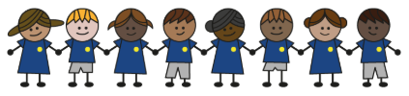
What is my child learning about in Autumn Term 1 (September-October)?
Year group: Year 5/6
Our topic is:
World War 2
Writing  Letter: An evacuee letter  Newspaper report: A plane crash  Personification poem: WW2 | Reading  Letters from the Lighthouse by Emma Carroll  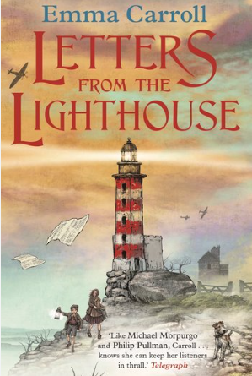 | Maths  Year 5: Place Value, Addition, Subtraction, Multiplication & Division  Year 6: Place Value, Addition, Subtraction, Multiplication & Division  Lessons are adapted from White Rose Maths
Science  Circulation & Health  Children understand how the circulatory system works, how blood travels around the body, and how factors such as exercise and lifestyle can affect health. Pupils investigate heart rate and exercise. | Computing  History of Computers  Children learn how computers have developed over time and explore early codebreaking during World War II. They also discover how the Enigma machine worked and why Alan Turing’s contributions were so important in the history of computing. | History  World War 2  Children learn about key events of World War II, including its causes, the Battle of Britain and the Blitz, using historical sources to develop their understanding. They also explore the experiences of evacuee children and examine how the war affected the lives of women and African-Caribbean migrants.
Art  Installations: 3D sculptures  Children explore installation art by studying real examples, discussing their ideas, and asking thoughtful questions. They design and model their own installation spaces, explain the creative choices they make, evaluate their designs, and consider how they would adapt them to create different moods or atmospheres. | Music  Earth (Hans Zimmer)  A Class Composition | PE  Disability Awareness Sports  Evade, Invade, Capture  Football
PSHE  Identity, society and equality: Stereotypes, discrimination & prejudice  Children learn about stereotyping, including gender stereotypes, and how these can influence the way people are treated.  Keeping safe and managing risk: When things go wrong  Children learn how to stay safe online and understand that violence in any relationship is never acceptable. They also discuss the risks and challenges that can arise when someone goes missing from home, helping them recognise unsafe situations and know when to seek help. | Spanish  Family  Children learn key vocabulary based on family members, how to talk about their family and translate about other families. | Trips/Workships  School Journey  WW2 Workshop

Home reading: Children must read daily at home with an adult or independently. Reading records must be signed with a comment about what your child has read that evening, for how long and how many pages.
Homework: A homework takeaway menu is sent home every half term with activities based on the various subject topics. Children are to complete at least two of these activities. Every Friday, spellings are posted on Class Dojo for children to learn. They are tested every Wednesday afternoon on these spellings.

