
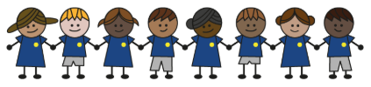
What is my child learning about in Summer Term 2 (June-July)?
Year group: Year 5/6
Our topic is:
Citizens of the World
Writing  Narrative: Diary Entry  Balanced Argument: Animal Organs used for Humans | Reading  Pig Heart Boy by Malorie Blackman  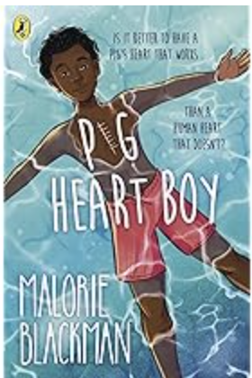 | Maths  Year 5: Decimals, Negative Numbers, Converting Units and Volume  Year 6: Themed projects and consolidation of learning  Lessons are adapted from White Rose Maths
Science  Making connections: Human Timeline  Children will recall and use knowledge from previous science topics. They will explore how humans change from a baby through to old age, including puberty, measurements of growth and gestation periods. | Computing  Scratch: Variables in Games  Children will plan (design) and make (code) an algorithm including variables. They will make, review and evaluate their game, which will include variables. | Geography  World Trade  Children learn about items that the UK imports and exports, the links between countries
DT  Cooking and Nutrition: Developing a Recipe  Children will learn about the idea of farm to fork. They will taste bolognese recipes, design their own label for their own sauce (that includes nutritional information) and cook their own bolognese recipe. | Music  Keyboard and Musical Notation  Year 6 Production | PE  Speed, Distance, Strength  Volleyball  Swimming (2 weeks – Year 6)
RE  What do Christians believe that Jesus was the Messiah?  Children explore why Christians believe Jesus fulfils the expectations of the Messiah and learn how Christmas relates to the Christian beliefs about Jesus. | Spanish  At School  Children learn key vocabulary about school and the subjects they learn. | Trips/Workshops  Chessington (Year 6)  Sports Day

Home reading: Children must read daily at home with an adult or independently. Reading records must be signed with a comment about what your child has read that evening, for how long and how many pages.
Homework: A homework takeaway menu is sent home every half term with activities based on the various subject topics. Children are to complete at least two of these activities. Every Friday, spellings are posted on Class Dojo for children to learn. They are tested every Wednesday afternoon on these spellings.

