
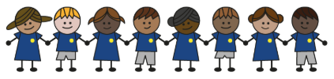
What is my child learning about in Spring Term 2 (February-April)?
Year group: Year 5/6
Our topic is:
Antarctica
Writing  Recount: Shackleton’s expedition  Instructions: Antarctica  Advert: Recruit new explorers for next journey | Reading  Shackleton’s Journey by William Caroll  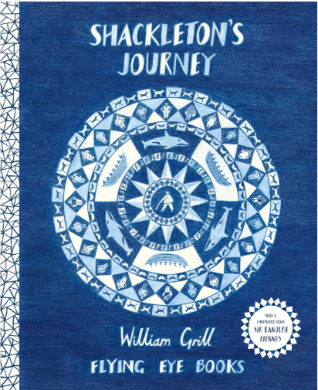 | Maths  Year 5: Decimals & Percentages, Perimeter & Area and Statistics  Year 6: Fractions, Percentages & Decimals, Area, Perimeter & Volume and Statistics  Lessons are adapted from White Rose Maths
Science  Living Things and their Habitats: Classifying Big & Small  Children will look at Carl Linnaeus’ work, focusing on what vertebrates and invertebrates are, their features and how they are classified. They will also look at plants and microorganisms. | Computing  Data and information – j2Database  Children will input data into a spreadsheet, will learn about how formulas can be used to produce calculated data and will choose suitable ways to present data. | Geography  Antarctica  Children will be able to locate Antarctica on a map and describe its physical features. They will also investigate impact of human activity on Antarctica and its role in Earth’s climate system.
DT  Structure: Bridges  Children explore how bridge designs and materials affect strength and stability through building a wooden truss bridge. | Music  Mambo! | PE  Explore, solve, challenge  Basketball
RE  Why do some people believe in God and some people don’t?  Children will learn about the patterns of belief in God in their local community, our country and around the world. They will be introduced to the concepts of agnostic, atheist and theist. | Spanish  Habitats  Children will learn vocabulary to describe different habitats and say about the habitat they (and others) live in. | Trips/Workshops
Home reading: Children must read daily at home with an adult or independently. Reading records must be signed with a comment about what your child has read that evening, for how long and how many pages.
Homework: A homework takeaway menu is sent home every half term with activities based on the various subject topics. Children are to complete at least two of these activities. Every Friday, spellings are posted on Class Dojo for children to learn. They are tested every Wednesday afternoon on these spellings.

