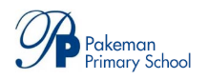
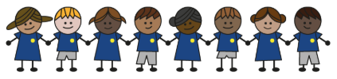
What is my child learning about in Spring Term 1 (January-February)?
Year group: Year 5/6
Our topic is:
Vikings
Writing  Narrative: Suspense writing  Newspaper: Battle for Eels Island (based on class reading)  Poetry: (Visual) Collage Poetry | Reading  Floodland by Marcus Sedgwick  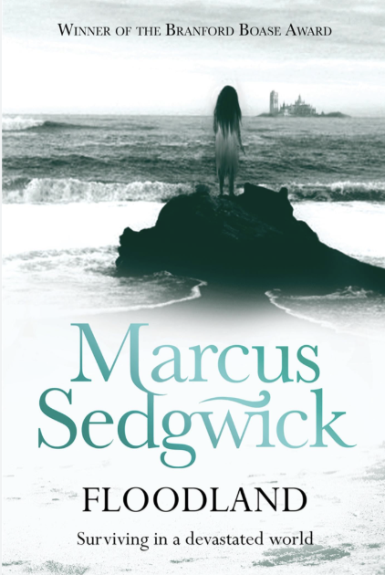 | Maths  Year 5: Multiplication & Division, Fractions, Decimals and Percentages  Year 6: Ratio, Algebra and Decimals  Lessons are adapted from White Rose Maths
Science  Energy: Circuits, Batteries and Switches  Children will develop their knowledge of circuits, the effects of changing voltage and how switches contribute to different devices. | Computing  Vector Drawing – Google drawings  Children will use Google drawings to create a vector drawing by combining shapes. They will use tools, layers, and objects to achieve a desired effect when creating Vector Drawings. | History  Were the Vikings raiders, traders or invaders?  Children will be able to explain where the Vikings came from and why they invaded Britain and use sources to draw inferences about them. They will learn about important Viking trade routes.
Art  Craft and Design: Architecture  This unit focuses on architecture, guiding pupils through observational drawing, printmaking, and building design. Children will explore architectural elements, analyse Hundertwasser's work, and create meaningful monuments, enhancing their understanding of composition, design, and art appreciation. | Music  Make You Feel My Love | PE  Watch, Move, Connect  Symmetry, Balance, Travel
PSHE  Identity, society and equality: Human Rights  Children will learn about people who have moved to Islington from other places, (including the experience of refugees). They will learn about human rights and the UN Convention on the Rights of the Child and about homelessness.  Mental health and emotional wellbeing: Dealing with Feelings  Children learn about a wide range of emotions and feelings and how these are experienced in the body, about times of change and how this can make people feel and about the feelings associated with loss and grief. | Spanish  Vikings  Children learn key vocabulary about the Vikings and how to describe what they look like. | Trips/Workshops  TfL Citizenship Workshop (Y6)

Home reading: Children must read daily at home with an adult or independently. Reading records must be signed with a comment about what your child has read that evening, for how long and how many pages.
Homework: A homework takeaway menu is sent home every half term with activities based on the various subject topics. Children are to complete at least two of these activities. Every Friday, spellings are posted on Class Dojo for children to learn. They are tested every Wednesday afternoon on these spellings.

