
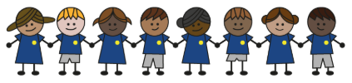
What is my child learning about in Autumn Term 2 (November-December)?
Year group: Year 5/6
Our topic is:
Weather and Climate
Writing  Narrative: An Ending (using dialogue)  Letter: Persuasive letter to Scrooge | Reading  A Christmas Carol by Tony Mitton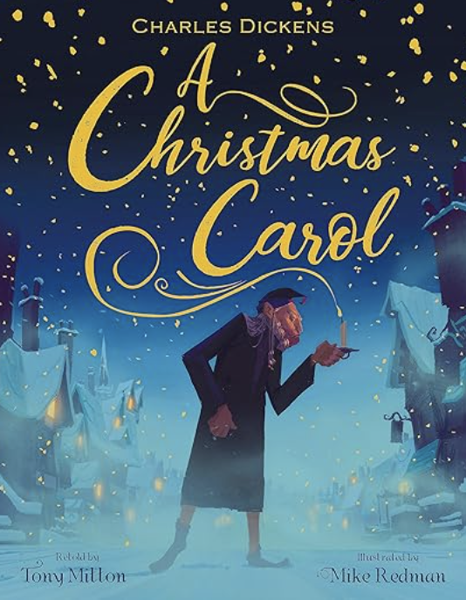 | Maths  Year 5: Multiplication & Division and Fractions  Year 6: Fractions and Converting Units  Lessons are adapted from White Rose Maths
Science  Livings Things and their Habitats: Life Cycles and Reproduction  Children will be exploring the life cycles of plants and animals (mammals, birds and amphibians) and the life process of reproduction. | Computing  iMovie  Children will learn how to use camera angles, frames and editing to create short films on the app iMovie. | Geography  Climate Zones  Children will learn how to identify lines of latitude and look at the location of climate zones. They will make comparisons between climates and weather patterns in a climate zone.
DT  Textiles: Stuffed Toys  Children will design a stuffed toy, consider the main component shapes of their toy and create an appropriate template for their stuffed toy. They will use a blanket stitch to assemble their stuffed toy, repairing it if needed. | Music  Songwriting: Christmas songs | PE  Inspire, Create, Perform  Tag Rugby
RE  Why is the Torah so important to Jewish people?  Children will explore what the Torah is and will learn why there are different types of synagogues. They will explore how the Torah may influence what Jewish people might eat. | Spanish  My Home  Children learn vocabulary about where their homes are, what type of home they have and the different room names. | Trips/Workshops  Shakespeare production

Home reading: Children must read daily at home with an adult or independently. Reading records must be signed with a comment about what your child has read that evening, for how long and how many pages.
Homework: A homework takeaway menu is sent home every half term with activities based on the various subject topics. Children are to complete at least two of these activities. Every Friday, spellings are posted on Class Dojo for children to learn. They are tested every Wednesday afternoon on these spellings.

