
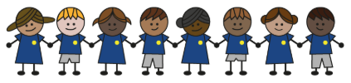
What is my child learning about in Autumn Term 1 (September-October)?
Year group: Year 5/6
Our topic is:
Ancient Greece
Writing  Narrative: A Letter  Non-Fiction: Non-chronological Report (Greek Gods)  Poetry: (Free verse) Narrative Poems | Reading  The Adventures of Odysseus by Daniel Morden & Hugh Lupton  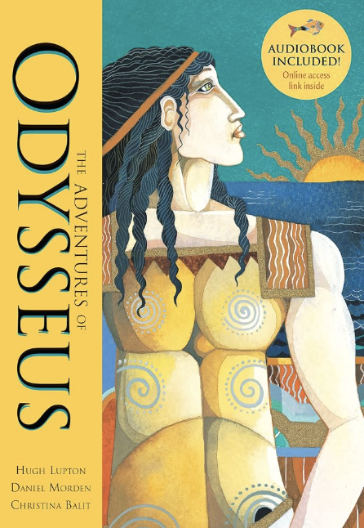 | Maths  Year 5: Place Value, Addition, Subtraction, Multiplication & Division  Year 6: Place Value, Addition, Subtraction, Multiplication & Division  Lessons are adapted from White Rose Maths
Science  Forces: Unbalanced Forces  Children will investigate gravity, friction, air and water resistance and their effects. They will carry out investigations to draw conclusions about each of these forces. | Computing  Computing Systems and Networks  Children will look at how to use a search engine, how results are ranked and recognise why the order of results is important. | History  What is the legacy of the ancient Greek civilisation?  Children will Identify the key periods in the ancient Greek civilisation, make inferences about Greek gods and research a Greek god. They will also compare Athens and Sparta and learn the different types of democracy, as well as explaining how Athenian democracy worked.
Art  Painting and Mixed Media: Portraits  Children will get the opportunities to develop skills in creating interesting portrait drawings using words, experimenting with materials and techniques, and constructing self-portraits that represent aspects of themselves. | Music  Bucket Beats 2 | PE  Fair, Share, Dare  Evade, Invade, Capture
PSHE  Physical Health and Wellbeing: In the Media  Children learn about misleading advertising in the media, about the relationship between media and role models and to learn about image manipulation.  Drug, Alcohol and Tobacco Education: Different Influences  Children learn about the risks associated with smoking drugs, investigate different influences on drug use and learn strategies that will help resist pressure to use drugs. | Spanish  The Date  Children will learn the months of the year and how to use these within speaking, reading and listening tasks. | Trips/Workshops  School Journey  The British Museum

Home reading: Children must read daily at home with an adult or independently. Reading records must be signed with a comment about what your child has read that evening, for how long and how many pages
Homework: A homework takeaway menu is sent home every half term with activities based on the various subject topics. Children are to complete at least two of these activities. Every Friday, spellings are posted on Class Dojo for children to learn. They are tested every Wednesday afternoon on these spellings.

