
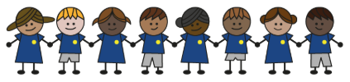
What is my child learning about in Summer term 2 (2026) (June/July)
Year group: Year 3/4
Our topic is:
Europe
Writing  Fiction: Narrative  Non- Fiction: Diary entry | Reading  The Journey by Francesca Sanna  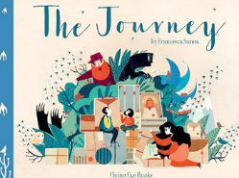 | Maths  Year 3: Tim, shape and statistics  Year 4: Shape, statistics, position and Direction
Science  Making Connections  Children will revise science topics, plan and carry out investigations, record data, draw conclusions, and present their findings, including using shadow puppets | Computing  Repetition  Scratch shapes  Children will plan and draw programs to create shapes, use and modify programs, apply count-controlled loops, and compare different ways of coding | Geography  Europe  Children will learn about European countries, Mediterranean tourism, migration, Greece’s landscape, Athens, and compare children’s lives in different places
Art and design/ DT  Cooking and nutrition:  Eating seasonally  Children will learn about food origins, seasonal foods, develop cutting and peeling skills, and design and evaluate a dish. | Music  The Beatles and School Show Preparation  Children will listen to Beatles songs, learn about the band, create and perform ostinatos, and play a song on the ukulele. | PE  Unit 11: Run, jump, throw  Children will learn to run, jump, and throw with control, adapting their speed, direction, and distance as needed.  Unit 12: React, roll, retrieve  Children will practise reacting quickly, rolling accurately, and moving efficiently to retrieve objects.
RE  Significant events of life  Children will learn how and why people mark significant life events, including Christian baptism, Jewish ceremonies marking becoming an adult, Hindu life ceremonies, and weddings. | Spanish  Goldilocks  Children will listen to Goldilocks in Spanish, learn new words, rewrite the story, and share it with the class. | Trips

Home reading:
Children should read at home daily, either with an adult or independently. Reading records must be signed, noting what your child read, for how long, and how many pages.

Homework:
Every half term, children receive a homework takeaway menu with activities linked to various subjects and are asked to complete at least two. Every Friday, spellings and times tables homework are set on Class Dojo. Spellings are tested on Wednesday, and times tables are tested on Friday.

