
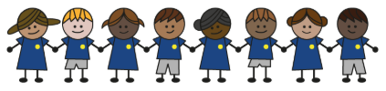
What is my child learning about in Spring term 1 (2026) (January/February)
Year group: Year 3/4
Our topic is:
Romans
Writing  Fiction: Character Description  Non-Fiction: Biography  Poetry: Visual (calligrams) | Reading  Anthony and Cleopatra by Andrew Mathews and Tony Ross  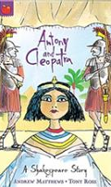 | Maths  Year 3: Multiplication, Division and Length and Perimeter  Year 4: Multiplication, Division, Length and Perimeter
Science  Forces and Magnets  Children will learn about forces and magnets, how objects move on different surfaces, plan investigations, compare magnets, explore their uses, and show results with bar charts. | Computing  Google slides  Children will learn to create and format slides, add images and animations, and explore ways to present their Google Slides. | History  Romans  Children will learn about the Roman invasion, Roman soldiers, life in Roman times, and the Roman legacy in Britain.
Art and design  Sculpture and 3D:  Mega materials  Children will learn to develop 3D art ideas through 2D drawing, shape and join different materials, work with wire, and create sculptures using a variety of materials. | Music  Bucket Beats 1  Children will learn bucket drumming, practise rhythms and fills, and perform “Stargazing” as a class, ending with a recorded performance. | PE  Unit 5: Inspire, create, perform  Children will learn to use dance actions and travel, and work with a partner to mirror movements.  Unit 6: Duel, win, lose  Children will learn to use tactics, think ahead, and show good sportsmanship in games.
PSHE  Democracy  Children will learn that Britain is a democratic society, how laws are made, and about the role of the local council.  Saving, spending and budgeting  Children will learn what influences people’s choices about spending and saving money, how to keep track of their money, and about different types of work. | Spanish  Vegetables  Children will learn to name ten vegetables with the correct plural articles, ask for a kilo or half kilo, use “quisiera” (I would like), and use “y” (and) to buy more than one vegetable. | Trips  Mithraeum Museum

Home reading:
Children should read at home daily, either with an adult or independently. Reading records must be signed, noting what your child read, for how long, and how many pages.

Homework:
Every half term, children receive a homework takeaway menu with activities linked to various subjects and are asked to complete at least two. Every Friday, spellings and times tables homework are set on Class Dojo. Spellings are tested on Wednesday, and times tables are tested on Friday.

