
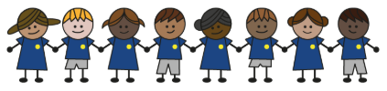
What is my child learning about in Spring term 2 (2026) (March/April)
Year group: Year 3/4
Our topic is:
Active Planet
Writing  Fiction: Retell a story  Non-fiction: To set Instructions | Reading  The Firework-Maker’s Daughter by Philip Pullman  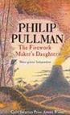 | Maths  Year 3: Fractions,  Mass and Capacity  Year 4: Fractions and  Decimals
Science  Rocks and soil  Children will learn about rocks, fossils, and soils by observing, sorting, and comparing their features and how they are formed. | Computing  Data logging –  using data loggers  Children will learn to use digital devices and data loggers to collect and analyse data over time. | Geography  Volcanoes and Earthquakes  Children will learn about Earth’s structure, plate boundaries, volcanoes, and earthquakes, including their features, locations, and effects
DT  Mechanical systems  Children will learn to design, build, and assemble prototype car chassis, including slingshot and mechanised toy cars, and assemble one from a kit. | Music  Mamma Mia  Children will listen to ABBA songs, learn about the band, and practise singing the chorus of Mamma Mia with confidence. | PE  Unit 7: Fair, share, dare  Children will learn to play fairly, share appropriately, and take sensible risks in games.  Unit 8: Pass, position, patience  Children will learn to pass accurately, choose the right pass, find and take effective positions, and combine passing with moving into space.
RE  Islam  Children will learn about Muslim festivals, family life, the Qur’an, prayer, the mosque, and the celebration at the end of Ramadan. | Spanish  Ice-creams  Children will learn ice-cream flavours, how to say “I would like” in Spanish, and practise ordering in a fun role-play. | Trips  Mosque trip

Home reading:
Children should read at home daily, either with an adult or independently. Reading records must be signed, noting what your child read, for how long, and how many pages.

Homework:
Every half term, children receive a homework takeaway menu with activities linked to various subjects and are asked to complete at least two. Every Friday, spellings and times tables homework are set on Class Dojo. Spellings are tested on Wednesday, and times tables are tested on Friday.

