
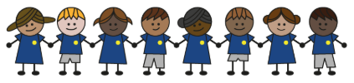
What is my child learning about in Autumn term 1 (2026) (September /October)
Year group: Year 3/4
Our topic is:
Ancient Egypt
Writing  Fiction: Recount  Non- Fiction: Non- chronological report  Poetry: using metaphors | Reading  The Egyptian Cinderella by Shirly Climo and Things about Ancient Egypt you wouldn’t want to know about by Victoria England  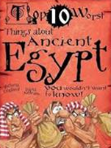  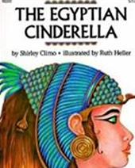 | Maths  Year 3: Place Value, Addition and Subtraction  Year 4: Place Value, Addition and Subtraction
Science  Movement and Nutrition  Children will learn to explain skeletons, muscles, and movement, group animals, understand nutrients and balanced diets, record and compare information, and explore how scientific knowledge develops and is used. | Computing  Computing systems and networks – The internet  Children will learn how networks connect, how the Internet works, and how websites and content are shared and accessed online. | History  Ancient Egypt  Children will learn about ancient Egyptian life, gods and goddesses, pyramid building, mummification, and make inferences about key beliefs using primary sources
Art and design  Craft and design:  Ancient Egyptian  scrolls  Children will learn to explore Ancient Egyptian art, apply its styles and techniques, and create their own contemporary response. | Music  Ukuleles  Children will learn to hold and play the ukulele, strum or pick the strings, and play C major, A minor, and F major chords in simple progressions. | PE  Unit 1: Look, run, avoid  Children will learn to use turning and running skills to move into space, get past defenders, and choose the best strategies to avoid them in a game.  Unit 2: Target, control, combine  Children will learn to send and catch objects using different techniques, choose the best methods for success, and combine skills effectively to play consistently
PSHE  Drug, alcohol and tobacco  education:  Children will learn about tobacco and other drugs, the risks of alcohol, and how people live with asthma.  Keeping safe and managing  risk:  Children will learn to define bullying, understand how to respond to different bullying situations, including cyberbullying, and know what to do if they witness bullying. | Spanish  Instruments  Children will learn to name ten instruments with their determiners/ articles and use “toco” (I play) in sentences. | Trips

Home reading:
Children should read at home daily, either with an adult or independently. Reading records must be signed, noting what your child read, for how long, and how many pages.

Homework:
Every half term, children receive a homework takeaway menu with activities linked to various subjects and are asked to complete at least two. Every Friday, spellings and times tables homework are set on Class Dojo. Spellings are tested on Wednesday, and times tables are tested on Friday.

