
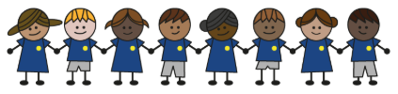
What is my child learning about in Spring Term 1 (2026) (January/February)
Year group: Year 3/4
Our topic is: Anglo Saxons

Writing  Fiction: Narrative  Non-Fiction: Non  Chronological  Report  Poetry: Visual | Reading  Beowulf by Michael Murpurgo and Micheal Foreman  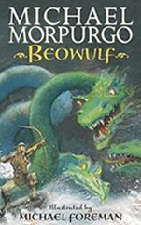 | Maths  Year 3: Multiplication, Division, Length and Perimeter.  Year 4: Multiplication, Division, Length and Perimeter
Science  Sounds and Vibrations  Children will explore how sounds are made and travel, how whales and dolphins communicate, the relationship between vibration, volume, and pitch, and how materials can muffle sound. | Computing  Google docs  Children will use titles, text, and images in Google Docs to create and edit fact files, explain how layouts suit different audiences, and apply digital writing skills to produce documents. | History  Anglo Saxons  Children will learn why the Anglo-Saxons invaded Britain, examine their settlements, make inferences about Sutton Hoo, understand their conversion to Christianity, and study Alfred the Great’s rule.
Art and design  Drawing: Growing artists  Children will use shape, tone, and texture in drawing, apply observational skills, and explore composition and scale to create abstract art. | Music  Music Technology 1  Children will learn to create a song on GarageBand using drumbeats and loops for different sections, refine their music, and share it with the class. | PE  Unit 5: Inspire, create, perform  Children will learn to create and perform dances using actions, music, and group coordination.  Unit 6: Duel, win, lose  Children will learn to use movement skills like running and dodging, apply simple strategies, work as a team, and show respect while competing in games.
PSHE  Playing safe: Children will learn how to stay safe near roads, water, building sites, and fireworks, handle emergencies with basic first aid, and use computers and games safely.  Celebrating difference:  Children will learn to value similarities and differences, understand what community means, and explore belonging to groups. | Spanish  Fruits  Children will learn 10 fruit nouns with articles, make them plural, and use “me gustan” and “no me gustan” to say what they like or don’t like. | Trips  British Museum

Home reading:
Children should read at home daily, either with an adult or independently. Reading records must be signed, noting what your child read, for how long, and how many pages.

Homework:
Every half term, children receive a homework takeaway menu with activities linked to various subjects and are asked to complete at least two. Every Friday, spellings and times tables homework are set on Class Dojo. Spellings are tested on Wednesday, and times tables are tested on Friday.

