
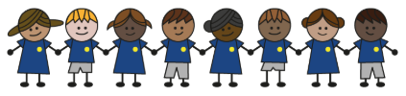
What is my child learning about in Autumn term 2 November – December (2026)
Year group: Year 3/4
Our topic is:
Journeys
Writing  Fiction: Character description  Non- Fiction:  Persuasive letter | Reading  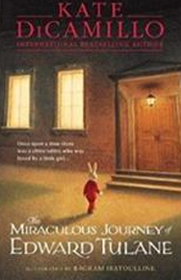  The Miraculous Journey of Edward Tulane by Kate DiCamillo | Maths  Year 3: Addition, Subtraction, Multiplication and Division  Year 4: Area, Multiplication and Division and Consolidation
Science  Electricity and Circuits  Children will explore how electrical appliances work, build and diagram circuits, learn about switches, conductors and insulators, investigate bulb brightness, and understand electrical safety. | Computing  Creating media  Children will identify that sound can be digitally recorded, use a digital device to record and store audio files, edit recordings, and combine different types of audios so they play together. | Geography  Exploring your local area  Children will explore the local area using aerial images and fieldwork, describe its human and physical features, create sketch maps, and use maps and other sources to gather information for a report.
DT  Electrical systems: Electrical poster  Children will research a topic, develop and refine a design, and assemble a finished product that includes a simple circuit. | Music  The Nutcracker  Children will explore music through listening, creating rhythms, and performing. They will make art and dance inspired by music, learn simple notation, play instruments, and structure their ideas into short musical pieces. | PE  Unit 3: Fair, share, dare  Children will learn to work together, follow rules, encourage teammates, and stay calm to keep games fun and respectful.  Unit 4: Hands, feet, equipment  Children will learn to dribble with control, use the right techniques for different sports, and apply strategies like changing direction or pace to keep possession.
RE  Judaism  Children will learn about Shabbat, Rosh Hashanah, Yom Kippur, and the story of Pesach, including how these are observed today in the UK. | Spanish  Animals  Children will learn to recognise and recall 10 animal nouns with their correct articles, practise spelling them, understand the use of the indefinite article, and use the verb “soy” (I am). | Trips  TFL museum  Cinema trip

Home reading:
Children should read at home daily, either with an adult or independently. Reading records must be signed, noting what your child read, for how long, and how many pages.

Homework:
Every half term, children receive a homework takeaway menu with activities linked to various subjects and are asked to complete at least two. Every Friday, spellings and times tables homework are set on Class Dojo. Spellings are tested on Wednesday, and times tables are tested on Friday.

