
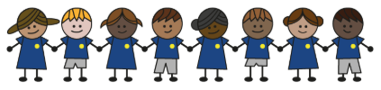
What is my child learning about in Autumn Term 1 September – October
Year group: Year 3/4
Our topic is:
Stone Age to Iron Age
Writing  Fiction: Retell a story  Non-Fiction: Instructions  Poetry: (Free Verse) poems using similes | Reading  Stone Age Boy by  Satoshi Kitamura  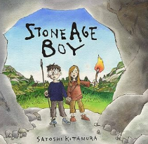 | Maths  Year 3: Place Value, Addition and Subtraction  Year 4: Place Value, Addition and subtraction
Science  Digestion and Food  Children will explore the skeleton, bones, muscles and movement, as well as nutrition and a balanced diet, using practical activities to draw conclusions. | Computing  Connecting Computers  Children will explore how digital devices work, identify their components, understand how they connect, and recognise the physical parts of a network. | History/  Stone Age to Iron Age  Children will explore prehistory, using archaeological evidence to learn about Skara Brae, bronze, and Iron Age trade.
Art and design  Painting and Mixed Media: Prehistoric Painting  Children will explore prehistoric art, enlarge drawings using scale, make natural pigments, apply painting techniques, and create a collaborative artwork. | Music  Ukuleles  Children will learn how to hold and play the ukulele, including strumming and picking the strings. They will learn the C major, A minor, and F major chords and practise changing between them while playing along to music. | PE  Unit 1: Look, run, avoid  Children will learn to turn and run in different directions, change speed, and move into open spaces. They will practise avoiding defenders by choosing the best times and places to move.  Unit 2: Target, control, combine  Children will learn to improve their agility, balance, and coordination, and use these skills effectively in games.
PSHE  Strengths and challenges  Children will learn about celebrating achievements, setting goals, handling setbacks positively, valuing differences, and understanding community and belonging.  What is important to me?  Children will learn about making healthy food and drink choices, how branding influences what people buy, and how to keep active along with the challenges of doing so. | Spanish  Unit 1: I am learning Spanish  Children will learn to find Spain on a map and name at least one other Hispanic country. They will practise key greetings, asking and answering, “How are you?” and “What is your name?”, and counting to 10 in Spanish. | Trips
Home reading:
Children should read at home daily, either with an adult or independently. Reading records must be signed, noting what your child read, for how long, and how many pages.

Homework:
Every half term, children receive a homework takeaway menu with activities linked to various subjects and are asked to complete at least two. Every Friday, spellings and times tables homework are set on Class Dojo. Spellings are tested on Wednesday, and times tables are tested on Friday.

