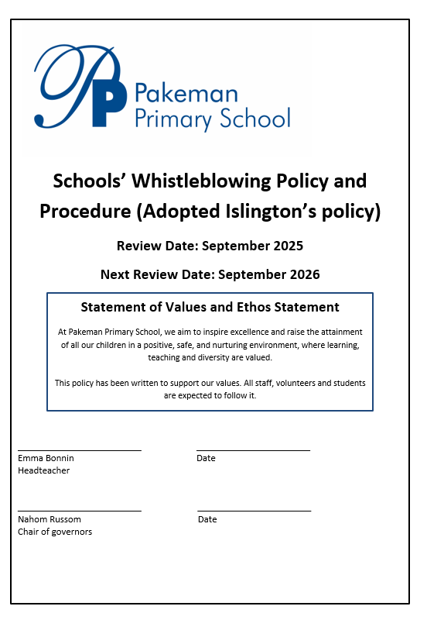
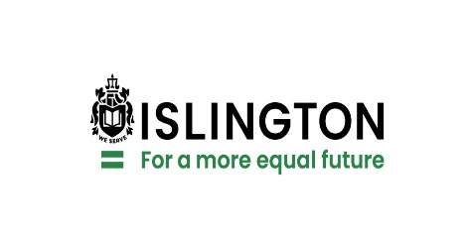

Schools Whistleblowing Policy and Procedure
1 BACKGROUND

1.1 Overall context
The School expects the highest standards of behaviour of all those who work for the School and its contractors.

The Whistleblowing Procedure is intended to encourage employees and others who are listed below to report inappropriate action by any of the above which would not normally be revealed due to fears of victimisation or retribution.

The procedure provides a framework for those with concerns to report such concerns and for them to be dealt with in an appropriate manner.

The procedure reassures employees that they will be protected from reprisals or victimisation for making reports of malpractice, in the public interest, which they reasonably believe to be true.

The School will ensure that workers are trained appropriately in relation to whistleblowing law and this procedure.

1.2 Regulatory and legal context
This disclosure policy has been devised in accordance with the provisions of the Employment Rights Act 1996, Public Interest Disclosure Act 1998 and the Enterprise and Regulatory Reform Act 2013.

1.3 Scope of the procedure
This procedure applies to a report where it is the reasonable belief of the employee or other person making the report that it discloses past, present or likely future wrongdoing in any of the following categories:

- a criminal offence, including bribery or corruption,
- a failure to comply with a legal obligation,
- a miscarriage of justice,
- a significant breach of child protection and/or safeguarding policy and procedures,
- a danger to the health and safety of an individual,
- damage to the environment,
- a deliberate attempt to conceal any of the above

in relation to the conduct of the School business, including activities carried out by contractors on its behalf.

1.4 Matters outside the scope of the procedure

Statutory whistleblowing protections do not normally cover day to day issues in relation to an employee’s terms and conditions of employment or a complaint about another employee, these can usually be referred to their line manager, or if necessary be pursued using the School’s Grievance Procedure.

Note: Employees generally do not receive statutory protection as a whistleblower when they complain merely about breaches of their own employment contract. A protected whistleblowing disclosure should have a public interest aspect to it. A grievance by contrast has no public interest factors, as it is a complaint about a particular employment situation. A grievance should be reported using the School’s Grievance Procedure, not the Whistleblowing Procedure. If employees are unsure about whether or not their concern raises a public interest matter, they may find it useful to seek further guidance from the sources of advice provided below.

Complaints or allegations relating to Members of the Council are subject to separate investigative procedures under the Islington Code of Conduct for Members and the relevant provisions of the Localism Act 2011.

There are other matters that may attract statutory whistleblowing protection, but nonetheless should be reported using other School procedures:

- Matters that would normally be dealt with by the School’s collective bargaining arrangements with its recognised trade unions.
- Matters relating to child abuse which should be reported to the Referral and Advice Team: telephone 020 527 7400 or Email: csctreferrals@islington.gov.uk Further information is available on the Islington School website: https://www.islington.gov.uk/children-and-families/worried-about-a-child
- Matters relating to the protection of vulnerable adults should be referred to the Access Team: telephone 020 7527 2299 or send an email to them at access.service@islington.gov.uk. Further information is available on the Islington School website: https://www.islington.gov.uk/social-care-and-health/abuse
- You can also make a referral at: dolsoffice@islington.gov.uk or in an emergency telephone 0207 527 8837
- For referral outside office hours in relation of child abuse or the protection of vulnerable adults contact the Emergency Duty Team on 020 7226 0992.
- Allegations which you would normally make to Internal Audit concerning fraud or financial irregularity which should continue to be made direct to Internal Audit by calling 0207 527 6538 or Email at: internal.audit@islington.gov.uk
- Matters relating to modern slavery should be raised as under paragraph 4 below.
- Complaints from the public that relate to standard of service delivered by the School or its contractors which should be reported through the School’s Complaints procedure.

1.5 Who is covered by the procedure?
All employees, contractors (and their staff), partner agencies (including the Health Authority and voluntary sector groups), casual and agency workers, consultants, trainees and self-employed people providing work for the School may make reports under this procedure outlining any concerns.

2 MAKING A WHISTLEBLOWING REPORT – Step 1

2.1 Reporting a concern within the management structure of your own Service Area
In the first instance you should normally report any concerns to your line manager or their manager, preferably in writing. However, if you feel the matter is extremely serious or sensitive or involves your line manager or their manager, you may report the matter to the Headteacher or Deputy Headteacher or Chair of Governors.

Before raising your concern, you may wish to take advice on the matter from any of those listed in paragraph 5.7 of this procedure or discuss your concerns with a colleague first. It is advisable that you report your concern as early as possible. A significant delay in reporting the matter may make the subsequent investigation difficult to pursue.

In raising your concern in writing, you should give as much detail as possible, i.e. the background and history, giving names and relevant dates and the reasons why you are particularly concerned about the situation.

If you feel hesitant about putting your concern in writing at this stage you should telephone the manager to whom you wish to make the report and arrange to meet them. Do bear in mind you may be asked to put the details in writing later.

Managers receiving a report under this section must notify the council’s whistleblowing officer of the referral within 24 hours.

Any evidence you provide may be useful. However, you do not need to provide evidence in order to make a report under this procedure.

2.2 Reporting a concern to the council’s Whistleblowing Officer
The council’s Whistleblowing Officer is the Head of Internal Audit, Investigations and Risk Management (Tel: 020 7974 2211)

You may also contact the Whistleblowing Officer via email at: internal.audit@islington.gov.uk. This mailbox is restricted and only accessed by authorised managers in Internal Audit.

You may make a written report to the council’s Whistleblowing Officer if you:

- Have previously raised an issue to management within your School or Chair of Governors and feel that it has not been dealt with properly or the matter involves your Headteacher or Chair of Governors, or
- Fear that you will be victimised if the matter is raised within your management structure, or
- Fear that relevant information may be concealed or destroyed if the matter is raised within your management structure.

If the matter you wish to raise involves the Whistleblowing Officer, you may make your report to the Director of Learning and Achievement. The Director of Learning and Achievement, with support from a relevant senior officer, will then assess the matter in accordance with the provisions of the Whistleblowing Policy.

3 INVESTIGATION OF YOUR REPORT – Step 2

3.1 What will happen?
An assessment will be made on whether the referral is appropriate for this procedure in the light of the matters set out in paragraphs 1.3 to 1.5 above.

Receipt of your report will be logged by the Whistleblowing Officer, following which you will normally be interviewed. In most cases you will be asked to provide a written statement detailing the allegations following the interview.

You will receive a written acknowledgement of your report and will be informed of the action that will be taken to investigate your concern within 10 working days of receipt. You will also be given an estimate of the likely timescale of the investigation, although this cannot be guaranteed.

Where possible, you will be kept informed of the progress of the investigation, unless the Investigator considers that there is a risk of the investigation being prejudiced by disclosures of the process being taken. You may not receive full details of the progress or the outcome of the investigation if provision of details would be inconsistent with obligations of confidentiality in relation to others.

The person making the disclosure and the person the disclosure is about have the right to be accompanied and/or represented by their trade union representative or a colleague at all stages of the procedure. If, following the assessment process, an investigation is undertaken, an employee who is the subject of the allegation will be given details of the allegation in order to respond during the investigation.

In some circumstances the matter may be referred to an external agency, such as the police, if crime is involved. Where possible the Whistleblowing Officer will advise you of this before doing so.

It may be considered appropriate for the allegations in your report to be investigated on behalf of the School by an external party. In these cases, the Director of Learning and Achievement will provide authority for an external investigation to be conducted. In exceptional circumstances, it may be considered appropriate to appoint a legal professional, such as a solicitor or barrister to conduct this investigation. In these cases, the council’s Audit Committee will provide the authority for an external investigation to be undertaken.

3.2 Conclusion of the investigation – Step 3

If your allegation is not proven or there is insufficient evidence on which to base a conclusion, you will be advised accordingly.

In all cases a written record will be kept of the decision reached in relation to whether or not the council will investigate.

In cases where action is necessary as a result of your allegation, a report will usually be sent to the Headteacher or the Chair of Governors. They will be responsible for implementing the recommendations in the report. You will be advised when the investigation is complete but it may not always be possible to tell you the details of the findings as this may be confidential.

If the investigation concerns inappropriate action by the Headteacher, the report will be sent directly to the Chair of Governors and Director of Learning and Achievement. If the report concerns inappropriate action by the Chair of Governors, the report will be sent directly to the Director of Learning and Achievement. If you are concerned about the Chair of Governors receiving the report you should discuss this with the investigator.

4 MODERN SLAVERY

4.1 Modern slavery is the illegal exploitation of people for personal or commercial gain, often in conditions which the victim cannot escape. Islington is committed to ensuring that this exploitation does not occur in any of the School’s activities and that staff and the public have the opportunity to report suspicions to the appropriate place.

Staff who suspect that modern slavery or human trafficking may be happening through any of the School’s activities, particularly in service delivery via third parties, should contact the council’s Head of Internal Audit, Investigations and Risk Management immediately (Tel: 020 7974 2211).

More information and advice can be found on the government’s website on modern slavery: https://www.gov.uk/government/collections/modern-slavery

5 GENERAL PROVISION

5.1 Anonymous reports

This policy encourages you to give your name when making an allegation. Whilst anonymous allegations do not carry the same weight, any such reports received by the School will be considered when the School believes this to be appropriate. In exercising this discretion, the factors to be taken into account would include:
- the seriousness of the issues raised;
- the credibility of the concern;
- the factual content and specific detail of the complaint (and any supporting material provided);
- the likelihood of confirming the allegation from other attributable sources.

Anonymous whistle blowers will not ordinarily be able to receive feedback. Anonymous whistle blowers may seek feedback through a telephone appointment or by using an anonymised email address. Please see the relevant contact details above. Such feedback will be provided subject to sufficient evidence that the person seeking the feedback is the same person who made the original complaint or allegation.

5.2 Anonymity
During the initial stages of the investigation, if you so wish, the School guarantees that your identity will only be disclosed to those directly involved in investigating the allegation. If you wish to remain anonymous, we will take all reasonable steps to maintain your anonymity throughout the enquiry. However, notwithstanding all reasonable steps being taken, it is possible that anonymity will not be maintained. For example, the matters to which your complaint relates may enable interviewees in an investigation to guess your identity. We may also be required by law to breach anonymity. For example, we may be required by law to disclose your identity to other investigating agencies, but we will discuss this with you before doing so.

5.3 Attendance at a disciplinary hearing
In cases where disciplinary action is taken, it may be necessary for you to provide witness evidence. We will try to gather evidence to support your allegation without requiring your attendance at a hearing, but this may not always be possible.

5.4 Non-disclosure agreements
Non-disclosure clauses in settlement agreements do not prevent you from making a disclosure under this policy or attracting the statutory protection.

5.5 Statutory protection
The Public Interest Disclosure Act 1998 and the Enterprise and Regulatory Reform Act 2013 provide individuals with protection from victimisation, dismissal or any other detriment provided they have a reasonable belief that what they have reported is true and the report is made in the public interest.

5.6 Protection to School employees
Action will not be taken against you by the School if you make a report with a reasonable belief that it is in the public interest even if it is not confirmed by the investigation.

The School will treat any victimisation or harassment of an employee because they made a report reasonably and in the public interest under this procedure as a serious disciplinary offence.

If you consider that you have been, are being or are likely to be victimised, dismissed, made redundant or made to suffer some other detriment as a result of making a report under this procedure, you should report your concerns to the Whistleblowing Officer. The matter will then be dealt with as a new referral under this procedure and an assessment will be made as to whether or not the referral is appropriate for consideration under the procedure.

Employees should not make reports which they do not reasonably believe to be true or which are malicious. Disciplinary action may be taken against an employee who makes an allegation frivolously, maliciously or for personal gain.

Please note that:
• Staff must believe the disclosure of information is in the public interest;
• Staff must believe it to be true;
• Staff must not act maliciously; or knowingly make false allegations; and
• Staff must not seek any personal gain.

Just as the School seeks to protect those who raise complaints in good faith, it will seek to protect those against whom potentially malicious claims are made. No action will be taken against anyone who reasonably raises a concern in good faith which transpires to be unfounded. However, the School will take disciplinary action against any employee who makes a vexatious claim, a malicious claim or obtains information inappropriately to inform a vexatious or malicious claim. In either case, where it turns out that a claim was without foundation, the School will ensure that any negative impact upon the person complained of is minimised.

If you are already the subject of a disciplinary, capability or redundancy procedure, this will not normally be halted as a result of your report.

5.7 Advice
If you wish to receive advice from a relevant professional in the council before making a report under this procedure, you should contact any of the following:

- Director of Learning and Achievement (sarah.callaghan@islington.gov.uk)
- Corporate Director of Children’s Services (jon.abbey@islington.gov.uk)
- The Corporate Health and Safety Manager. Email- CorporateHealthandSafety@islington.gov.uk

Alternatively, you may wish to ask for confidential help from your trade union:

- UNISON:
Jane Doolan Tel: 0207 527 8298 or 07940393741
email: secretary@islingtonunison.org.uk

- GMB:
Marie McCormack Tel: 07783 460 987
email: Marie.McCormack@islington.gov.uk

George Sharkey 07540995440
email: george.sharkey@islington.gov.uk

Gary Harris
Email: Gary.Harris@islington.gov.uk
- Unite:

Bobby Haddock Mobile 07813361144
email: Robert.Haddock@islington.gov.uk

- NAHT
Paul Smith Mobile: 07970789683
Email: paul.smith@naht.org.uk

- NASUWT
Susanna Thompson
Email: Susanna.Thompson@mail.nasuwt.org.uk

- NEU
Tony Buttifint Mobile: 07776654579
Email: Tony.Buttifint@neu.org.uk

Pippa Doswell Mobile: 07791677952
Email: pippa.dowswell@neu.org.uk

Or your professional organisation.

You may also contact the following organisations outside the School for assistance with your concern:
- Public Concern at Work, now known as Protect Tel: 020 3117 2520 or visit their website: https://protect-advice.org.uk/contact-us/

For additional support you can contact the Employee Assistance Programme (EAP)
Phone: 0808 196 1441
Web: app.mclmedicseap.com
App: MCL Medics EAP app (available both in App Store and Google Play)
Use unique company code for schools: 861525

The National Society for the Prevention of Cruelty to Children (NSPCC) has a national whistleblowing helpline for employees wishing to raise concerns about a child at risk of abuse.

You can find more information on this NSPCC whistleblowing helpline on their official website at: https://www.nspcc.org.uk

5.8 Reporting outside the School/council
This procedure is intended to provide you with an avenue within the School/council to raise concerns. The School/council hopes you will be satisfied with any action taken. If you are not, and if you feel it is right to take the matter outside the School/council following completion of the process set out above, the following are possible contact points:
- HM Revenue & Customs,
- the Financial Services Authority,
- the Office of Fair Trading,
- the Health and Safety Executive,
- the Environment Agency,
- the Director of Public Prosecutions,
- the Department of Health,
- the Care Quality Commission,
- the Serious Fraud Office,
- Ofsted,
- or other appropriate regulatory body.

For a full list of bodies and person who you can make a disclosure to see:
https://www.gov.uk/government/publications/blowing-the-whistle-list-of-prescribed-people-and-bodies

A report made externally, i.e. to the police, media or Member of Parliament, will only be protected and count as a qualifying disclosure under the legislation if the following apply:

- the report is in the public interest: if you honestly and reasonably believed the information and any allegation contained in it to be substantially true,
- the allegation has not been made for personal gain,
- the allegation has already been raised with the School, unless you reasonably believed you would be victimised or that there may be a cover-up or that the matter is exceptionally serious.

Also a disclosure is not a qualifying disclosure if:
- by making the disclosure, you have committed an offence (e.g. under the Official Secrets Act 1989), or
- the information should be protected from disclosure because of legal professional privilege (e.g. the disclosure has been made by a legal adviser (or their secretary) who has acquired the information in the course of providing legal advice).

5.9 Review of the whistleblowing procedure
The procedure and reports made under it should be reviewed at least every four years. The Audit Committee will receive a regular monitoring report on the use of this procedure, detailing all referrals made under this procedure.

Previous Version January 2020
This Version January 2024

