School Improvement Plan

2025/2026

School Improvement Plan Priorities
2025-2026
 |  | 
1 – To ensure the school is financially stable (attracting external funding) | 2 – To ensure effective provision for all SEND pupils (universal approach to SEND, assessment, strategies…) | 3 – To increase engagement of families in all aspects of school.
 | 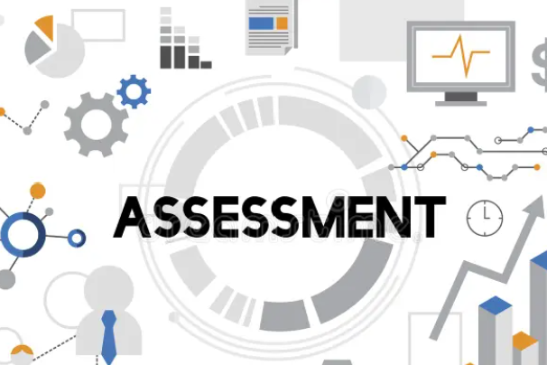 | 
4 – To introduce a clear digital strategy to improve teaching, learning and assessment of children’s learning | 5 – To ensure effective use of assessment in all subjects. | 6 – To ensure effective progress of children who are new to English

Priorities | Success criteria
1 – To ensure the school is financially stable (attracting external funding) | - The school attracts external funding to fund additional opportunities for the development of children, families and staff.  - A balanced budget is set for the year 2024/25.  - The school shows financial stability through its income and expenditure.  - School spending priorities, as shown on the DfE financial benchmarking comparison website, represent value for money.  - All funding lines have been reviewed to ensure any possible savings.  - Ensure pupil numbers are increasing.
2 – To ensure effective provision for all SEND pupils (universal approach to SEND, assessment, strategies…) | - SEND non negotiables are established in all classes and monitored by team leaders  - A universal approach to SEND is in place to ensure all children can access learning (visual timetables…)  - All staff can access CPD in relation to the needs of children they work with (including class clinics)  - Adaptive teaching and learning is embedded throughout the school  - Progress of SEND pupils is tracked through pupil passports and data (using engagement model and pre key stage)  - The learning environment and resources used to access learning are clearly differentiated to meet the needs of individual children (recorded in pupil passports)  - Lead SEND LSA role models strategies and processes needed for SEND children to flourish  - Provision is adapted for all children being currently assessed even when the diagnosis is not yet established  - A clear transition is organised for new joiners with a diagnosis of SEND – This includes observations and assessments leading to a plan to best support the child  - All children are aware of disabilities and their challenges in society  - Environment is well equipped to meet the needs of all pupils (Sensory provision in Nursery, intervention room in EYFS, sensory EYFS environment)  - Children with SEND have access to the ‘whole’ school day and there is a wider club offer for all (disability sports coaching…)
3 – To increase engagement of families in all aspects of school. | - Curriculum is shared effectively and comprehensively with parents/carers online and in person  - Homework focuses on impactful activities based on topics and key skills  - Parents/carers are engaged with their child’s learning though home reading, spellings and maths core skills  - Parents/carers are supported through meetings and coffee mornings in relation to learning and inclusion  - All parents/carers are engaged on Class Dojo (through messages, chats or acknowledgements)  - Parents/carers governors are proactive in making positive changes for school and take an active role in discussions  - Parents/carers promote school values and ethos to their children and the rest of the school community, and act as role models (inclusion, diversity and behaviour)  - The number of parents/carers attending coffee mornings increases each time  - The school is making inroads into engaging its hard to reach families.  - Uptake of the city harvest project increases.  - Parents/carers engage with their children at school (Create club, BAPTS)  - An effective PTA is set up to increase engagement  - School classroom events promote parental engagement  - A new parent volunteering program is established and encourage engagement of families
4 – To introduce a clear digital strategy to improve teaching, learning and assessment of children’s learning | - A clearly documented digital strategy is created, communicated, and accessible to staff, pupils, and parents.  - Staff receive training to confidently use chosen digital tools and platforms.  - Teachers embed digital tools purposefully to enhance lesson delivery, interactivity, and engagement.  - Pupils demonstrate increased independence, collaboration, and digital literacy in their learning.  - Digital resources are used to provide differentiated and personalised learning opportunities.  - Digital platforms are used consistently to capture, track, and monitor pupil progress.  - Data from digital assessment informs planning and targeted interventions.  - Regular reviews measure the effectiveness of digital tools in improving outcomes.  - Evidence of improved pupil attainment, engagement, or progress can be demonstrated.  - Staff and pupils provide feedback showing confidence and satisfaction with digital learning approaches.  - The digital strategy is adaptable and updated annually based on evaluation and new technologies.  - A culture of innovation and safe, responsible digital use is embedded across the school.
5 – To ensure effective use of assessment in all subjects. | - Fine motor and writing project in EYFS  - Assessment policy is implemented consistently across all subjects and year groups.  - Teachers have a clear understanding of formative, summative, and diagnostic assessment purposes.  - Teachers use assessment information to adapt planning, ensuring lessons meet the needs of all learners.  - Assessment supports progression by identifying gaps and strengths across the curriculum.  - Pupils are given regular opportunities to reflect on feedback and understand their next steps.  - Systems for recording and tracking assessment are used effectively and consistently by all staff.  - Data is analysed to identify trends, inform interventions, and support subject leadership.  - Progress across core and foundation subjects can be evidenced for individuals and groups (e.g., SEND, disadvantaged).  - Assessment outcomes are used to celebrate achievement as well as highlight areas for improvement.  - Subject leaders monitor assessment practices and provide feedback to improve consistency and impact.  - Evidence from assessment informs school self-evaluation and development planning.  - Parents are kept informed of progress in all subjects through clear reporting systems.
6 – To ensure effective progress of children who are new to English | - All children are assessed using the acquisition data – 6 categories  - There is consistency in approach to new joiners with little language – use of resources packs.  - The learning environment supports learning – visuals and lanyards.  - Partner work and peer learning is used effectively to enable communication.  - IT is used effectively to aid communication and assist teaching  - All children and families feel welcome in the school community.  - The progress of children with EAL is similar to that of children whose first language is English (from a different starting point)

