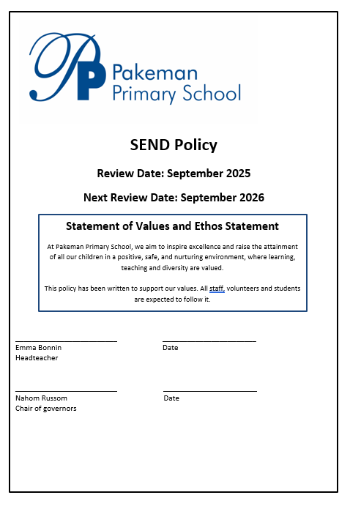

Legislation

- Maintained schools – The Education (Special Educational Needs) (Information) Regulations 1999: SI 1999/2506.
- The Special Educational Needs and Disabilities Code of Practice (2014)
- The Children and Families Act (2014)

Introduction
Pakeman Primary School is committed to meeting the needs of all pupils including those with special educational needs and disabilities (SEND). Our expectation is that children and young people with SEND will receive an education that enables them to make progress so that they:

• achieve their best
• become confident individuals living fulfilling lives

We believe that:
- All teachers are responsible for the planning and teaching of children with Special Educational Needs and Disabilities (SEND) within their class
- All children with SEND will be supported to reach their full potential through a differentiated curriculum which is in line with their developmental needs
- The views of children should be sought and taken into account
- Parents/Carers and school work in partnership supporting their child’s education and planning for the future
- Children with SEND are viewed positively by all members of the School and local community.

We will use our best endeavours to make sure that a pupil with SEND gets the
support they need – this means doing everything we can to meet the pupils special
educational needs.

Aims and Objectives

This policy accepts the definition of Special Educational Needs (SEN) as set out in the Special Educational Needs and Disabilities (SEND) Code of Practice. It reflects the new approach to and arrangements for SEND outlined in the Children and Families Act 2014.

The Governing Body and teaching staff will do their best to ensure that the necessary provision is made for any pupil who has special educational needs and/or disabilities. Where the headteacher or the appropriate governor has been informed that a child has SEND, those needs will be made known to all who are likely to teach them.

All staff and governors in the school are aware of the importance of identifying and providing for children who have SEND.

The Headteacher, staff and governors will draw up and report annually to parents on the policy and effectiveness of the school’s work for pupils with SEN. This will be published on the school website.

All staff will ensure children with SEND can join in the activities of the school together with pupils who do not have SEND, so far as that is reasonably practical and compatible with the pupil receiving the necessary special educational provision, the efficient education of other children in the school and the efficient use of resources

Responsible Persons

The ‘responsible person’ for SEND is the Headteacher, Emma Bonnin. The person co-ordinating the day-to-day provision of education for pupils with SEND is the Assistant Head for Inclusion, Tracey Gulliford and in the Early Years, SENCO, Lauren Howard.

Admission and Inclusion

All the teachers in the school are teachers of children with Special Educational Needs. As such Pakeman Primary adopts a 'whole school approach' to SEND that involves all staff adhering to a model of good practice based on a Quality First Teaching model. The staff of the school are committed to identifying and providing for the needs of all children in a wholly inclusive environment. Inclusion is given a high priority in this policy, in line with the policies of Islington Local Authority.
All children with SEND are afforded the same rights as other children in terms of their admission to school.

Specialist Provision

Pakeman Primary School is a flat site at pavement level with 3 playgrounds that are all at the same level and are step free. The school buildings consist of a main three-storey block, a separate one-storey nursery block, a Lodge, science lab and 2+ Centre. Whilst nursery and reception classrooms are on the ground floor all other year groups are on the middle and top floors. There are 2 separate flights of stairs to all floors but no lifts. There is a disabled toilet. The school office is on the ground floor.

Equipment available in our school to all children at any time needed:

• Communication books (for home and school)
• Devices for additional recording e.g. Cameras, video recorders, voice recorders
• SEND software - Communication in Print to produce printed matter with visual prompts, specific maths and literacy computer programmes.
• sensory equipment – the school has an interactive sensory room, equipment (also available in classes) to support children’s sensory needs.

The school will consider purchasing other equipment if there is an agreed identified need. We will consider this at the pupil’s termly or annual review.

Access to the Curriculum

The Curriculum will be made available for all pupils, including those with predictable SEND. Where pupils have SEND, a graduated response will be adopted. The school will, in other than exceptional cases, make full use of classroom and school resources before drawing on external support, as outlined in the Local Offer.
The school will make provision for pupils with SEND to match the nature of their individual needs and the class teacher and SENDCo will keep regular records of the pupils’ SEND, the action taken and the outcomes.

There will be flexible grouping of pupils so that learning needs may be met in individual, small grouping or whole class contexts.

The curriculum will be differentiated to meet the needs of individual pupils. Teaching styles and flexible groups will reflect this approach.
Schemes of work for pupils, within classes and year groups, will reflect whole school approaches to teaching and learning and will take account of SEND.

Curriculum tasks and activities may be broken down into a series of small and achievable steps for pupils who have marked learning difficulties.

Providing the graduated response: SEND Support

The school offers a differentiated curriculum. When a pupil fails to make progress and shows signs of difficulty in some of the following areas: acquiring literacy and numeracy; presenting persistent behaviour, emotional and social difficulties; has sensory or physical problems; or communication or interaction difficulties, the school follow an ‘Assess, Plan, Do, Review’ approach.
Assessments will allow the child to show what they know, understand and can do, as well as to identify any learning difficulties. Following assessment, we will put a plan in place detailing appropriate interventions, such as;

- Classroom organisation and management
- In-class support by teacher
- Small group work
- Managed specialist interventions
- Home/school reading schemes
- Behaviour modification programmes
- Use of specialist equipment
- Alternative teaching strategies

The plans will be outcome focused.

The resources deployed to help the child achieve the agreed outcomes will be captured in a Provision Map, an Individual Plan and/or a Pupil Passport. Parents and children will be involved in developing the plan.

The plan will also set out review arrangements.

Where more than one agency is involved, the school, in discussion with parents and other agencies will initiate an early help assessment to assist planning and support.

Identification, assessment, planning, intervention and review of children with SEND will be undertaken by all staff, with advice and support from the SENCo where needed. Appropriate records will be maintained, including continuous assessment, standardised tests, Key Stage attainment tests. Where necessary, pupils will be referred to the SENCo for diagnostic testing to construct a profile of strengths and weaknesses.

Additionally, the progress of any child receiving exceptional needs funding, or with an EHCP will be reviewed annually.

Resources

The school is allocated a notional SEND budget (a combination of funding streams specifically to support SEND children and a proportion of other income is assumed to be used to support SEND pupils). In addition, additional funding is sometimes awarded to support pupils with higher needs.

The principles which guide the governing body in allocating resources are SENCo recommendation, Teacher Assessments and Pupil Progress meetings.

Parent/Carer Participation

The school will actively seek the involvement of parents/carers in the education of their children. It is recognised that it is particularly important with pupils who have SEND where the support and encouragement of parents is often the crucial factor in achieving success.

Parents/Carers will always be kept informed about the special educational needs experienced by their children in accordance with the recommendations outlined in the Code of Practice. Communications between the parent and the school will be consistently maintained. We will always discuss with parents/carers before we seek support from an external agency.

The school will work to ensure that children are fully aware of their own needs and the targets in their plans. We will encourage all children to be independent learners and to work towards a positive progression to adulthood from the earliest stage.

Multi-agency working

Regular liaison is maintained with the following external agencies:
- Outreach Support Services
- Educational Psychologist
- Child Adolescent Mental Health Service
- Health Service (school nurse, dietician, therapists)
- Families First

Arrangements for the Treatment of Complaints:

If you have a complaint about SEND provision, please tell us promptly by contacting the following people in this order;
• the class teacher
• the SENCo
• The head teacher – using the main school number
• The SEND governor (a letter can be submitted through school office)

The SEND governor will then refer to the complaints procedure to try and address the issue.

Further information about our complaints procedure can be found through the school office.

Workforce Development
In-service training needs related to special educational needs will be identified by the Headteacher in consultation with the staff and will be incorporated into the school development plan.

Evaluating Success

This policy will be kept under review. The governors will gauge the success of the policy by the achievements of the outcomes outlined in individual plans. In addition, evidence will be gathered regarding:

- Staff awareness of individual need
- Success of early help intervention
- Academic progress of pupils with SEND
- Accelerated progress displayed with additional interventions.
- Improved behaviour of the children, where this is appropriate
- Pupil attendance
- Consultation with parents
- Children’s awareness of their targets and achievements

Relationship to other policies

This policy should be read in conjunction with the policies on teaching and learning, the school curriculum, equality and assessment, recording and reporting. The Accessibility Plan and School Information Report on the school website are integral to this policy.

