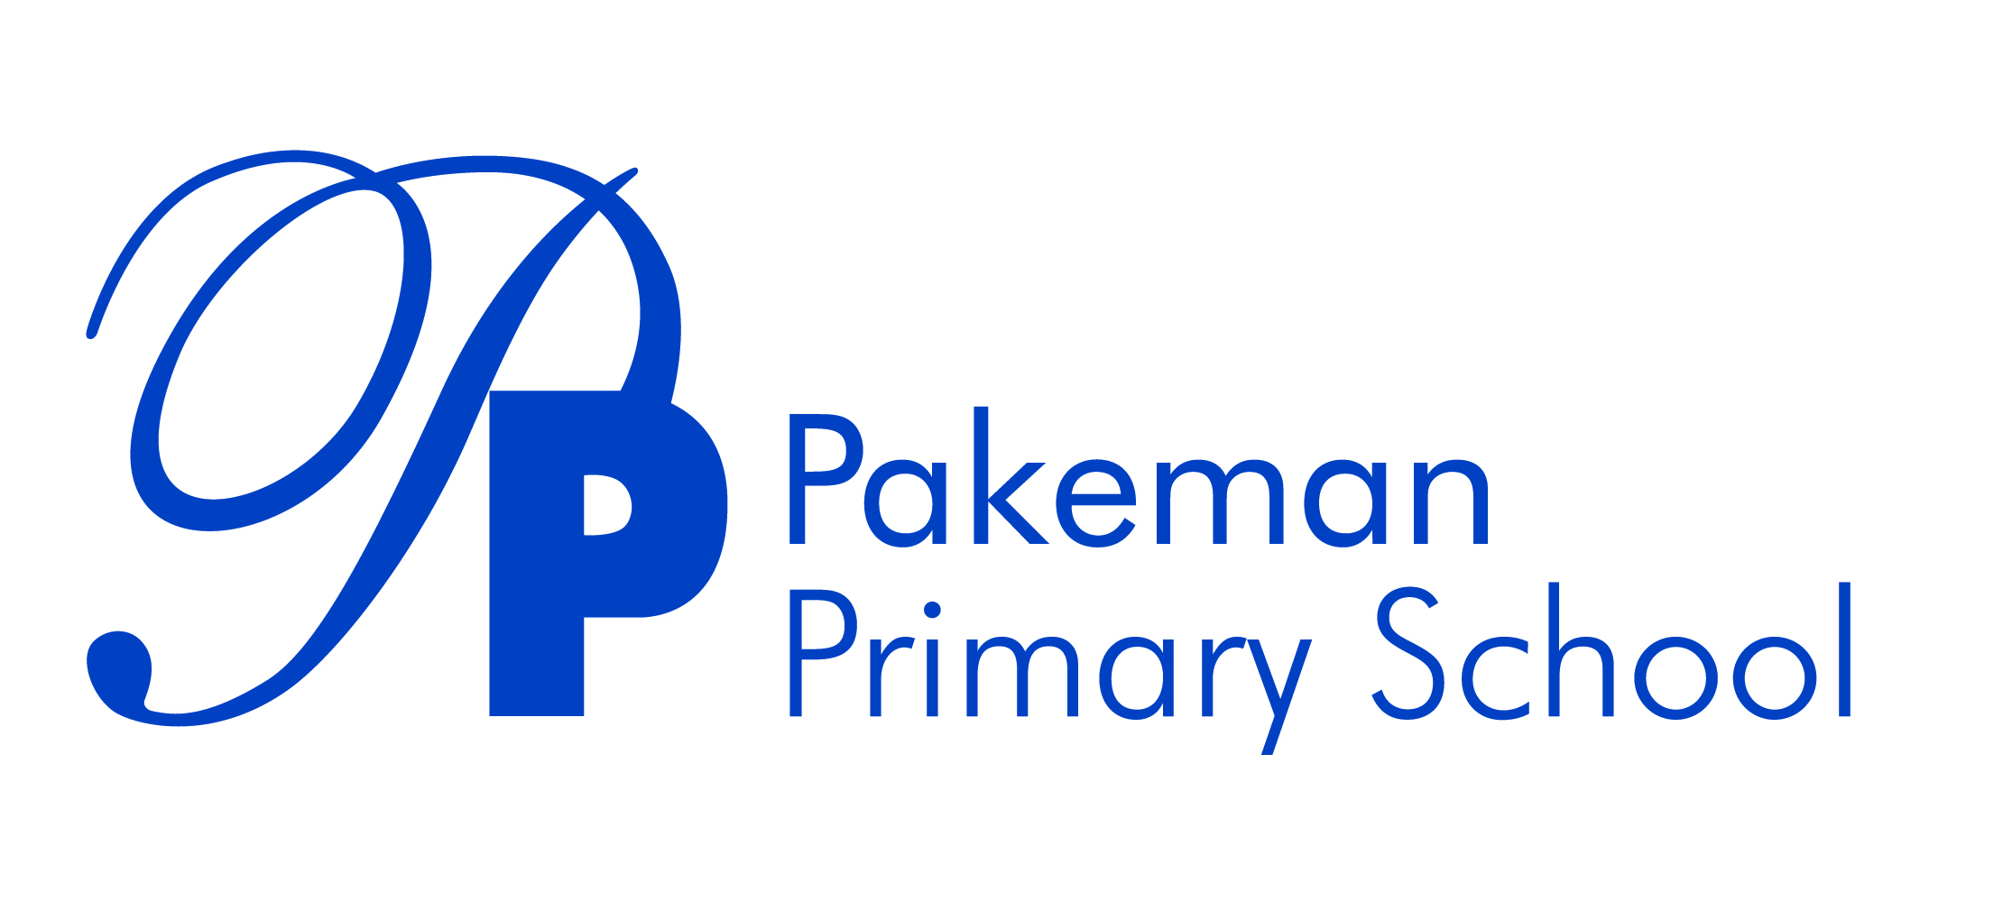
Charging and remissions
Review Date: September 2025
Next Review Date: September 2026

_________________________ _______________________
Emma Bonnin Date
Headteacher

_________________________ _______________________
Nahom Russom Date
Chair of governors

Statement of Values and Ethos Statement
At Pakeman Primary School, we aim to inspire excellence and raise the attainment of all our children in a positive, safe, and nurturing environment, where learning, teaching and diversity are valued.

This policy has been written to support our values. All staff, volunteers and students are expected to follow it.

Introduction
We believe that all of our pupils should have an equal opportunity to benefit from school activities, both on and off site, within and outside the curriculum, regardless of their family’s financial means. This policy sets out our school approach to charging and remissions. In doing this our intention is to ensure transparency in setting charges and ensure that all children are able to access all the provision on offer.

Admissions
No charge is made for admission to the school.

School meals
No children in Islington primary schools pay for school meals.

Exams
No charge is made for entering pupils for public examinations set out in regulations.

No charges
No charge is made for transport relating to curriculum activities, e.g. swimming. However, we may ask parents/carers for a voluntary contribution to support costs of incoming theatre groups etc.

We may charge for some activities that take place outside school hours. The Headteacher will decide which activities we make a charge for.

Where we make a charge, the total collected will not exceed the cost of providing the activity. Parents/carers will not be asked to subsidise the cost to other pupils by paying more than an amount equal to the total cost of the activity divided by the number of pupils participating.

Residentials
We charge pupils the full cost of board and lodging on residentials, whether it is classified as taking place within or outside school hours. Charges may be reduced or waived at the discretion of the head teacher.

Music tuition within school hours
No charge is made if the music tuition is part of the national curriculum or a public examination syllabus being followed by the pupil (including instrument hire, music books etc).

We do charge for all other instrumental and vocal tuition requested by parents/carers and delivered by specialist tutors. Charges are determined by the head teacher and may vary depending on the length of lesson and type of instrument.

Childcare
We charge families for any childcare offered to children before and after school (and during school holidays if provided) with the level of fees and any remissions to be reviewed in line with local authority guidelines.

Breakfast Club
Each child is charged £2/day for breakfast club.

Playcentre
Each child is charged £5/day (if FSM) or £8.50/day (if non FSM) for play centre.

Clubs
Each child is charged £2/club.

Lettings
Details of charges can be obtained from the school office.

Damage to property and breakages
We may seek to recover some or all of the costs incurred due to wilful damage or breakage of school property. This will be determined by the head teacher with advice from those involved.

Remissions policy
We may remit, in full or part, charges for certain activities and pupils, as determined by the head teacher with the governing body. The circumstances in which remissions are applied will be reviewed regularly. For example, pupils on free school meals may be entitled to remission.

