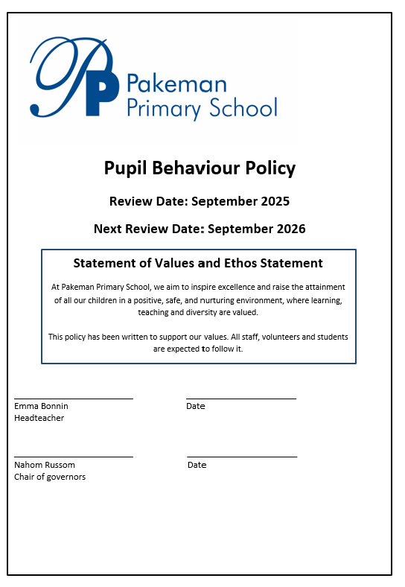

Table of contents:

- Introduction – page 3
- Aims of our policy – page 3
- Our school rules – page 3
- Good to be green classroom charts and behaviour ladder – page 4
- Hidden heroes and secret student – page 4
- The need for sanctions – page 4
- Reflection sheets – page 5
- Exclusions – page 5
- Tracking behaviour over time – page 5
- Alternative provision – page 5
- Pastoral team and child and family support workers – page 5
- Understanding the root causes of challenging behaviour – page 6
- The role of the teacher and SLT – page 6
- The role of parents/carers and outside agencies – page 7
- Escalation protocol – page 7
- Monitoring the policy – page 7

Appendices

- Good to be green chart
- Behaviour ladder
- Celebrations
- Reflection sheet

Introduction

At Pakeman we strongly believe that high standards of behaviour lie at the heart of a successful school. Good behaviour allows staff to teach effectively and enables children to make the best possible progress in all aspects of their school life.

All children and staff have a right to feel happy and safe in school and, to that end, we encourage mutual respect between children, and between pupils and staff.

Aims of our policy

The aims of this policy are to enable all members of the school community to have a positive, consistent and comprehensive understanding of the expectations we have regarding behaviour. Everyone, whether staff, students and volunteers in school, has an important role to play in ensuring the success of this policy. Parents/carers, visitors and governors are also expected to have an understanding of the expectations.

Good behaviour is actively encouraged throughout the school and it is our policy to adopt a calm and positive approach when dealing with children and to praise them whenever possible. This helps to raise the children’s self-esteem and to create a secure and purposeful learning atmosphere. We aim to work closely with parents to achieve excellent behaviour in our school. We have school rules which are intended to create an environment that protects children from physical and emotional hurt. These school rules were developed with the children and are displayed in all classrooms and around the school building. These rules are revisited yearly with children.

Our School Rules

The school rules apply to all members of our school community and are the fundamental beliefs upon which we base our actions. These rules are displayed prominently around the school (inside and outside) so that they can be used for reference, whenever appropriate. High standards of behaviour are always expected.

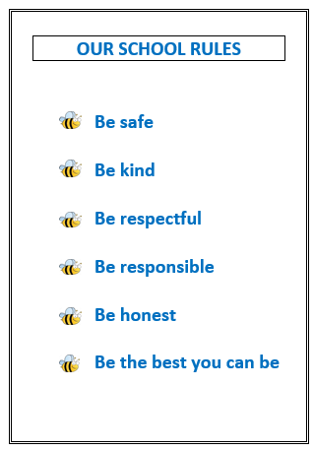

Good To Be Green Classroom Charts and Behaviour Ladder

At the beginning of every academic year, each child is allocated their own name card on a class chart (see Appendix 1 – Good to be Green chart). Green cards are displayed at the start of each day for all. Our school behaviour ladder explains how different types of behaviours relate to different coloured cards (see Appendix 2 – Behaviour ladder).

If children behave very well, they may be awarded a silver card followed by a gold card – children will receive a special sticker to reflect this. The focus and expectations are that children should always be on a green or better card.

Hidden Heroes and Secret Student

We celebrate children demonstrating an excellent understanding of the school rules or who are identified as carrying out additional acts of kindness by awarding a Hidden Hero slip. These slips are collected in the Head teacher’s office – every month a number of names are drawn from the box and children selected go on a special trip.

Every day adults will choose a Secret Student – if that pupil follows the school rules throughout the day the class are given a reward at the end of the day.

The Need for Sanctions

As a school we believe that positive reinforcement and confidence building are essential in promoting a high standard of behaviour. However, for the well-being of all members of the school community, including those children with behaviour difficulties, some behaviour cannot be ignored and a consistent sanctions system is necessary.

When children display unwanted behaviour, they will be given a non-verbal warning, followed by a verbal warning. A non-verbal warning is a warning that does not interrupt a lesson or conversation. It could be a look, a hand on the table to indicate that a child needs to stop, gently removing an object from a child's table... If the challenging behaviour continues, the child can be given a 5 minute card. This results in missing 5 minutes of playtime in the classroom with their teacher to discuss the behaviour. If they are outside they will miss 5 minutes of playtime on the bench. Should the behaviour continue the child will be given a Time Out card – the child will spend a short period of time in another classroom and may also miss their playtime. The next step would be a reflection time card – this takes place at lunchtime with either Ben, Emma or Tracey. During reflection time the child is encouraged to look at their behaviour, identify what went wrong and why and look at alternative strategies and ways forward. There can be movement back to green if children show improved behaviour. Class teachers will inform parents/carers at the end of the day.

If unwanted behaviour persists and is repeated on a regular basis parents will be invited to a meeting initially with the class teacher and team leader. Children may be placed on a Behaviour Book to monitor good behaviour and identify areas where behaviour is more difficult so that intervention and strategies may be put in place. A further meeting with the Headteacher and/or Deputy and/or Assistant Head will be arranged if behaviour continues to be a concern. Referrals to outside agencies may be made.

All staff recognise that behaviour is a means of communicating that something is wrong for a child and we endeavour to investigate the causes of this. Approaches may differ according to the needs of the child.

Reflection Sheets

When children miss their play, they will be asked to reflect on the incident. Reflection sheets are used to encourage a child to think about what has happened and are used by staff to resolve issues between children. The focus questions are:
- What happened?
- Who was upset or affected by my actions?
- Which zone I was in (referring to zones of regulation)?
- What I could have done to get myself back to the green zone?
- What could I do next time?
- How can I make it better?

Appendix 4 – Behaviour Reflection Sheet

Suspensions

Pakeman School is an inclusive environment and the leadership team endeavour to keep children at school where they can best be nurtured. Removal from class and placement elsewhere within the school can be an effective way of modifying seriously inappropriate behaviour. This is organised by the Deputy Headteacher or Headteacher.

Only under the most severe of circumstances would a fixed term suspension from the school be applied and only for matters where there was a significantly violent outburst, which endangered pupils and staff, or for extreme circumstances leading to major disruption of education for other pupils. In these circumstances, the school would ensure that suspended pupils had access to relevant learning activities for completion away from the school site. During a period of suspension, the school would endeavour to plan alternative support for the child on their return. This plan would be explained to the parent/carer during a re-integration meeting on the first day of their return to school.

Permanent Exclusions from the school would only be pursued when all other avenues of support have been explored, and where there remains a significant safety risk to children and staff, or where it has become impossible to guarantee successful uninterrupted learning experiences for other pupils.

Tracking Behaviour Over Time

An analysis of behaviour is carried out weekly at pastoral care meetings to identify the types of incidents, focus children and support that needs to be put in place. The behaviour analysis is shared with the Headteacher, Inclusion Manager and Pastoral Team who provide targeted support for children who find emotional regulation and behaviour management difficult.

Alternative Provision

To support children who are struggling to cope socially and emotionally, we have a range of provision on offer which includes nurture groups with our Child/Family Support Workers as well as a wide programme of activities designed to increase self-esteem, build confidence and resilience. These include gardening, choir, quiet activities or team building games.

Pastoral team and Child and Family Support Worker

To support children to manage their behaviour, we have a pastoral team who model how to make friends, play positively, share and behave appropriately in social situations. The pastoral team work with groups of children who have been on steps 3 and 4 of the behaviour ladder (Time Out and Reflection cards).
The pastoral team have also trained 12 pupil leaders to lead play in the lodge for children who need or prefer a quieter environment.
The responsibilities of the pupil leaders are to:
- Ensure all children are in a safe environment
- Know who to go to for help
- Help create and lead fun games
- Help create a happy playtime
- Ensure all children have friends and are not sad
- Follow our school rules at all times

For children who are struggling at playtimes we have focus groups led by our Child and Family Support Worker. This focus group time is an opportunity for children to reflect on their behaviour, identify triggers and ways to overcome them.

Understanding the root causes of challenging behaviours

A key to appropriate support for children lies in an understanding of the reasons why negative behaviours may occur. Each child comes to school with unique experiences and needs. A wide range of factors will affect individuals. Some of these factors will affect the child for life, whereas other difficulties will be temporary.
The school has control of a fraction of these factors, and so it is vital that the school’s input is effective, appropriate, positive and consistent. With this in mind, it is essential that there is effective communication between staff, and that staff really take the time to listen to children and observe them from a perspective of objectivity.

The role of the teacher

In class, each teacher uses strategies that encourage children to take responsibility for developing good behaviour and responding positively. The following are examples of these strategies:
- Circle time
- Assemblies about behaviour empowering children to come up with solutions to behavioural issues
- Emotional regulation input for children – Getting Back to Green Programme and use of Zones of Regulation in all classes
- PSHE lessons relating to conflict resolution (Personal, Social, Health and Economic Education)
- School Council’s input to resolve issues
- Exciting and engaging lessons - If children are interested in what they are doing, there is less reason for them to respond negatively
- Activities well suited to the needs of individual children
- Reflection time
- Mindfulness

Staff who are concerned about a child’s behaviour should speak to the parents/carer in the first instance. If the behaviour continues the teacher and team leader will then request a formal meeting with the parent. This meeting will be a way of finding strategies to avoid the situation becoming serious.

The role of the SLT

If behaviour reaches step 6 of the behaviour ladder, the parents/carer will be required to attend a meeting with the team leader and the class teacher. This meeting would provide an opportunity to discuss possible support from outside agencies and any alternative provision necessary to improve behaviour.

The role of parents/ carers

We see parents as an important part of maximising a child’s opportunity to learn and we seek to work closely with them in managing behaviour. Parents know their children well and it is important for us to work together to identify patterns of behaviour and solutions.

Whilst the school has a duty to establish a positive learning environment it is essential that parents acknowledge responsibility for their children and their behaviour. Behavioural issues can often be resolved through constant contact and monitoring by the parent. The monitoring may take the form of coming into class and seeing the teacher on a regular basis or the daily completion of a home/school behaviour book.

Parents are welcome to meet the class teacher at any agreed time or they may see the Headteacher or Deputy Headteacher by appointment through the school office.

Parents are expected to read and adhere to the Behaviour Policy, sign the Home/School agreement and work alongside school to set clear standards of behaviour. Setting a good example to your child by being respectful and polite to all members of the school community is a fundamental part of Pakeman school values.

The role of outside agencies

In some cases, external support is required to assist children with challenging behaviour. School staff and parents/carers will agree a plan of action which could involve support through therapy using art and creative play, CAMHS, Early Help and the New River College Behaviour Team.

Monitoring the policy

The policy will be reviewed once a year by the SLT and amendments will be agreed with the Governing Body.
Records of suspensions will be presented to governors at termly meetings. At specific times of the year the whole school monitoring process will focus on the effective implementation of this policy.

Appendix 1 – Good to be Green chart

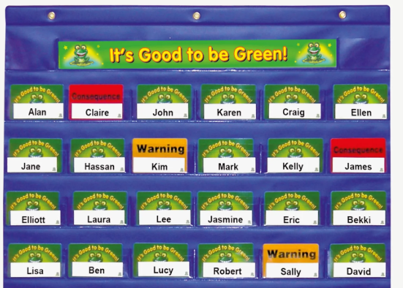

Appendix 2 – Behaviour ladder

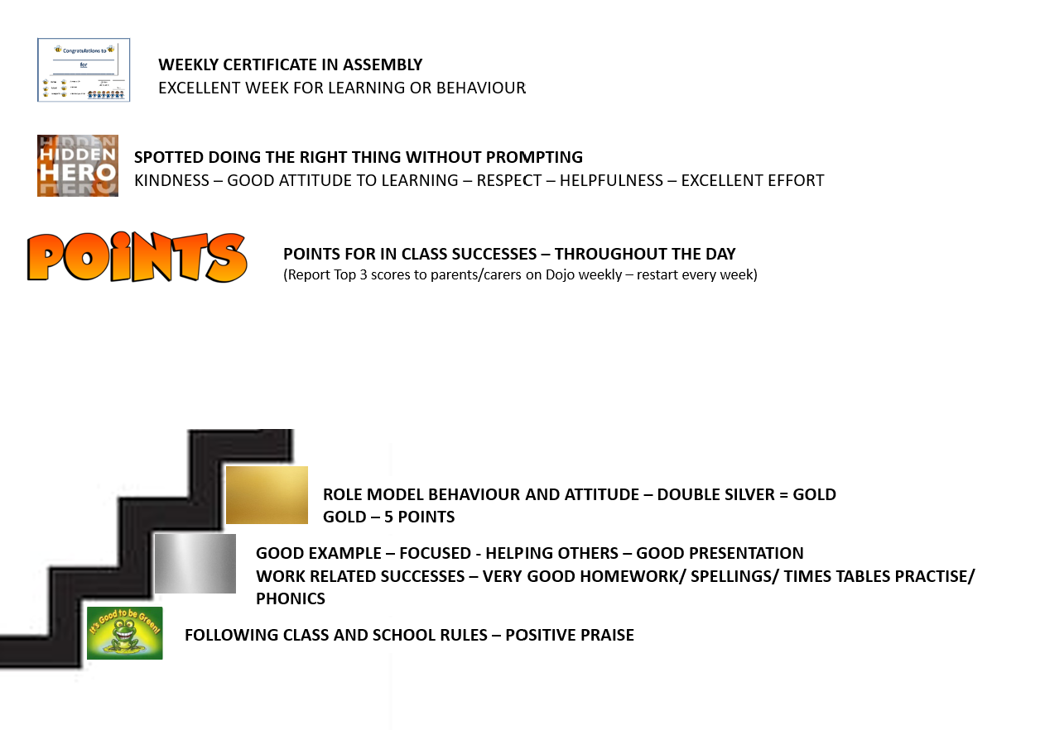

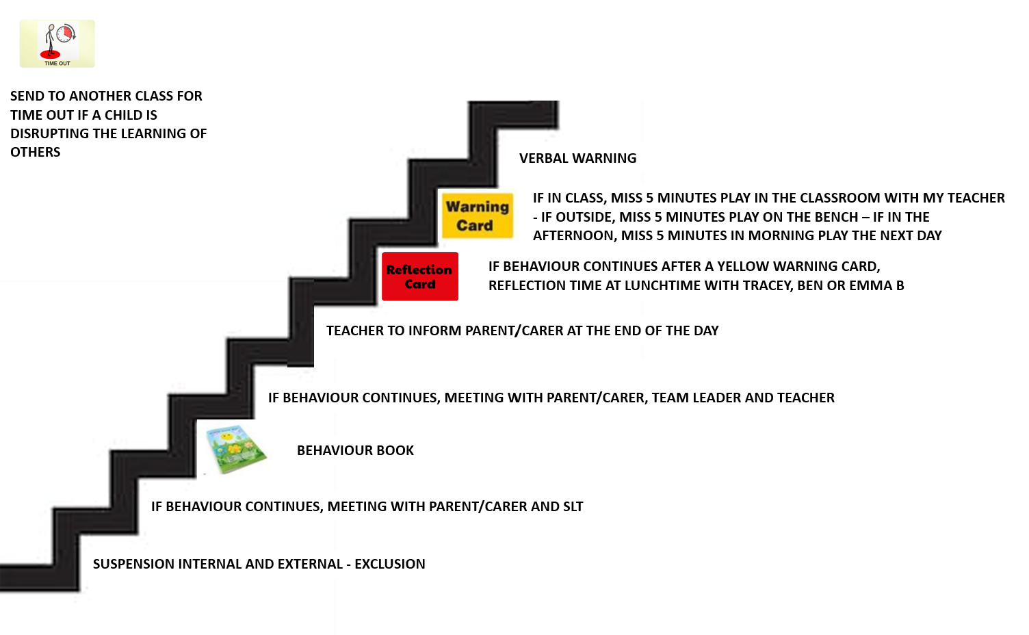

Appendix 3 – Behaviour celebrations

Appendix 4 – Behaviour reflection sheet

