
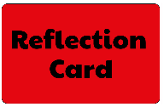
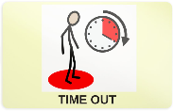

IF IN CLASS, MISS 5 MINUTES PLAY IN THE CLASSROOM WITH MY TEACHER - IF OUTSIDE, MISS 5 MINUTES PLAY ON THE BENCH – IF IN THE AFTERNOON, MISS 5 MINUTES IN MORNING PLAY THE NEXT DAY
VERBAL WARNING
IF BEHAVIOUR CONTINUES AFTER A YELLOW WARNING CARD, REFLECTION TIME AT LUNCHTIME WITH TRACEY, BEN OR EMMA B

SEND TO ANOTHER CLASS FOR TIME OUT IF A CHILD IS DISRUPTING THE LEARNING OF OTHERS
SUSPENSION INTERNAL AND EXTERNAL - EXCLUSION
IF BEHAVIOUR CONTINUES, MEETING WITH PARENT/CARER AND SLT
BEHAVIOUR BOOK
IF BEHAVIOUR CONTINUES, MEETING WITH PARENT/CARER, TEAM LEADER AND TEACHER
TEACHER TO INFORM PARENT/CARER AT THE END OF THE DAY

