School Improvement Plan

2023/2024

School Improvement Plan Priorities
2023-2024
 |  | 
1 – To ensure the school is financially stable (attracting external funding) | 2 – To support the mental health of children and families, particularly refugee families | 3 – To increase parental engagement in learning and curriculum related events
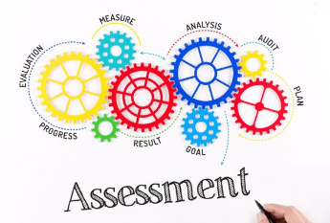 |  | 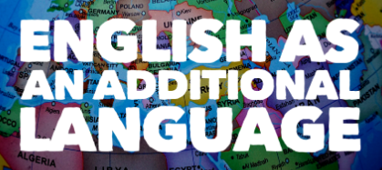
4 – To ensure effective use of assessment, data tracking and feedback | 5 – To raise attainment in writing through new teaching strategies, effective interventions and impactful tracking | 6 – To ensure effective progress of children who are new to English

Priorities | Success criteria
1 – To ensure the school is financially stable (attracting external funding) | - The school attracts external funding to fund additional opportunities for the development of children, families and staff.  - A balanced budget is set for the year 2024/25.  - The school shows financial stability through its income and expenditure.  - School spending priorities, as shown on the DfE financial benchmarking comparison website, represent value for money.  - All funding lines have been reviewed to ensure any possible savings.  - Ensure pupil numbers are increasing.
2 – To support the mental health of children, families and staff (particularly refugee families) | - Pupil voice indicates that children are happy at school and speak positively about their own and others’ cultural heritage.  - Pupil voice indicates that children feel supported in their pastoral care and academic support.  - Surveys show that families feel supported by the child and pastoral support workers through accessing services, and they are being listened to with concerns followed up.  - Surveys show that staff feel supported in reducing workload, from their team leaders and from senior staff, and in terms of access to free counselling. This enables staff to support our families.  - Satisfaction rates from parents/carers are very high in surveys.  - Pupils’ attitudes to learning and behaviour are positive, including movement around the school and within classes. This is demonstrated in learning walks and reviews.  - Pupil voice shows that the PSHE curriculum and assemblies support children’s mental and wellbeing.
3 – To increase parental engagement in learning and curriculum related events | - Parents/carers are engaged in their children’s learning by hearing them read, supporting them with their homework and attending parents’ meetings about core subjects.  - The number of parent/carer champions increases to support other parents/carers in the school community, including having one for each of the main languages spoken in the school.  - Parents/carers on the governing body take an active role in discussing/challenging school decisions.  - The number of parents/ carers who regularly attend themed weekly coffee mornings/ curriculum events increases.  - The school is making inroads into engaging its hard to reach families.  - Number of parents/carers who regularly engage with Class Dojo increases.  - Uptake of the city harvest project increases.  - All parents/carers can participate in workshops (participation in ESOL first…).
4 – To ensure effective use of assessment, data tracking and feedback | - All assessments are accurate and consistently applied.  - Particular attention is given to the reliability of assessment in the foundation subjects.  - Pupil interventions are informed by effective data analysis.  - Regular team meetings enable discussions about data and progression.  - School marking policy in books (and verbally) supports children’s progress.  - Termly summative assessments enable effective progress tracking.  - Moderation with local schools, in phases and across teams ensure assessment is accurate and consistent.  - Partnership with LEA and SIP consultants ensures consistency and high quality provision.
5 – To raise attainment in writing through new teaching strategies, effective interventions and impactful tracking | - All children make good progress in writing.  - Attainment in writing at the end of Year 2 and Year 6 is in line with or above the Islington or national average.  - Attainment in phonics in Year 1 is approaching 90%.  - The attainment gap between disadvantaged and non-disadvantaged pupils is closing rapidly.  - Outcomes show that at least 20% of learners achieve at greater depth.  - There is a consistent approach to the teaching of writing in all year groups.  - Staff are confident in their subject knowledge and pedagogical approaches  - Transition and induction into and out of the school, including through EYFS, KS1 and KS2 are effective and meet the needs of all children.  - Parents/carers feel confident in supporting their children at home in writing.
6 – To ensure effective progress of children who are new to English | - There is consistency in approach to new joiners with little language – use of resources packs.  - The learning environment supports learning – visuals and lanyards.  - Partner work and peer learning is used effectively to enable communication.  - IT is used effectively to aid communication and assist teaching (translations, phonics and reading apps).  - All children and families feel welcome in the school community.  - The progress of children with EAL is similar to that of children whose first language is English.

