Pakeman Primary School
EYFS Thematic Curriculum
(2 year cycle – 2022/23 is Year B)

Nursery  Year A | Autumn 1 | Autumn 2 | Spring 1 | Spring 2 | Summer 1 | Summer 2
Main Theme | Marvellous Me | Building & Construction | Making Music | Pirates | Shopping | Pets
Possible ideas/ mini themes (These may be changed or adapted depending on cohort and children’s interests.) | Settling-in  Emotions  Family  Facial features  Body parts  Autumn | Types of homes/ buildings  How to build  Different materials for building  Construction role-play | Different types of music  Different instruments  Learning and singing songs  Making instruments  Using everyday objects to make music  Body percussion | Adventures  Treasure hunts/maps  Pirate role-play  Boat making  Costume/prop making | Different types of shops  Visiting the shop  Shop role-play  Shopping lists | Pet types  How to care for pets  Describing pets  Naming pets  Vets
Key texts | 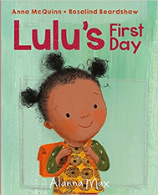  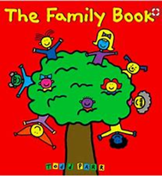  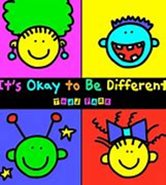  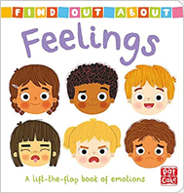  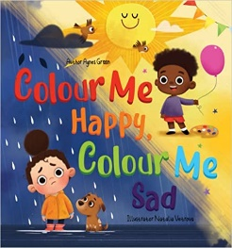  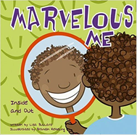  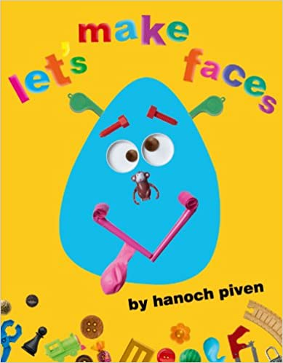 | 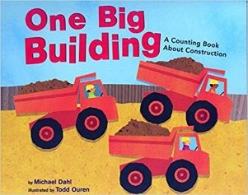  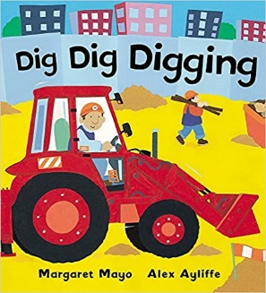  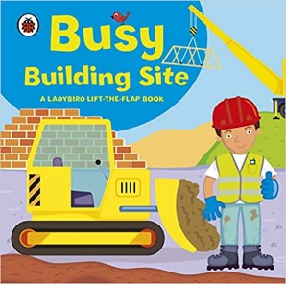  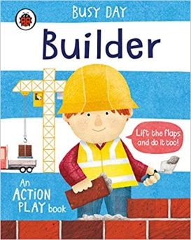  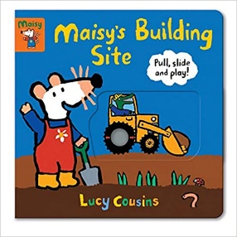  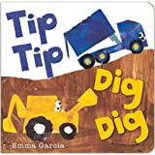  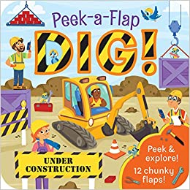 | 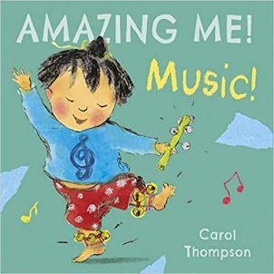  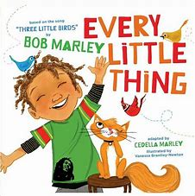  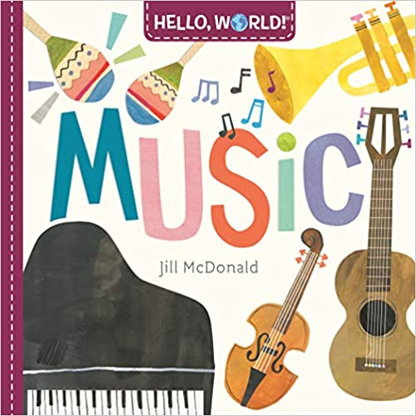  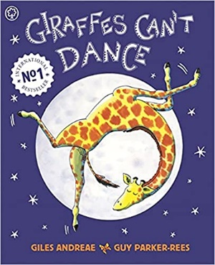  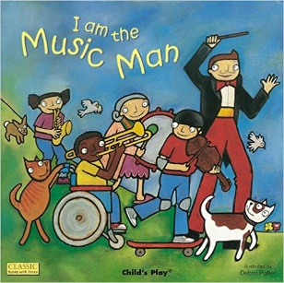  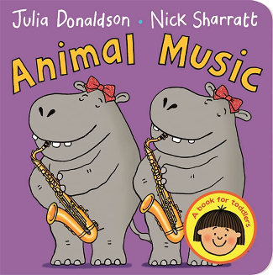 | 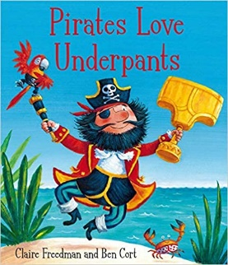  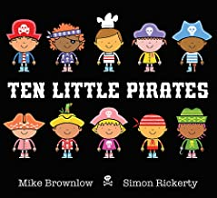  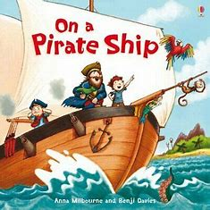  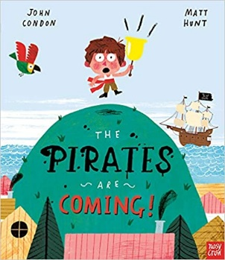  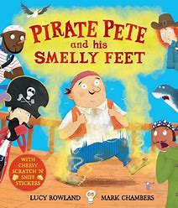  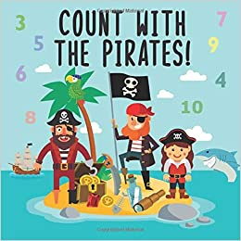 | 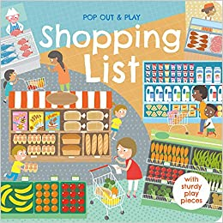  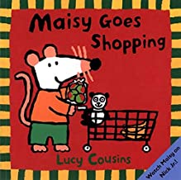  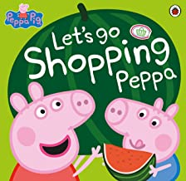  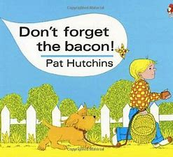  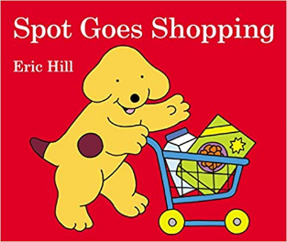  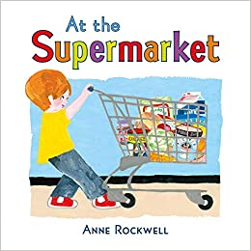 | 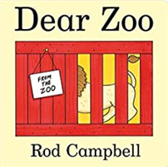  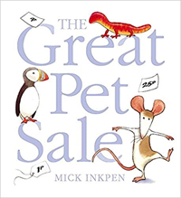  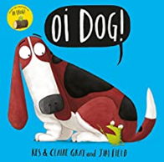  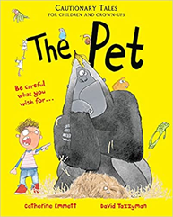  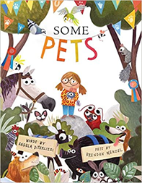  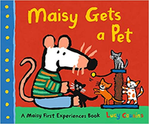
Possible ‘Wow’  moments and  experiences  (Not an  exhaustive list) | Autumn Walk  Sharing baby/family photos | Building a wall (bricks and wet sand)  Bonfire Night – toasted marshmallows  Winter Walk - ice/snow  Nativity performance | Making instruments  Music workshop or a session with Jack | Pirate dressing up day and treasure hunt  Easter nest cakes  Easter egg hunt | Visit a shop  Spring Walk  Collecting ducks eggs  Eid party | Transition  Visits from pets  Vet visit Q&A?
Key Events in the Calendar | Jeans for Genes Day  BHM  Roald Dahl Day  National Poetry Day  Peace week | Remembrance Day  Human Rights Day  International Day  Anti-bullying week | Holocaust Memorial Day  Internet safety day | World book day  World maths day  British science week  Mother’s Day Comic/sports relief | The Queen’s birthday  World refugee day | Father’s Day
Festivals | Diwali  Rosh Hashanah  Harvest festival | Diwali  Hanukah  Christmas  Inter Faith week | Chinese New Year  Shrove Tuesday  Holi | Easter  St David’s day  St Patrick’s day | Ramadan  Eid  St George’s day
School Events | Cinema night | Christmas Fair | International evening | Easter Raffle | Cinema night  Eid Party | Summer Fair
Home project ideas | All About Me special box – Show & Tell | Create a house/building | Make up your own song/make an instrument | Design a treasure map (tea bag staining) | Complete a shopping trip with parents | Share a photo and info about a pet (own or family/friend pet)
Role-Play Area Ideas | Home-corner  - include multicultural resources | Building site | Musical instrument workshop  Karaoke booth! | Pirate ship  Treasure island | Supermarket  Toy shop | Vets
Opportunities for parental involvement | Share information about family, heritage & culture.  Parents to come in to do ‘Show & Tell’ with their child (Covid permitting). | Any parents who work in construction?  Share photos of unusual buildings they have visited. | Any parents who play an instrument that could come in and demonstrate? | Help children create costume for Pirate Day. | Any parents who work in a shop that could visit in their uniform and carry out Q&A? | Parents visit with small family pet?
Key vocabulary (including but not limited to) | Names for:  Relatives  Body parts  Feelings  Autumn:  - acorn  - conker  - pine cone  - pumpkin | Names for:  Construction vehicles  Tools  Job roles  Positional language | Names for different instruments.  Words to describe music e.g. loud, quiet, fast, slow.  Words to describe how to play instruments, e.g. bang, strum, blow. | Ship, pirate, captain, treasure, parrot, hook, treasure chest, desert island, eye patch, treasure map, compass, flag, telescope, cannon. | Till, shopkeeper, trolley, basket, shopping list, receipt, money, purse/wallet, different names for food items. | Names for different pet animals, vets/veterinary clinic, hutch, tank, aquarium, cage, bowl, lead, bone, kennel, bedding, groom.
Communication & Language Weekly Activities/ Continuous Provision | Rhyme of the week  Show & Tell/News Sharing  Six Stories Shared – new vocab highlighted and revisited – recorded in class book  Weekly Helicopter Stories session  Box Clever (intervention)
PSED Continuous Provision | School & class rules  Strategies for sharing/turn-taking  Making relationships  Managing feelings - Zones of Regulation
PE Nursery | Ball Skills  - (EYFS focused) | Throwing and Catching  - (EYFS focused) | Working with Others  (EYFS focused) | Outdoor and adventure  (Core Activity 1) | Movement Development  (EYFS focused) | Games  (Core activities 1 to 3)
Physical Development  Continuous Provision | Range of differentiated scissors available (spring loaded, double holes, left/right-handed)  Indoors: tweezers, pens, pencils, brushes, glue sticks, tools for dough/sand/water/cooking, small construction  Outdoors: Chalks, paintbrushes, climbing and building equipment, tricycles, 3 wheeled scooters, balls/bats/hoops/stilts
Literacy  Continuous Provision | Phase 1 phonics activities  Carpet sessions linked to topic/focus book  Daily shared reading – Six Stories Shared
Now Press Play |  | Christmas Story |  | Under the Sea
Maths coverage (See overview for more detail) | *Settling & baseline*  - Colours  - Sorting  - Pattern | - Size  - Counting principles  - Comparing | - Number & place value  - Number 1  - Number 2  - Number 3 | - Number & place value  - Number 4  - Number 5  - Number 6 | - Shape  - My Day  - Length & height | - Weight  - Capacity  - Positional language
 | Note: for children who attend nursery for 4/5 terms and are repeating coverage activities will be differentiated e.g. If the children are working on ordering 2 /3 objects according to size and developing vocabulary around this, the older cohort may sequence more objects, be encouraged to verbalise as they complete the activity and complete the activity with increasing independence.
UTW links – topic related | - Begin to make sense of their own life-story  and family’s history  - Continue developing positive attitudes about the differences between people. | - Explore and talk about different forces they can feel.  - Talk about the differences between materials and changes they notice.  - Explore how things work. | - Explore how things work.  - Use all their senses in hands-on exploration of natural materials.  - Explore collections of materials with similar and/or different properties  - Talk about the differences between materials and changes they notice.  - Know that there are different countries in the world and talk about the differences they have experienced or seen in photos. | - Explore and talk about different forces they can feel.  - Talk about the differences between materials  - and changes they notice.  (Floating/sinking/boat making).  - Talk about what they see, using a wide vocabulary.  - Explore how things work. | - Show interest in different occupations.  - Explore how things work. | - Show interest in different occupations.  - Understand the key features of the life cycle of a plant and an animal.  - Begin to understand the need to respect and care for the natural environment and all living things
UTW links - ongoing | Festivals:  - Continue developing positive attitudes about the differences between people.  Season changes:  - Use all their senses in hands-on exploration of natural materials.  - Explore collections of materials with similar and/or different properties.  - Talk about what they see, using a wide vocabulary.  - Plant seeds and care for growing plants.  - Understand the key features of the life cycle of a plant and an animal.  - Begin to understand the need to respect and care for the natural environment and all living things.  Far-Away Fridays:  - Know that there are different countries in the world and talk about the differences they have experienced or seen in photos.  - Continue developing positive attitudes about the differences between people.
Expressive Arts & Design opportunities  (Topic-related) | - Draw with increasing complexity and detail, such as representing a face with a circle and including details.  - Explore colour and colour mixing.  - Show different emotions in their drawings – happiness, sadness, fear, etc.  - Take part in simple pretend play, using an object to represent something else even though they are not similar.  - Begin to develop complex stories using small world equipment like animal sets, dolls and dolls houses, etc. | - Make imaginative and complex ‘small worlds’ with blocks and construction kits, such as a city with different buildings and a park.  - Explore different materials freely, to develop their ideas about how to use them and what to make.  - Develop their own ideas and then decide which materials to use to express them.  - Join different materials and explore different textures  - Create closed shapes with continuous lines and begin to use these shapes to represent objects. | - Listen with increased attention to sounds.  - Respond to what they have heard, expressing their thoughts and feelings.  - Explore different materials freely, to develop their ideas about how to use them and what to make.  - Use drawing to represent ideas like movement or loud noises.  - Develop their own ideas and then decide which materials to use to express them.  - Join different materials and explore different textures.  - Remember and sing entire songs.  - Sing the pitch of a tone sung by another person (‘pitch match’).  - Sing the melodic shape (moving melody, such as up and down, down and up) of familiar songs.  - Create their own songs or improvise a song around one they know.  - Play instruments with increasing control to express their feelings and ideas. | - Create closed shapes with continuous lines and begin to use these shapes to represent objects.  - Take part in simple pretend play, using an object to represent something else even though they are not similar.  - Begin to develop complex stories using small world equipment like animal sets, dolls and dolls houses, etc.  - Make imaginative and complex ‘small worlds’ with blocks and construction kits, such as a city with different buildings and a park.  - Explore different materials freely, to develop their ideas about how to use them and what to make.  - Develop their own ideas and then decide which materials to use to express them.  - Join different materials and explore different textures. | - Create closed shapes with continuous lines and begin to use these shapes to represent objects.  - Draw with increasing complexity and detail, such as representing a face with a circle and including details.  - Take part in simple pretend play, using an object to represent something else even though they are not similar.  - Begin to develop complex stories using small world equipment like animal sets, dolls and dolls houses, etc.  - Make imaginative and complex ‘small worlds’ with blocks and construction kits, such as a city with different buildings and a park. | - Take part in simple pretend play, using an object to represent something else even though they are not similar.  - Begin to develop complex stories using small world equipment like animal sets, dolls and dolls houses, etc.  - Make imaginative and complex ‘small worlds’ with blocks and construction kits, such as a city with different buildings and a park.  - Create closed shapes with continuous lines and begin to use these shapes to represent objects.  - Draw with increasing complexity and detail, such as representing a face with a circle and including details.  - Explore colour and colour mixing.
Music in class | Continuous Provision:  - Explore different genres - Explore music from around the world - Explore and make a range of instruments  - Learn & sing songs and rhymes - Move to music

Nursery  Year B | Autumn 1 | Autumn 2 | Spring 1 | Spring 2 | Summer 1 | Summer 2
Main Theme | Marvellous Me | Building & Construction | Songs & Rhymes | Dinosaurs | People Who Help Us | On Safari
Possible ideas/ mini themes (These may be changed or adapted depending on cohort and children’s interests.) | Settling-in  Emotions  Family  Facial features  Body parts  Autumn | Types of homes/ buildings  How to build  Different materials for building  Construction role-play | Learn a range of songs and rhymes  Practice rhyming strings  Counting rhymes | Dinosaur names  Past tense vocabulary  Excavation play  Dinosaur small-world | Different job roles  Stranger danger  Dental care  Fire safety | Animal names  Animal habitats  Animal features  Safari camp role-play
Key texts |  | 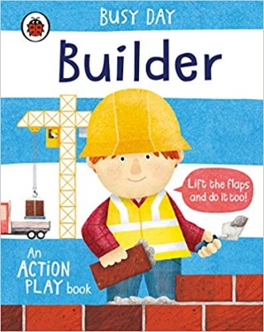 | 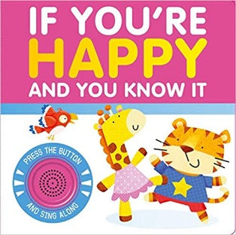  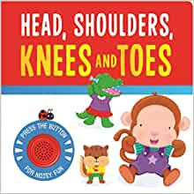  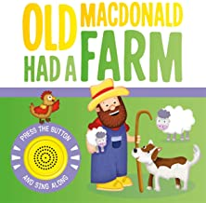  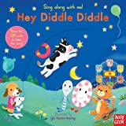  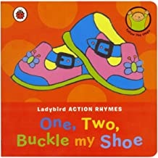  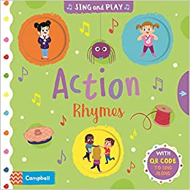 | 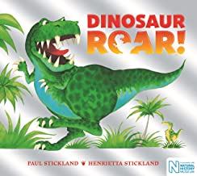  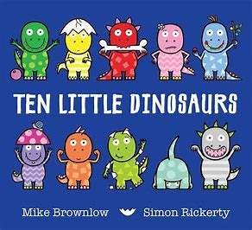  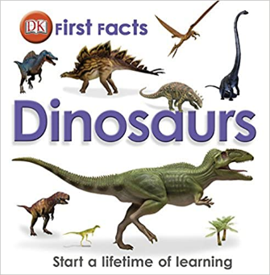  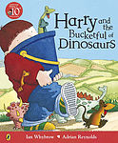  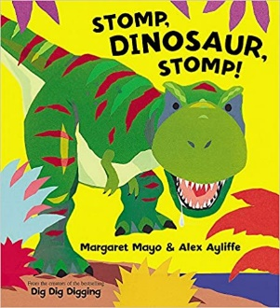  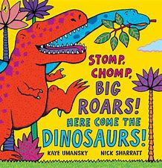 | 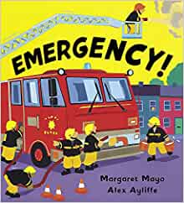  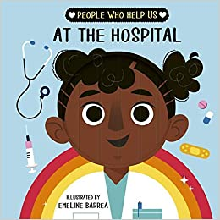  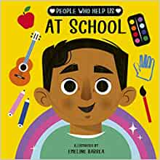  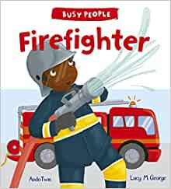  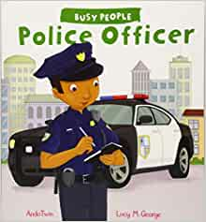  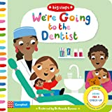 | 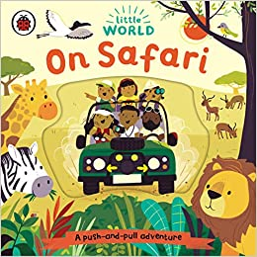  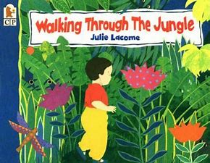  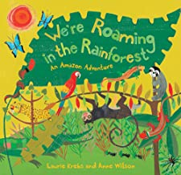  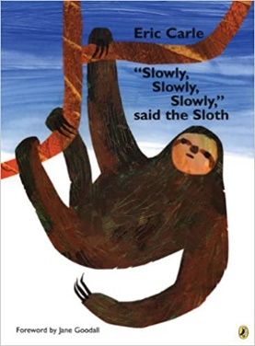  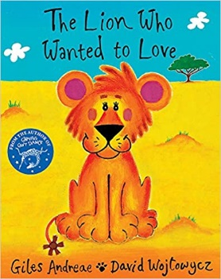  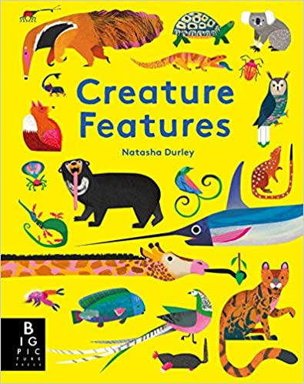
Possible ‘Wow’  moments and  experiences  (Not an  exhaustive list) | Autumn Walk  Sharing baby/family photos | Building a wall (bricks and wet sand)  Bonfire Night – toasted marshmallows  Winter Walk - ice/snow  Nativity performance | Organise a nursery rhyme themed show? | Discover a dinosaur egg in class!  Discover a sand filled tray containing dinosaur skeletons that need excavating!  Easter nest cakes  Easter egg hunt | Fire engine visit school  Spring Walk  Collecting ducks eggs  Eid party | Zoo trip?  Set up a safari camp  Transition
Key Events in the Calendar | Jeans for Genes Day  BHM  Roald Dahl Day  National Poetry Day  Peace week | Remembrance Day  Human Rights Day  International Day  Anti-bullying week | Holocaust Memorial Day  Internet safety day | World book day  World maths day  British science week  Mother’s Day Comic/sports relief | The Queen’s birthday  World refugee day | Father’s Day
Festivals | Diwali  Rosh Hashanah  Harvest festival | Diwali  Hanukah  Christmas  Inter Faith week | Chinese New Year  Shrove Tuesday  Holi | Easter  St David’s day  St Patrick’s day | Ramadan  Eid  St George’s day
School Events | Cinema night | Christmas Fair | International evening | Easter Raffle | Cinema night  Eid Party | Summer Fair
Home project ideas | All About Me special box – Show & Tell | Create a house/building | Learn favourite nursery rhyme and upload video of it being recited – or perform to class? | Create dinosaur skeleton art | Complete a tooth-brushing chart for a week | Create a piece of art based on favourite wild animal
Role-Play Area Ideas | Home-corner  - include multicultural resources | Building site | Cottage | Archaeologist site  Museum | Hospital  Classroom  Police station | Safari camp
Opportunities for parental involvement | Share information about family, heritage & culture.  Parents to come in to do ‘Show & Tell’ with their child (Covid permitting). | Any parents who work in construction?  Share photos of unusual buildings they have visited. | Parents to visit for a song/rhyme themed morning/afternoon |  | Any parents work in key worker roles? Come in uniform and Q&A session | Share photos of any family animal encounters
Key vocabulary (including but not limited to) | Names for:  Relatives  Body parts  Feelings  Autumn:  - acorn  - conker  - pine cone  - pumpkin | Names for:  Construction vehicles  Tools  Job roles  Positional language | Nursery rhyme character names  Uncommon words in rhymes, e.g. pail, well, waterspout, fiddle, dish, dame, spout, curds and whey… | Dinosaur names, fossil, bones, scales, eggs, reptile, extinct, herbivore, carnivore, prehistoric | Names of different job roles,  Vocabulary linked to these roles e.g. fire engine, uniform, badge etc.  Vocabulary around safety. | Animal names  Animal body parts  Baby animal names  Habitat names
Communication & Language Weekly Activities/ Continuous Provision | Rhyme of the week  Show & Tell/News Sharing  Six Stories Shared – new vocab highlighted and revisited – recorded in class book  Weekly Helicopter Stories session  Box Clever (intervention)
PSED Continuous Provision | School & class rules  Strategies for sharing/turn-taking  Making relationships  Managing feelings - Zones of Regulation
PE Nursery | Ball Skills  - (EYFS focused) | Throwing and Catching  - (EYFS focused) | Working with Others  (EYFS focused) | Outdoor and adventure  (Core Activity 1) | Movement Development  (EYFS focused) | Games  (Core activities 1 to 3)
Physical Development  Continuous Provision | Range of differentiated scissors available (spring loaded, double holes, left/right-handed)  Indoors: tweezers, pens, pencils, brushes, glue sticks, tools for dough/sand/water/cooking, small construction  Outdoors: Chalks, paintbrushes, climbing and building equipment, tricycles, 3 wheeled scooters, balls/bats/hoops/stilts
Literacy  Continuous Provision | Phase 1 phonics activities  Carpet sessions linked to topic/focus book  Daily shared reading – Six Stories Shared
Now Press Play |  | Christmas Story |  | Dinosaurs | People Who Help Us
Maths coverage (See overview for more detail) | *Settling & baseline*  - Colours  - Sorting  - Pattern | - Size  - Counting principles  - Comparing | - Number & place value  - Number 1  - Number 2  - - Number 3 | - Number & place value  - Number 4  - Number 5  - Number 6 | - Shape  - My Day  Length & height | - Weight  - Capacity  Positional language
 | Note: for children who attend nursery for 4/5 terms and are repeating coverage activities will be differentiated e.g. If the children are working on ordering 2 /3 objects according to size and developing vocabulary around this, the older cohort may sequence more objects, be encouraged to verbalise as they complete the activity and complete the activity with increasing independence.
UTW links – topic related | - Begin to make sense of their own life-story  and family’s history  - Continue developing positive attitudes about the differences between people. | - Explore and talk about different forces they can feel.  - Talk about the differences between materials and changes they notice.  - Explore how things work. | - Use all their senses in hands-on exploration of natural materials.  - Explore collections of materials with similar and/or different properties  - Talk about the differences between materials and changes they notice. | - Talk about the differences between materials and changes they notice.  - Talk about what they see, using a wide vocabulary.  - Explore how things work. | - Show interest in different occupations.  - Begin to make sense of their own life-story and family’s history. | - Talk about what they see, using a wide vocabulary.  - Understand the key features of the life cycle of a plant and an animal.  - Begin to understand the need to respect and care for the natural environment and all living things.  - Know that there are different countries in the world and talk about the differences they have experienced or seen in photos.
UTW links - ongoing | Festivals:  - Continue developing positive attitudes about the differences between people.  Season changes:  - Use all their senses in hands-on exploration of natural materials.  - Explore collections of materials with similar and/or different properties.  - Talk about what they see, using a wide vocabulary.  - Plant seeds and care for growing plants.  - Understand the key features of the life cycle of a plant and an animal.  - Begin to understand the need to respect and care for the natural environment and all living things.  Far-Away Fridays:  - Know that there are different countries in the world and talk about the differences they have experienced or seen in photos.  - Continue developing positive attitudes about the differences between people.
Art & Design opportunities | - Draw with increasing complexity and detail, such as representing a face with a circle and including details.  - Explore colour and colour mixing.  - Show different emotions in their drawings – happiness, sadness, fear, etc.  - Take part in simple pretend play, using an object to represent something else even though they are not similar.  - Begin to develop complex stories using small world equipment like animal sets, dolls and dolls houses, etc. | - Make imaginative and complex ‘small worlds’ with blocks and construction kits, such as a city with different buildings and a park.  - Explore different materials freely, to develop their ideas about how to use them and what to make.  - Develop their own ideas and then decide which materials to use to express them.  - Join different materials and explore different textures  - Create closed shapes with continuous lines and begin to use these shapes to represent objects. | - Listen with increased attention to sounds.  - Respond to what they have heard, expressing their thoughts and feelings.  - Use drawing to represent ideas like movement or loud noises.  - Join different materials and explore different textures.  - Remember and sing entire songs.  - Sing the pitch of a tone sung by another person (‘pitch match’).  - Sing the melodic shape (moving melody, such as up and down, down and up) of familiar songs.  - Create their own songs or improvise a song around one they know.  - Play instruments with increasing control to express their feelings and ideas. | - Create closed shapes with continuous lines and begin to use these shapes to represent objects.  - Begin to develop complex stories using small world equipment like animal sets, dolls and dolls houses, etc.  - Make imaginative and complex ‘small worlds’ with blocks and construction kits, such as a city with different buildings and a park.  - Explore different materials freely, to develop their ideas about how to use them and what to make.  - Develop their own ideas and then decide which materials to use to express them.  - Join different materials and explore different textures. | - Draw with increasing complexity and detail, such as representing a face with a circle and including details.  - Take part in simple pretend play, using an object to represent something else even though they are not similar.  - Begin to develop complex stories using small world equipment like animal sets, dolls and dolls houses, etc.  - Make imaginative and complex ‘small worlds’ with blocks and construction kits, such as a city with different buildings and a park. | - Take part in simple pretend play, using an object to represent something else even though they are not similar.  - Begin to develop complex stories using small world equipment like animal sets, dolls and dolls houses, etc.  - Make imaginative and complex ‘small worlds’ with blocks and construction kits, such as a city with different buildings and a park.  - Draw with increasing complexity and detail, such as representing a face with a circle and including details.  - Explore colour and colour mixing.
Music in class | Continuous Provision:  - Explore different genres - Explore music from around the world - Explore and make a range of instruments  - Learn & sing songs and rhymes - Move to music

