Pakeman Primary School
EYFS Thematic Curriculum

2 Plus | Autumn 1 | Autumn 2 | Spring 1 | Spring 2 | Summer 1 | Summer 2
Main Theme | All About Me | Nursery Rhymes | Favourite Stories | Transport | Down at the Farm | Under the Sea
Possible ideas/ mini themes (These may be changed or adapted depending on cohort and children’s interests.) | Settling-in  Emotions  Family  Facial features  Body parts  Autumn | Learn a range of nursery rhymes  Counting rhymes & props  Instruments | Puppets & toys linked to characters  Colours & colour mixing  Exploring fruit & animals  Hunts & trails | Train track building  Cardboard box rockets  Wheel track paintings  Paper planes & fan play | Animal sounds  Farm small-world  Animal prints and textures | Sealife  Submarines and boats  Floating and sinking
Key texts | 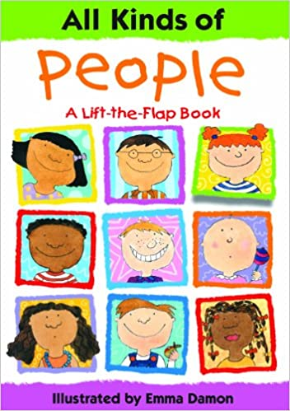  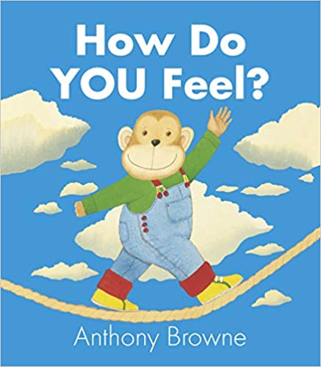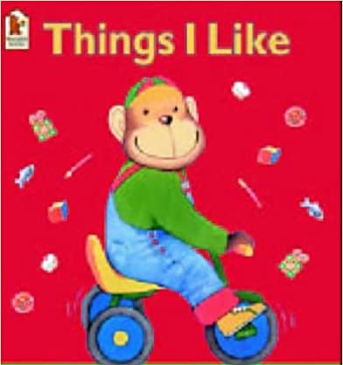  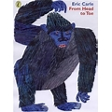  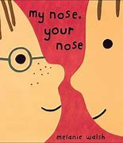 | 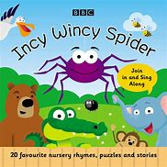  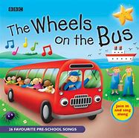  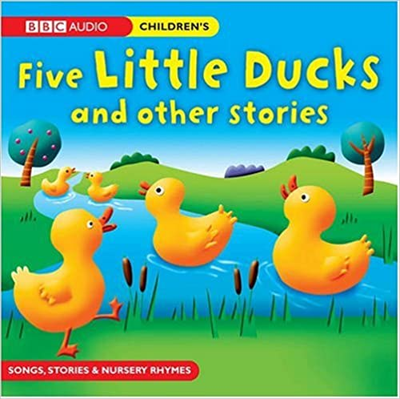  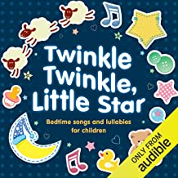  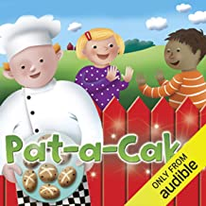  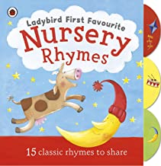  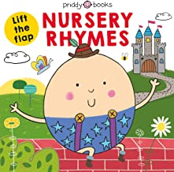 | 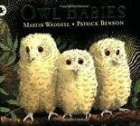  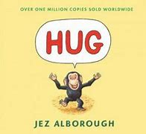  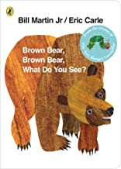  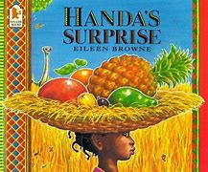  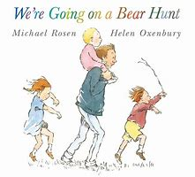  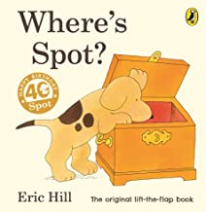 | 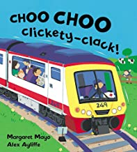  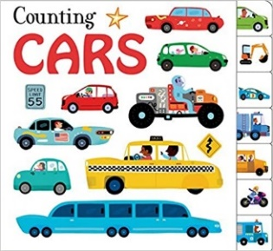  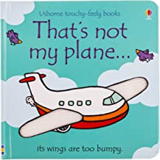  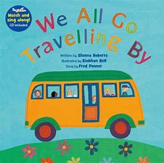  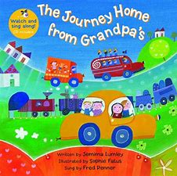 | 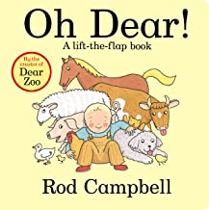  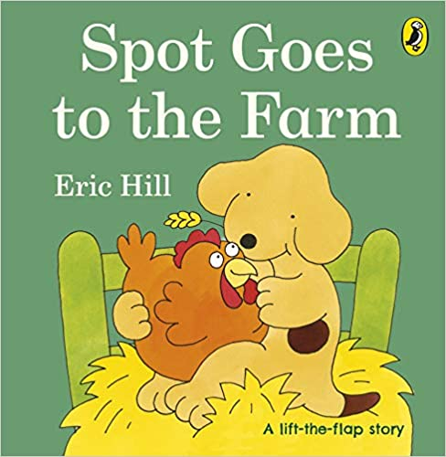  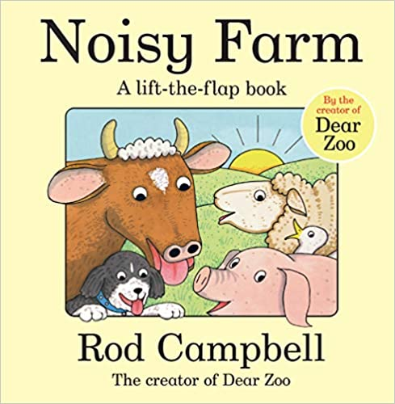  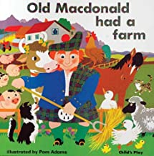  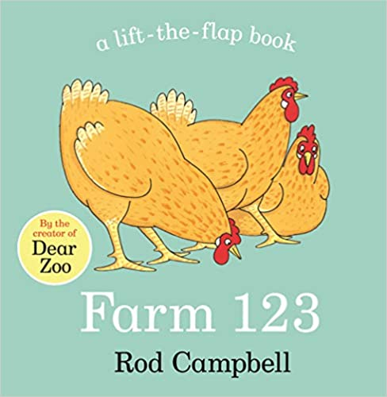  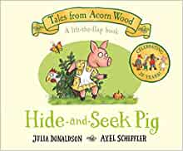 | 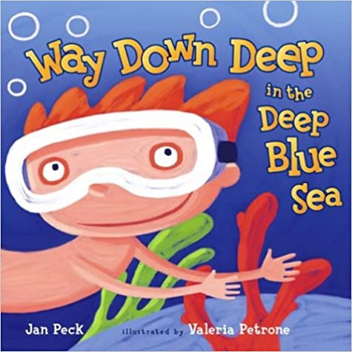  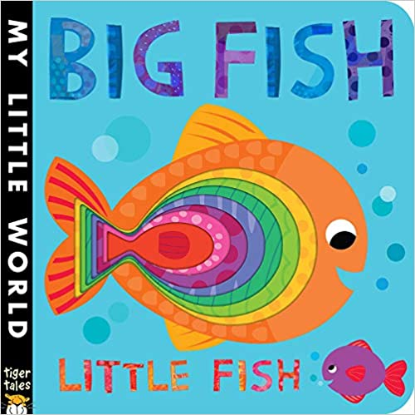  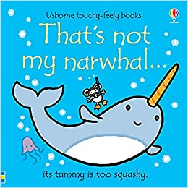  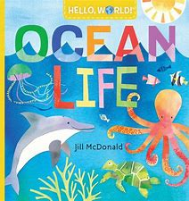  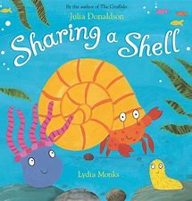  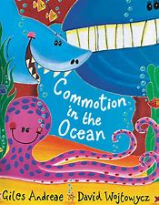
Possible ‘Wow’  moments and  experiences  (Not an  exhaustive list) | Autumn Walk  Sharing baby/family photos | Transition  Bonfire Night – toasted marshmallows  Winter Walk - ice/snow  Nativity performance | Fruit tasting  Bear hunt sensory trail | Transition  Vehicle to visit school playground – fire engine/taxi?  Easter nest cakes  Easter egg hunt | Spring Walk  Farm visit?  Collecting ducks eggs  Eid party | Transition  Whole school trip – beach?
Key Events in the Calendar | Jeans for Genes Day  BHM  Roald Dahl Day  National Poetry Day  Peace week | Remembrance Day  Human Rights Day  International Day  Anti-bullying week | Holocaust Memorial Day  Internet safety day | World book day  World maths day  British science week  Mother’s Day Comic/sports relief | The Queen’s birthday  World refugee day | Father’s Day
Festivals | Diwali  Rosh Hashanah  Harvest festival | Diwali  Hanukah  Christmas  Inter Faith week | Chinese New Year  Shrove Tuesday  Holi | Easter  St David’s day  St Patrick’s day | Ramadan  Eid  St George’s day
School Events | Cinema night | Christmas Fair | International evening | Easter Raffle | Cinema night  Eid Party | Summer Fair
Home project ideas | All About Me special box – Show & Tell | Learn an entire nursery rhyme | Share favourite bedtime story | Send photos of children on a type of transport to share in school | Make a small world farm with family | Make a boat that can float
Role-Play Area Ideas | Home-corner  - include multicultural resources | Add nursey rhyme characters and props to home corner | Small-world linked to favourite stories | Create a temporary train/bus using chairs, tickets etc | Create a small barn/farmyard outdoors | Sea life small-world play
Opportunities for parental involvement | Share information about family, heritage & culture.  Parents to come in to do ‘Show & Tell’ with their child (Covid permitting). | Come into class and share favourite rhymes with the children. | Come into class and share a favourite story with the children. | Any parents work in transport?  Photos of family travel on different types of transport. | Farm visit with school. | Beach visit with school.
Key vocabulary (including but not limited to) | Names for:  Relatives  Body parts  Feelings  Autumn:  - acorn  - conker  - pine cone  - pumpkin | Names for characters in rhymes.  Uncommon words that arise in rhymes, e.g. waterspout, baker, fiddle etc. | Story language – ‘once upon a time, one day…’  Positional language  Colour names  Animal names | Names of transport and vehicles.  Transport sounds.  Parts of transport and vehicles – steering wheel, doors, wheels, sail etc.  Words describing ways to travel – fly, drive, sail etc. | Animal names.  Animal body parts e.g. tail, snout, fur etc.  Animal homes on the farm – barn, pond, pigsty etc. | Sea life names, submarine, boat, float, sink
Communication & Language Weekly Activities/ Continuous Provision | Rhyme of the week  Show & Tell/News Sharing  Six Stories Shared – new vocab highlighted and revisited – recorded in class book  WellComm (intervention)
PSED Continuous Provision | School & class rules  Strategies for sharing/turn-taking  Making relationships  Managing feelings - Zones of Regulation
Physical Development  Continuous Provision | Range of differentiated scissors available (spring loaded, double holes, left/right-handed)  Indoors: tweezers, pens, pencils, brushes, glue sticks, tools for dough/sand/water/cooking, small construction  Outdoors: Chalks, paintbrushes, climbing and building equipment, tricycles, 3 wheeled scooters, balls/bats/hoops/stilts
Literacy  Continuous Provision | Sessions linked to topic/focus book  Daily shared reading – Six Stories Shared
Maths coverage | Continuous provision for mathematical development in the 2 Plus will reflect the Development Matters for this stage (see overview for more detail)
UTW links – topic related | - Make connections between the features of their family and other families.  - Notice differences between people. | - Notice differences between people.  - Repeat actions that have an effect.  - Explore materials with different properties. | - Notice differences between people.  - Repeat actions that have an effect.  - Explore materials with different properties. | - Repeat actions that have an effect.  - Explore materials with different properties. | - Explore and respond to different natural phenomena in their setting and on trips.  - Explore natural materials, indoors and outside. | - Explore and respond to different natural phenomena in their setting and on trips.  - Explore natural materials, indoors and outside.  - Repeat actions that have an effect.
UTW links - ongoing | Festivals:  - Make connections between the features of their family and other families.  - Notice differences between people.  Season changes:  - Explore and respond to different natural phenomena in their setting and on trips.  - Explore natural materials, indoors and outside.
Expressive Arts & Design opportunities  (Topic-related) | - Notice patterns with strong contrasts and be attracted by patterns resembling the human face.  - Start to make marks intentionally.  - Explore paint, using fingers and other parts of their bodies as well as brushes and other tools.  - Express ideas and feelings through making marks, and sometimes give a meaning to the marks they make.  - Start to develop pretend play, pretending that one object represents another. For example, a child holds a wooden block to her ear and pretends it’s a phone. | - Enjoy and take part in action songs, such as ‘Twinkle, Twinkle Little Star’.  - Show attention to sounds and music.  - Respond emotionally and physically to music when it changes.  - Move and dance to music.  - Anticipate phrases and actions in rhymes and songs, like ‘Peepo’.  - Explore their voices and enjoy making sounds.  - Join in with songs and rhymes, making some sounds.  - Make rhythmical and repetitive sounds.  - Explore a range of soundmakers and instruments and play them in different ways. | - Explore different materials, using all their senses to investigate them. Manipulate and play with different materials.  - Use their imagination as they consider what they can do with different materials.  - Start to develop pretend play, pretending that one object represents another. For example, a child holds a wooden block to her ear and pretends it’s a phone.  - Start to make marks intentionally.  - Explore paint, using fingers and other parts of their bodies as well as brushes and other tools.  - Express ideas and feelings through making marks, and sometimes give a meaning to the marks they make. | - Explore different materials, using all their senses to investigate them. Manipulate and play with  different materials.  - Use their imagination as they consider what they can do with different materials.  - Make simple models which express their ideas.  - Start to develop pretend play, pretending that one object represents another. For example, a child holds a wooden block to her ear and pretends it’s a phone.  - Start to make marks intentionally.  - Explore paint, using fingers and other parts of their bodies as well as brushes and other tools.  - Express ideas and feelings through making marks, and sometimes give a meaning to the marks they make. | - Explore different materials, using all their senses to investigate them. Manipulate and play with different materials.  - Use their imagination as they consider what they can do with different materials.  - Start to develop pretend play, pretending that one object represents another. For example, a child holds a wooden block to her ear and pretends it’s a phone.  - Start to make marks intentionally.  - Explore paint, using fingers and other parts of their bodies as well as brushes and other tools.  - Express ideas and feelings through making marks, and sometimes give a meaning to the marks they make. | - Explore different materials, using all their senses to investigate them. Manipulate and play with different materials.  - Use their imagination as they consider what they can do with different materials.  - Make simple models which express their ideas.  - Start to develop pretend play, pretending that one object represents another. For example, a child holds a wooden block to her ear and pretends it’s a phone.  - Express ideas and feelings through making marks, and sometimes give a meaning to the marks they make.
Music in class | Continuous Provision:  - Explore different genres - Explore music from around the world - Explore and make a range of instruments  - Learn & sing songs and rhymes - Move to music

