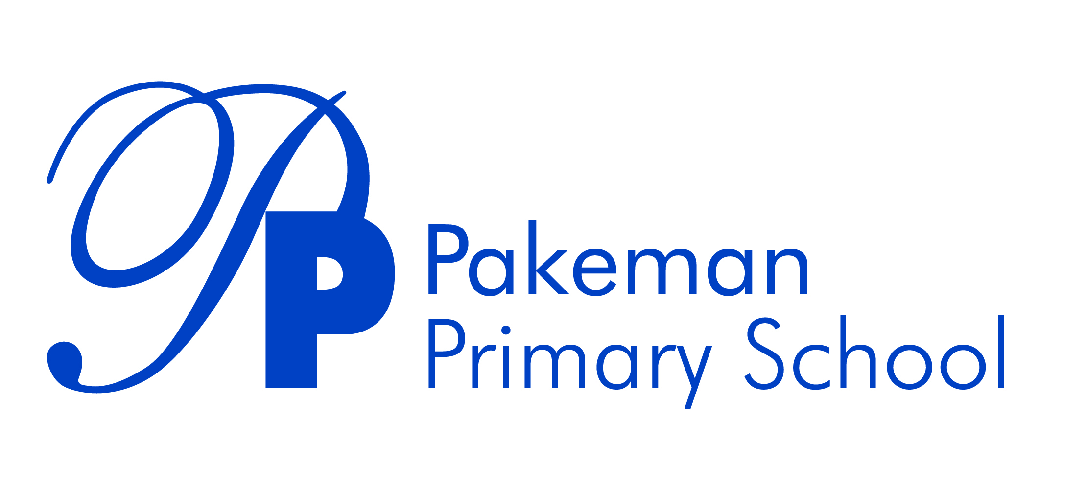

Times Tables Policy

Review Date: October 2022
Next Review Date: October 2023

_________________________ _______________________
Emma Bonnin Date
Headteacher

_________________________ _______________________
Janet Convery Date
Chair of Governors

What is the purpose of the policy?
Ethos Statement
Pakeman School offers a positive, safe learning environment for its community, in which everyone has equal and individual recognition and respect. We celebrate success and are committed to the continuous improvement and fulfilment of potential in every child. We encourage increasing independence and self-discipline amongst the pupils. Everyone within the school has an important role to play in sharing responsibility for the development of this policy.

The purpose of this policy is to ensure that children learn the appropriate times tables skills for their age group leading to times tables fluency. All members of staff are expected to use the suggested methods within this policy.

Why do we need a times table policy?

By learning all of the times tables, a child is much better prepared to access a wide range of maths units including division, multiplication, decimals, fractions and algebra. Pupils who do not memorise the times tables will find many aspects of maths much more difficult. We expect all children at Pakeman to have a secure grasp of their times tables.

Times tables expectations

- Children achieve fluency in the focus times tables for their age group by the end of the academic year
- Staff offer regular opportunities for children to practise their times tables
- Chanting is used in conjunction with the counting stick method (staff trained and modelling training session)
- Weekly tests allow children and staff to identify gaps in learning and plan accordingly
- Consistency in the teaching of times tables across year groups is crucial
- The benefit of times tables is highlighted when teaching maths lessons
- Children and parents/carers are provided with support to practise times tables at home
- An annual Spring Times Tables Slam celebrates times tables across the school

Expectations for year groups

Year group | Times tables | Knowledge and methods
Year 1 | Count in multiples of 2, 5 and 10. Recall and use all doubles to 10 and corresponding halves | Part-whole, bar model, repeated addition
Year 2 | Recall and use multiplication and division facts for the 2, 5 and 10 times tables, including recognising odd and even numbers | As above plus arrays
Year 3 | Recall and use multiplication and division facts for the 3, 4 and 8 times tables | As above plus column multiplication. Also count in 50s and 100s
Year 4 | Recall and use multiplication and division facts for times tables up to 12 x 12 | As above plus decimals. Also count in 25s and 1000s
Year 5 | Revision of all times tables and division facts up to 12 x 12 | As above plus prime numbers to 100
Year 6 | Revision of all times tables and division facts up to 12 x 12 | As above plus working with numbers up to 10,000,000

Chanting and counting stick

Class teachers ensure that children regularly chant their times tables as a class. A counting stick should be used to introduce and revise times tables up to the 12 times table. Children should be familiar with the pattern below that helps them memorise the first ten number jumps in any times table.
Put a zero
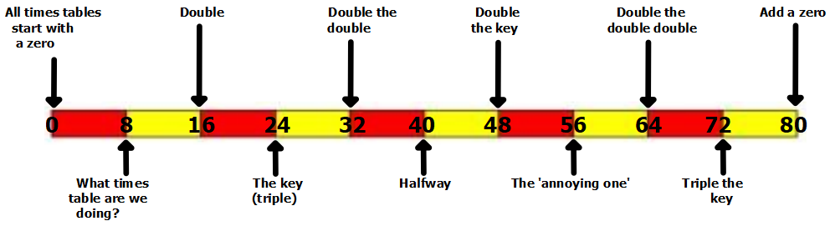

Assessment

Pupils have their multiplication skills formally tested in the summer term of year 4 and are expected to know all of their times tables up to the 12 times table. Children in Year 3/4 have weekly times tables tests to develop their speed and accuracy. Teachers can use the results of these tests to focus interventions on particular pupils or times tables.

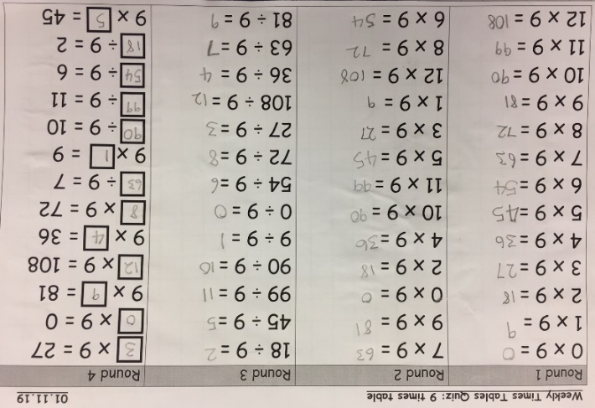

Home learning

We subscribe to Mathletics and Purple Mash. All children in KS1 and KS2 have an individual login for these online learning platforms which they can access from home. We also encourage parents and carers to practise times tables with their children at home. In order to prepare for the year 4 national times tables test, we have weekly focus times tables which we ask parents/carers to test their children on as part of their homework.

Additional support and interventions

Children who require additional support should be identified through the weekly times tables assessments and offered interventions in order to learn all times tables up to 12 x 12.

