Pakeman Primary School
EYFS Thematic Curriculum

Reception | Autumn 1 | Autumn 2 | Spring 1 | Spring 2 | Summer 1 | Summer 2
Main Theme | Who Am I? | Bears | What We Eat | Traditional Tales | Spring | Adventures
Possible ideas/ mini themes (These may be changed or adapted depending on cohort and children’s interests.) | Settling-in  Emotions  Family  Similarities & differences  The senses  Autumn | Special toys  Toys past/present  Story-telling  Different types of bears  Winter | Favourite foods  Healthy eating  Where food comes from  Foods from around the world  Foods past & present  Cooking | Story language  Character descriptions  Story retelling  Story writing  Differences past & present | Minibeasts  Life-cycles  Growing  Spring | Pirate adventures  Map reading  Animal adventures  Space adventures  Adventures afar  Local adventures  Story telling/writing  Differences in places/time
Key texts | 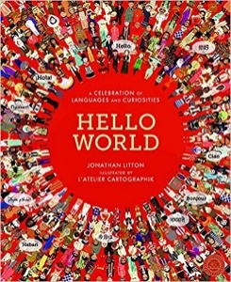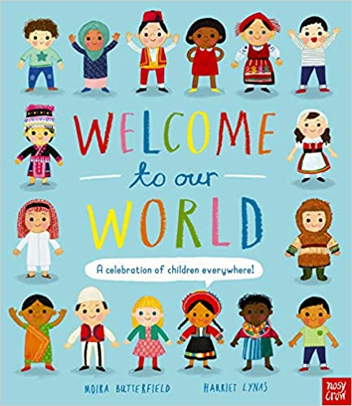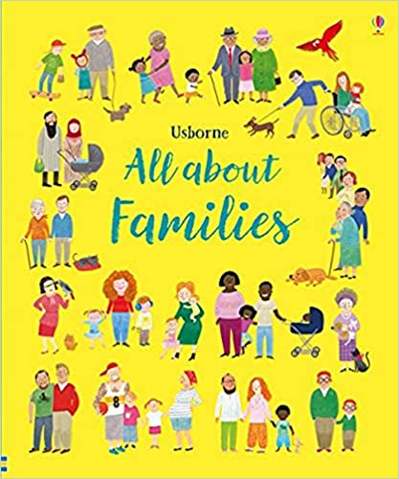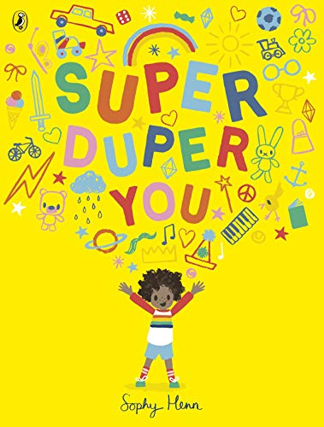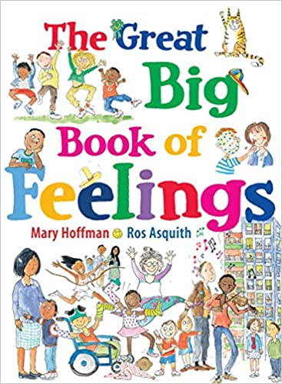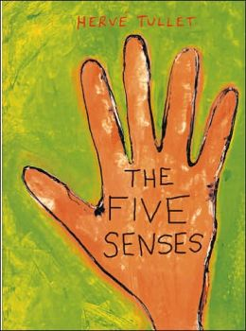 | 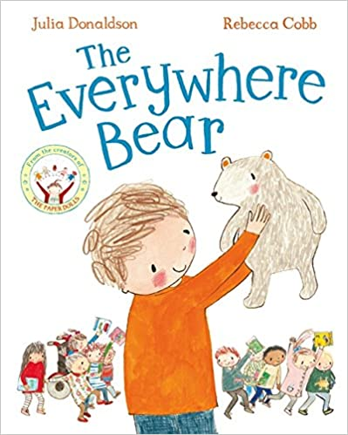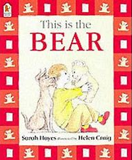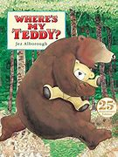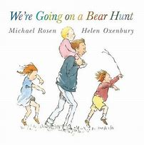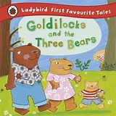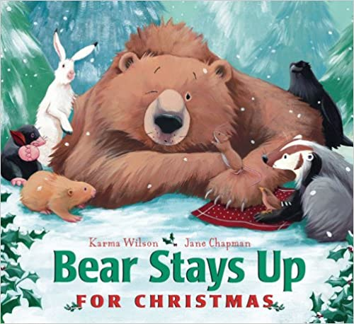 | 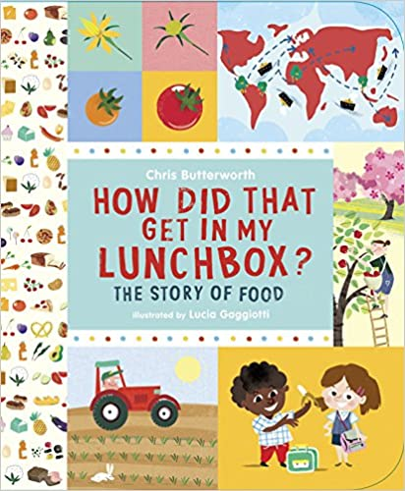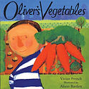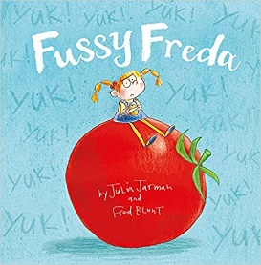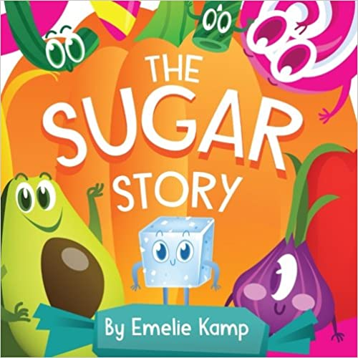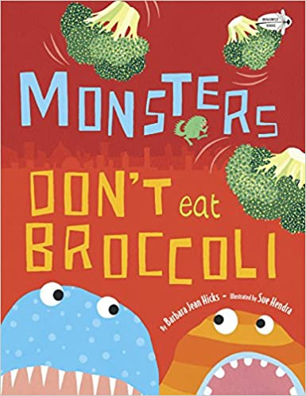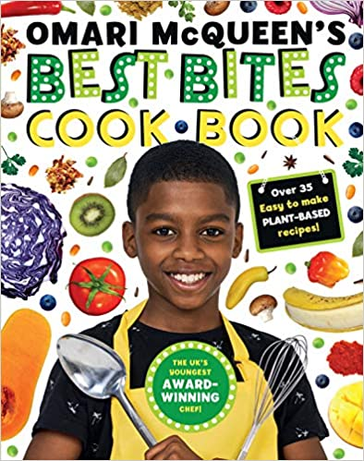 | 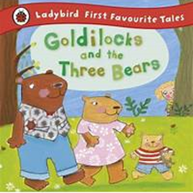  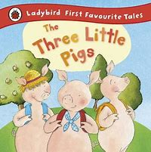  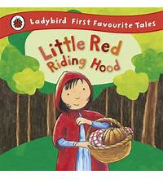  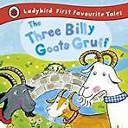  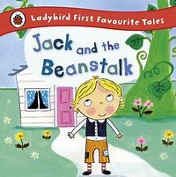  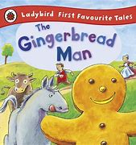 | 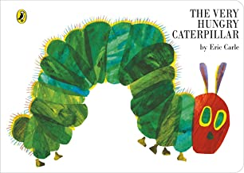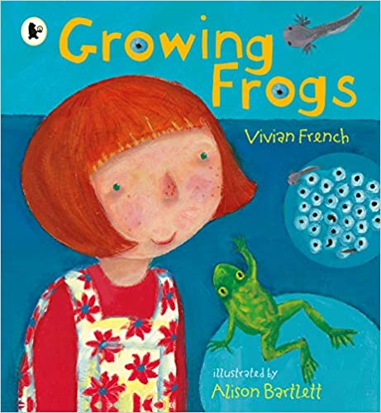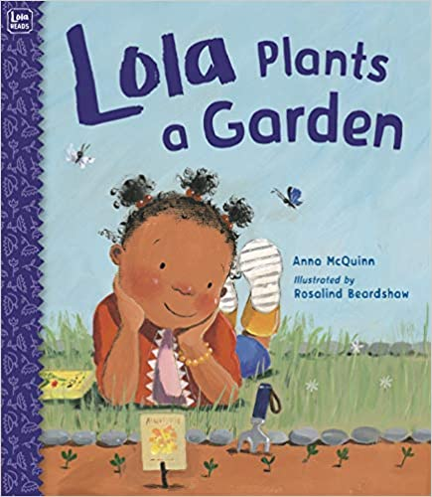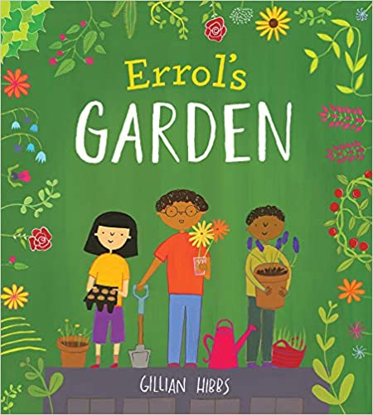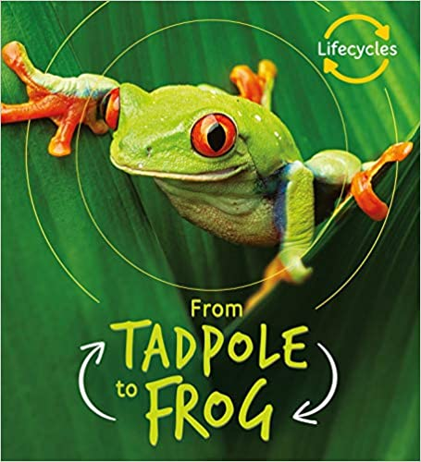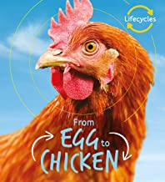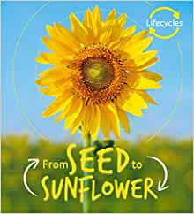 | 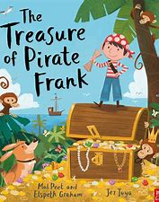  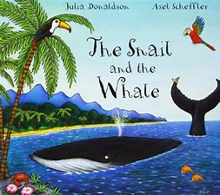  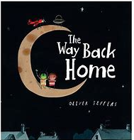  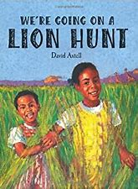  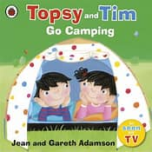  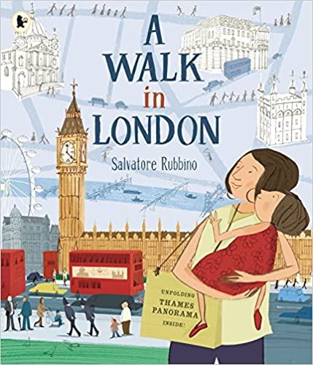
Possible ‘Wow’  moments and  experiences  (Not an  exhaustive list) | Autumn Walk  Sharing baby/family photos | Bonfire Night – toasted marshmallows  Teddy Bear Tea Party/Picnic  Meet Take-Home Bear  Winter Walk - ice/snow  Nativity performance  Puppet show/workshop – Little Angel Puppet Theatre? | Modelled tooth-brushing  Cooking skills: spreading, chopping, mixing, measuring  Cooking – with Marcia? With parents if possible regarding Covid.  Traditional recipes from around the world. | Planting beans  Easter nest cakes  Easter egg hunt  Captain Dan Tastic Fairy-tale Workshop: http://www.captaindantastic.com/fairy-tale-workshop-2/ | Spring Walk  Collecting ducks eggs  Hatching caterpillars  Planting sunflower seeds  Eid party  Gillespie Ecology Centre | Treasure hunt  Transition  Graduation assembly  Whole school trip? Beach?
Key Events in the Calendar | Jeans for Genes Day  BHM  Roald Dahl Day  National Poetry Day  Peace week | Remembrance Day  Human Rights Day  International Day  Anti-bullying week | Holocaust Memorial Day  Internet safety day | World book day  World maths day  British science week  Mother’s Day Comic/sports relief | The Queen’s birthday  World refugee day | Father’s Day
Festivals | Diwali  Rosh Hashanah  Harvest festival | Diwali  Hanukah  Christmas  Inter Faith week | Chinese New Year  Shrove Tuesday  Holi | Easter  St David’s day  St Patrick’s day | Ramadan  Eid  St George’s day
School Events | Cinema night | Christmas Fair | International evening | Easter Raffle | Cinema night  Eid Party | Summer Fair
Homework project ideas | All About Me special box – Show & Tell | Introduce Take-Home Bear to be taken home weekly. | Cook a recipe at home and write it up with parents to create class cookbook | Fairy-tale in a shoebox project | Sunflower growing competition | Create an adventure story – can be written/story map/video recording
Role-Play Area Ideas | Home-corner  - include multicultural resources | Three Bears Cottage  Toy Shop | Café/restaurant  Bakery  Dental surgery | Fairy-tale cottage  Enchanted forest | Gardening centre  Farm shop  Science lab | Pirate ship  Campsite  Space rocket
Opportunities for parental involvement | Share information about family, heritage & culture.  Parents to come in to do ‘Show & Tell’ with their child (Covid permitting). | Do parents still have teddy/toy from their own childhood that they can share with class? In person or via Class Dojo. | Sharing home recipes – coming in to cook with the children (Covid permitting). | Story-sharing morning. Parents to attend with children (Covid permitting). | Family planting day outdoors – contribute towards cake sale to raise funds for gardening in reception playground and then attend the family planting/gardening day. (Covid permitting). | Share holiday adventures with the class - in person or via Class Dojo.
Key vocabulary (including but not limited to) | Names for:  Relatives  Body parts  Feelings  Senses  Past/present  Countries & languages  Autumn:  - acorn  - conker  - pine cone  - pumpkin | Bear names  - Polar bear  - Panda bear  - Brown bear  - Sun bear  - Black bear  Hibernate  Cave  Habitat  Teddy bear  Past/present | Food names  Cooking vocabulary  Healthy  Unhealthy  Balanced diet  Energy  Farm  Grow  Crop  Harvest  Factory  Import | Character  Setting  Beginning  Middle  End  Problem  Resolution  Story language/openers  Speech bubble  Thought bubble | Names for minibeasts  Weather names  Life-cycle  Plant  Grow  Bulb  Seed  Stem  Sprout | Adventure  Travel  Discover  Explore  Map reading  Local  Distant  Sail  Swim  Fly  Hunt  Camp
Communication & Language Weekly Activities/ Continuous Provision | Word of the week (taught through Concept Cat stories)  Show & Tell/News Sharing  Six Stories Shared – new vocab highlighted and revisited – recorded in class book  Weekly timetable of activities for ‘soft start’ and ‘snack time’ include daily opportunities for discussion, singing, questioning, responding to stimulus  Weekly Helicopter Stories session  Box Clever (intervention)
PSED Weekly Activities/ Continuous Provision | Zones of Regulation – reference display and weekly circle time  Individual targets display– reviewed regularly with the children and achievement card sent home once achieved.  ‘Think together Thursday’ (Team work/problem solving activities)
PE Reception | Games  - (Core Activities 1 to 3) | Gymnastics  (Core Activities 1 to 2) | Throwing and Catching  (EYFS focused) | Outdoor and Adventure  (Core Activity 1) | Athletics  (Core Activities 1 to 2) | Games  (Core  Activities 1 to 3 - Ext)
Physical Development Weekly Activities/  Continuous Provision | Move & Groove Monday (Fine-motor activities all morning)  Weekly drawing skills/construction skills lesson taught explicitly  Fine motor group (intervention)  Range of differentiated scissors available (spring loaded, double holes, left/right-handed)  Indoors: tweezers, pens, pencils, brushes, glue sticks, tools for dough/sand/water/cooking, small construction  Outdoors: Chalks, paintbrushes, climbing and building equipment, balance bikes, 2 wheeled scooters, balls/bats/hoops/stilts
Writing development opportunities | Name writing (own, family, friends)  initial  Initial sounds  CVC words  Lists  Topic word cards/mats | Recount (Weekend/holiday  news)  CVC words  Name writing  Lists  Labels  Greetings cards | Recount (Weekend/holiday  news)  Captions  Shopping lists  Menus/orders  Recipes  Information books | Recount (Weekend/holiday  news)  Speech/thought bubbles  Character descriptions  Cards/letters  Wanted posters  Retelling (traditional tales)  Book making | Recount (Weekend/holiday  news)  Captions  Labels  Information books  Instructions | Stories  Book making  Character descriptions  Setting descriptions  Wanted posters  Transition letters/fact files
Literacy  Weekly Activities/ Continuous Provision | Daily differentiated phonics lessons  Daily literacy lessons linked to topic/focus book  1:1 reading weekly (twice a week for those working below ARE)  Daily shared reading – Six Stories Shared  Weekly independent reading session (soft start timetable)  Writing challenges set for children to attempt independently
Now Press Play | People Who Help Us | Goldilocks  Christmas Story | The Gingerbread Man | The Three Little Pigs  Little Red Riding Hood  Jack & the Beanstalk | On The Farm  Minibeasts | Space  Under the Sea  Dinosaurs  Transport
Maths coverage (See overview for more detail) | *Settling & Baseline*  - Match & sort  - Compare amounts  - Compare size, mass & capacity  - Exploring pattern | - Representing 1,2 & 3  - Comparing 1, 2 & 3  - Composition of 1,2 & 3  - Circles & triangles  - Positional language  - Representing numbers to 5  - One more and less  - Shapes with 4 sides  - Time | - Introducing zero  - Comparing numbers to 5  - Composition of 4 & 5  - Compare mass  - Compare capacity  - 6, 7 & 8  - Making pairs  - Combining 2 groups  - Length & height  - Time | - 9 & 10  - Comparing numbers to 10  - Bonds to 10  - 3D shape  - Pattern  *Consolidation* | - Building numbers beyond 10  - Counting patterns beyond 10  - Spatial reasoning:  Match, rotate, manipulate  - Adding more  - Taking away  - Spatial reasoning:  Compose & decompose | - Doubling  - Sharing & grouping  - Even & odd  - Spatial reasoning :  Visualise & build  - Deepening understanding :  Patterns & relationships  - Spatial reasoning:  Mapping
UTW links – topic related | - Talk about members of their immediate family and community.  - Name and describe people who are familiar to them.  - Comment on images of familiar situations in the past.  - Recognise some similarities and differences between life in this country and life in other countries.  - Recognise some environments that are different from the one in which they live. | - Understand the effect of changing seasons on the natural world around them.  - Comment on images of familiar situations in the past.  - Explore the natural world around them.  - Recognise some environments that are different from the one in which they live. | - Recognise some similarities and differences between life in this country and life in other countries  - Recognise some environments that are different from the one in which they live.  - Comment on images of familiar situations in the past. | - Comment on images of familiar situations in the past.  - Compare and contrast characters from stories,  including figures from the past.  - Draw information from a simple map. | - Describe what they see, hear and feel whilst outside.  - Explore the natural world around them.  - Understand the effect of changing seasons on the natural world around them. | - Compare and contrast characters from stories, including figures from the past.  - Draw information from a simple map.  - Recognise some similarities and differences between life in this country and life in other countries.  - Recognise some environments that are different from the one in which they live.
UTW links - ongoing | Festivals:  - Understand that some places are special to members of their community.  - Recognise that people have different beliefs and celebrate special times in different ways.  Season changes:  - Understand the effect of changing seasons on the natural world around them.  Far-Away Fridays:  - Recognise some environments that are different from the one in which they live.  - Recognise some similarities and differences between life in this country and life in other countries.
Focus Artist & Key pieces | Wassily Kandinsky  (Kandinsky style Autumn trees)  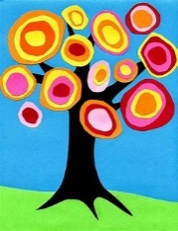 | Piet Mondrian  (linked to 2D shape – use ICT)  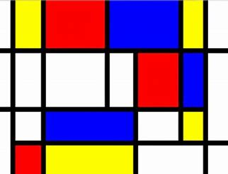 | Alma Thomas  Mosaic-style paintings – replicate using fruit/vegetable prints  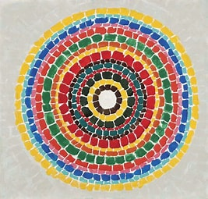 | Claude Monet  Bridge over a Pond of Water Lilies (Link to Billy Goats Gruff)  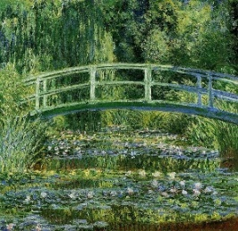 | Vincent Van Gogh  Sunflowers  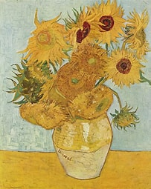 | Henri Rousseau  Tiger in a Tropical Storm  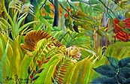
Art & Design opportunities | Drawing – Portraits of Ourselves, friends and family  Collage – Autumn collage  Colour Mixing – mixing  Autumn colours | Sculpting – making diva lamps  Puppet making – Three Bears | Printing – fruit & vegetables  Drawing – still life fruit & vegetables | Collage – 3 Pigs Houses  Junk Modelling – design and make castle/cottage/bridge | Drawing – Flowers & Plants  Printing - Butterlies | Sculpture – bead and coin making (treasure)  Junk Modelling – design and make a boat
Music in class | Continuous Provision:  - Explore & respond to different genres - Explore & respond to music from around the world - Explore and make a range of instruments  - Learn & sing songs and rhymes - Move to music - Respond to dance performances

