Pakeman Primary School
Thematic Curriculum

Year 5/6 | Autumn 1 | Autumn 2 | Spring 1 | Spring 2 | Summer 1 | Summer 2
YEAR A | Whole school topic – Heroes | Myths and legends | Weather and climate | Homelessness | Windrush:  The migration story of Britain | Artists: Impressionism to cubism
Trips/ Workshops | Sky studios | British museum | Science Museum |  | Homelessness charity talk | National Gallery
Key Events | Jeans for Genes Day  BHM  Roald Dahl Day  National Poetry Day  Peace week | Remembrance Day  Human Rights Day  International Day  Anti-bullying week | Holocaust Memorial Day  Internet safety day | World book day  World maths day  British science week  Mother’s Day Comic/sports relief | The Queen’s birthday  World refugee day | Father’s Day
Festivals | Diwali  Rosh Hashanah  Harvest festival | Hanukah  Christmas  Inter Faith week | Chinese New Year  Shrove Tuesday  Holi | Easter  St David’s day  St Patrick’s day | Ramadan  Eid  St George’s day
School Events | Cinema night | Christmas Fair | International evening | Easter Raffle | Cinema night | Eid Party  Summer Fair
Homework project | Research project – biography writing of a hero | Make an ancient Greek artefact | Country study |  | Write a speech for the launch of a homelessness charity | Art produced in a style related to one of the artists studied and a biography of that particular artist
Entry point | Hero assembly | Dress up day – Dress up as a Greek god or goddess | Clothing/objects climate game | Now press play – murder of a homeless man in New York | Respect/Diversity workshops | National Gallery; National Portrait Gallery
Key Fiction texts | 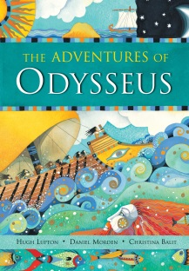 | 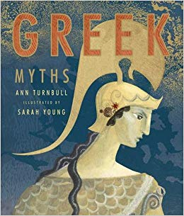 | 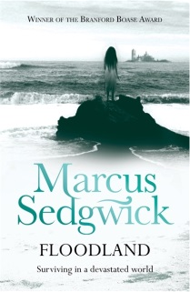 | 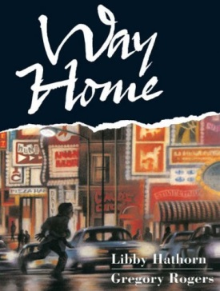 | 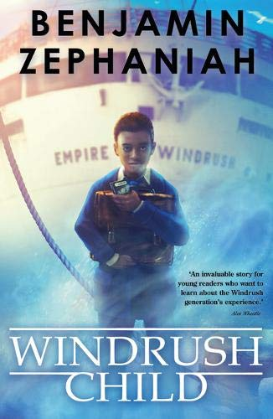 | 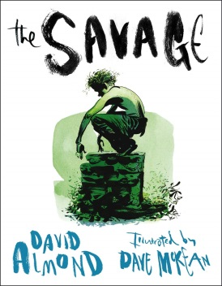
Fiction writing | Diary entry (Narrative)  Letter (recount) | Write a myth (Narrative) | Apocalyptic story (Narrative) | Adventure/suspense (Narrative) | (Narrative) | Living as the savage (Narrative)
Non-Fiction texts |  | Newspaper report (Information text) | Report on Climate Change to the Government (Persuasion) | Different lives; different voices – diary entries by different homeless people, or someone who gives a homeless person money | (Instructions) | Artist/monarch biography (Information)
Poetry | Poetry project FZ |  | Rap writing (poetry) | Writing through film |  | Poems about grief
Maths Y5 | Place value  Addition  Subtraction  Statistics (handling data) | Multiplication  Division  Perimeter  Area | Multiplication  Division  Fractions | Position  Direction  Converting units  Volume  Measure | Decimals  Shape | Fractions  Decimals  Percentages
Maths Y6 | Place value  Addition  Subtraction  Multiplication  Division | Fractions  Decimals  Position  Direction | Decimals  Percentages  Perimeter  Area  Volume  Conversion | Maths investigations | Problem solving  Statistics  Algebra | Algebra  Ratio  Shape
Science | Light: How light travels, eye, colours that we see, shadows an why they have the same shape | Electricity: associating brightness and volume with voltage of cells, comparing and giving reasons for how components function, symbols in a circuit | Water cycle  Change of state: solids, liquids and gases  Rotation of the Earth linked to seasons and climate | Materials and their properties: insulators/conductors, permeable/impermeable, reversible and irreversible changes | Animals including humans: circulatory system, diet and exercise, nutrients and water transportation  Life cycle of human | Forces: air resistance, water resistance and friction, levers, pulleys and gears
History | ANCIENT GREECE : A STUDY OF GREEK LIFE AND ACHIEVEMENTS AND THEIR INFLUENCE ON WESTERN WORLD  Heroes throughout black history: David Olusoga’s book ‘Black and British’ | - STUDY OF A THTEME EXTENDING BEYOND 1066: Legacy of Greek and Roman culture (art, architecture or literature) on later periods of British history, up to today | SIGNIFICANT TURNING POINT IN BRITISH HISTORY: Industrial Revolution in Britain and the first railways.  Isambard Kingdom Brunel and famous industrialists.  Slavery and the industrial revolution.  Children create inventions of their own to solve modern problems. | A NON-EUROPEAN SOCIETY THAT CONTRASTS WITH BRITISH HISTORY: Early Islamic Civilisation, including a study of Baghdad | STUDY OF AN ASPECT OF BRITISH HISTORY: Migrations and the migration story of Britain  Different key migrations to Britain through the ages including post-Ice Age, Romans, Anglo-Saxons, Normans, and Windrush  Britain and the slave trade;  Resistance - the power of protest | STUDY OF A THEME IN BRITISH HISTORY: THE CHANGING POWER OF MONARCHS  Through famous portraits of monarchs; and their reigns.
Geography |  | - Creating maps of Ancient Greece, Mediterranean & Africa, naming city states and seas.  How to create our own marketing materials to sell a holiday | Climates around the world;  life in different climates, food from different places, extreme weather events.  Water cycle; where the water that supplies our homes comes from; water and climate change; how drought and flooding can affect communities around the world. | Homelessness map of UK; human geography of city and countryside life, population spread; create maps of UK and Ireland, learn major cities, rivers, counties. | Migration maps | Impressionists & the Mediterranean  Seas and oceans
Art | Hero portraits | - Print making: tiles  - Finding out about Ancient Greek art  - Creating our own piece of art in a Greek style  Clay pots | Collage  Painting Constable and Ludolf Bakhuizen storms  Umbrella art display | City scape stencils – mixed media | Black protest art  Posters | Watercolour –  The savage (art to express emotion)  Graphic novels
DT |  | Greek buildings and shields  Ancient Greek necklaces | Factories for industrial revolution
Artist/Designer | Ed Chapman |  | Ludolf Bakhuizen |  | Banksy | Monet, Pissaro, Seurat, Van Gogh, Picasso,  Braque, Matisse
Music | Specialist Music Curriculum following the National Curriculum – Specialist teacher
Now Press Play | Online Safety | Ancient Greece | Water cycle  Materials | Mental maths (Murder of a homeless man in New York) |  | Transition
Computing | i-motion for film making  Blogging on school website/Islington forums  E-safety activity | Social media/advertising – critically evaluate information streams  E-safety activity | ‘Network weather stations’ + ‘Weather station curric. resource’ (Lgfl)  ‘Scratch’ / ‘Kodu’ coding  E-safety activity | Critically evaluate information streams – Fake news  Blogging on school website/Islington forums | ‘Comic life’/‘Book creator’  ‘Healthy minds’ (Lgfl)  E-safety activity | ‘Publisher’  ‘Thinking skills for life’ (Lgfl)  E-safety activity
PE | Net and Wall games  (Core Activity 7 to 11) | Gymnastics  (Core Activities 9 to 16) | Yoga, Health and Wellbeing | Outdoor and Adventure  (Core Activities 6 to 10) | Athletics  (Core Activities 8 to 13) | Striking and Fielding  (Core Activities 4 to 7)  Invasion Games  (Core Activities 6 to 13)
PHSE / RSE | Physical health and wellbeing: In the Media  Positive role models and everyday heroes | Drug, alcohol and tobacco education: Weighing up risk and Influences  Keeping safe – Managing risks – out and about | Identity, society and equality:  Human rights | Mental health and emotional wellbeing: Dealing with feelings  Mindfulness: How art can help with mental health | Careers, financial capability and economic wellbeing: Borrowing and earning money  wellbeing  Keeping safe - out and about | Sex and relationship education:  - puberty  - personal hygiene  - male and female body parts  - gender stereotyping  - values in relationships  - human reproduction  - how babies are made  - roles and responsibilities of parents and carers
RE | Ancient Beliefs – Greek Gods/Goddesses | Why do some people believe God exists? |  | What do religions say to us when life gets hard? | What would Jesus do? Can we live by the values of Jesus in 21st century? | What does it mean to be a Muslim in Britain today?

Year 5/6 | Autumn 1 | Autumn 2 | Spring 1 | Spring 2 | Summer 1 | Summer 2
YEAR B | Whole school topic - Time Travel | World War 2 | Mission to Mars | Endangered species | Journeys of Discovery | Titanic
Trips/ Workshops | Sky studios  Cally tower  Splatt theatre immersive day | Imperial war museum | Science Museum | London Zoo
Key Events | Jeans for Genes Day  BHM  Roald Dahl Day  National Poetry Day  Peace week | Remembrance Day  Human Rights Day  International Day  Anti-bullying week | Holocaust Memorial Day  Internet safety day | The Queen’s birthday  World refugee day | World book day  World maths day  British science week  Mother’s Day Comic/sports relief | Father’s Day
Festivals | Diwali  Rosh Hashanah  Harvest festival | Hanukah  Christmas  Inter Faith week | Chinese New Year  Shrove Tuesday  Holi | Ramadan  Eid  St George’s day | Easter  St David’s day  St Patrick’s day
School Events | Cinema night | Christmas Fair | International evening | Cinema night | Easter Raffle | Eid Party  Summer Fair
Homework project | Make an air raid shelter | Find out about a person who was alive during World War Two | Design or make a spaceship that could take you to the moon | Research project on an endangered animal | Design your own Kensuke’s kingdom journey in a scrap book or on a map | Make a model of the Titanic
Entry point | Immersive WW2 Experience |  | Mission to space day -dress up | London ZSL | Stranded on a desert island | Floating and Sinking investigation
Key Fiction texts | 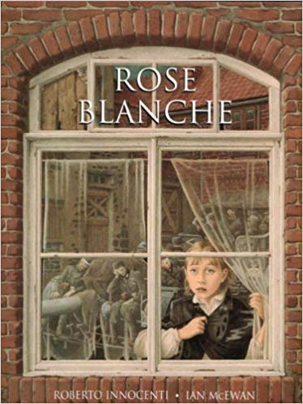 | 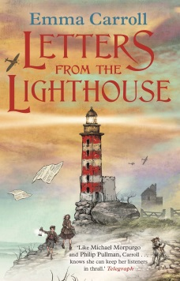 | 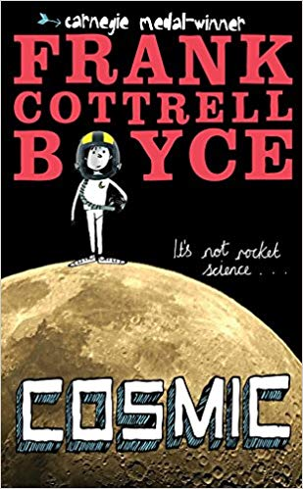 | 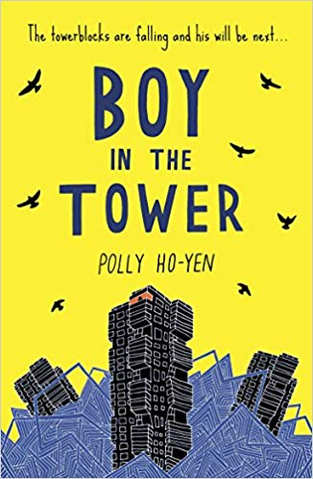 | 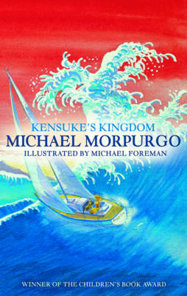 | 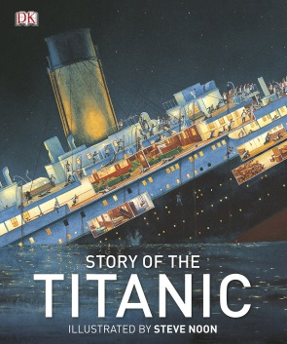
Fiction writing | Two truths: Evacuee letter compared with diary (Narrative) | Dramatic story inspired by characters or moments in Letters from the Lighthouse  (Narrative) | Trip to space advert (Persuasion) | Drama sci-fi story (Narrative) | Ship’s log (Narrative) | Letter from different passenger perspectives about journey (recount)
Non-Fiction texts | How to survive an air raid (Instructions) | Budmouth Point Herald: German plane crash  (Newspaper report) | Guide to the Planet Mars (Information) | NEW SPECIES! What are Bluchers? (Information) | A survival guide to life at sea (Instructions) | Adverts for a trip on the Titanic (Persuasion)
Poetry | Poetry project FZ | Poetry project FZ | Space poetry | Reciting: The Tyger | The Highwayman | Poems about the sea
Maths Y5 | Place value  Addition  Subtraction  Statistics (handling data) | Multiplication  Division  Perimeter  Area | Multiplication  Division  Fractions | Decimals  Shape | Fractions  Decimals  Percentages
Maths Y6 | Place value  Addition  Subtraction  Multiplication  Division | Fractions  Decimals  Position  Direction | Decimals  Percentages  Perimeter  Area  Volume  Conversion | Problem solving  Statistics  Algebra | Algebra  Ratio  Shape
Science | Forces: gravity, air resistance, water resistance and friction  Children make parachutes for soldiers | SC1 investigation | Earth and space: movement of the Earth, planets, orbiting, Earth, sun and moon, night and day; planets of our solar system | Living things and their habitats: classifying, characteristics, reproduction in plants and animals, life cycles | Evolution and inheritance: living things change over time, fossils, inheriting characteristics, adaptation, evolution
History | - AN ASPECT OF BRITISH HISTORY THAT EXTENDS PUPILS KNOWLEDGE BEYOND 1066: Britain at war in WW2, including the Blitz; a comparison of the lives of children in Britain and Germany (evacuees, Hitler Youth, Jewish refugees)  - How the war started, and key events (Dunkirk or Battle of Britain) | - The Holocaust; compare and contrast with other historic crimes?  - Oral history of WW2: stories from families within living memory  LOCAL HISTORY: traces of the war in local area, including memorials |  |  | THEME OF BRITISH HISTORY: Journeys of discovery  Famous explorers and how they changed history: Charles Darwin and the Beagle – theory of evolution; Christopher Columbus and conquistadors;  Ibn Battuta, Amelia Earhart, Neil Armstrong and the moon landings | THEMES OF BRITISH HISTORY: Travel and transport Story of the Titanic in the context of a history of marvellous machines
Geography | Map of Europe – linked to Hitler’s expansion; Allies and Axis countries | World map – linked to America and Japan joining the war | Comparing locations of global space agencies, launch sites and telescope sites.  Most extreme geographical climates of earth compared with climates of Mars (Mariana Trench in oceans; coldest/hottest/driest/wettest places on Earth); adaptation of flora and fauna which survive there (Darwinism). | - Endangered species fact files and maps; causes of problems and campaigns to help them. | - Map reading and making | PORTS AND PLACES: Journey of the Titanic (Belfast, Southampton, New York) triggers discussion about key sea ports and their cities around the world  Famous trade routes (Silk Road)  Famous railway journeys: Trans-Siberian
Art | London landscapes – painting  Blitz searchlight art |  | Printing constellations | Batik art | Sketchbooks as a way of recording (as in Kensuke’s Kingdom);  the rough line, famous artist sketch books, images of pets, people, flora, fauna | Japanese art – water colours, symbols – ink work
DT | Design and make a bomb shelter |  | 3D Solar System  3D Mars surface (modroc) |  |  | Make titanic cabin
Artist/Designer |  |  | Albrecht Dürer – printing constellations |  | Hokusai |  | Monet, Pissaro, Seurat, Van Gogh, Picasso,  Braque, Matisse
Music | Music curriculum taught by specialist teacher
Now Press Play |  | WW2  Relative clauses (concentration camp) | Mission to mars  Forces (Moon gravity) | Recycling | Evolution | Fractions (Titanic)
Computing | ‘Introduction to HTML’ (Barefoot)  Blogging on school website/Islington forums  E-safety activity |  | Code a rover (Lego Wedo/Scratch)  Internet research (Nasa website etc) for topic writing on Powerpoint  Space Adventures (Lgfl)  E-safety activity | (Originally for ‘Natural world’ topic)  Water cycle debug challenge - Barefoot  https://scratch.mit.edu/projects/39761324/  Blogging on school website/Islington forums  E-safety activity | Polar Exploration (Lgfl)  Explore Geography (Lgfl)  E-safety activity | Titanic animations  ‘Comic Life’  ‘Excel’  E-safety activity
PE | Net and Wall games  (Core Activity 7 to 11) | Gymnastics  (Core Activities 9 to 16) | Yoga, Health and Wellbeing | Outdoor and Adventure  (Core Activities 6 to 10 | Athletics  (Core Activities 8 to 13) | Striking and Fielding  (Core Activities 4 to 7)  Invasion Games  (Core Activities 6 to 13)
PHSE / RSE | Identity, society and equality: Stereotypes, discrimination and prejudice (including tackling homophobia) | Keeping safe: When things go wrong (online safety) | Mental health and emotional wellbeing: Dealing with feelings including death | Mental health and emotional wellbeing: Healthy minds  Helping others | Mindfulness: How art can help with mental health | Sex and relationship education (See Year A)
RE | Places of worship: If God is everywhere, why go to a place of worship? | Judaism (link to Holocaust) | What matters most to Christians and to Humanists? | Is it better to express your religion in arts and architecture or in charity and generosity? |  | What difference does it make to believe in Ahimsa  (harmlessness), Grace (the generosity of God), and Ummah (community)?  Hinduism: Reincarnation and Karma

