Pakeman Primary School
Thematic Curriculum

Year 3/4 | Autumn 1 | Autumn 2 | Spring 1 | Spring 2 | Summer 1 | Summer 2
YEAR A | Whole school topic – London transports history | Journeys | Stone Age to Iron Age | Vikings/Anglo Saxons | Rainforests | Rainforests
Trips/ Workshops |  | National Gallery – Other cultures/Travel  Cinema |  | Natural History Museum | Kenwood House | Zoo
Key Events | Jeans for Genes Day  BHM  Roald Dahl Day  National Poetry Day  Peace week | Remembrance Day  Human Rights Day  International Day  Anti-bullying week | Holocaust Memorial Day  Internet safety day | World book day  World maths day  British science week  Mother’s Day Comic/sports relief | The Queen’s birthday  World refugee day | Father’s Day
Festivals | Diwali  Rosh Hashanah  Harvest festival | Hanukah  Christmas  Inter Faith week | Chinese New Year  Shrove Tuesday  Holi | Easter  St David’s day  St Patrick’s day | Ramadan  Eid  St George’s day
School Events | Cinema night | Christmas Fair | International evening | Easter Raffle | Cinema night | Eid Party  Summer Fair
Homework project |  | Prepare a show and tell about the country your family comes from | Cave making |  | Research book making about the rainforest
Entry Point |  | Getting ready for a trip game | Making a stone age axe
Key Fiction texts |  | 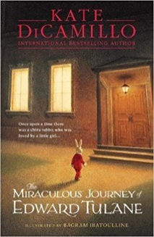 | 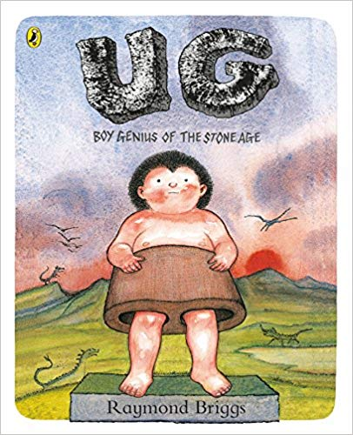  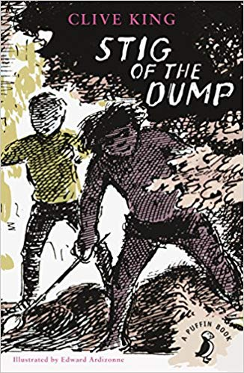 | 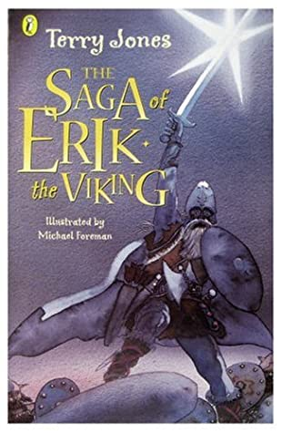  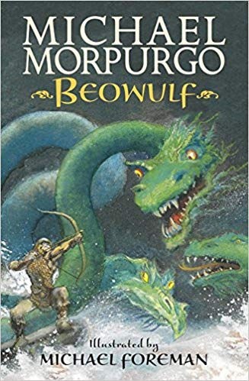 |  | 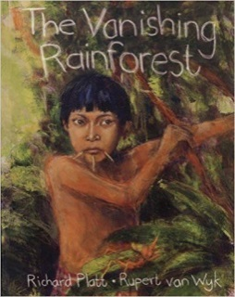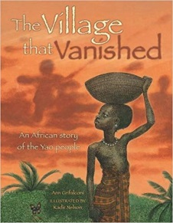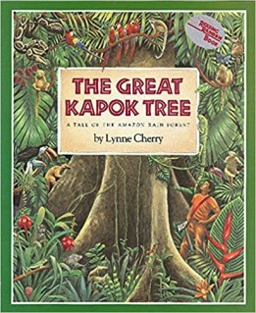
Maths links | Place value  Addition  Subtraction | Multiplication  Division | Measure  Perimeter  Area | Fractions  Decimals | Money  Statistics – handling data  Time | Shape  Mass  Capacity  Position  Direction
Science | SC1 investigation | Sound: identifying sounds, vibrations, how sound travels, pitch of sound, volume and distance | Rocks: formation of fossils, what is soil, rock types  Marbling techniques – art | Animals including humans: identify teeth and their functions, digestive system, nutrition, skeletons, muscles and food chains | Plants: life cycle of plants, flowering plants functions, what a plant needs and pollination | SC1 investigation
History |  |  | Changes in Britain from stone to iron ages: farming, hunter gatherers, forts, tribal kingdoms and bronze age religion |  |  | Local history – cally tower
Geography
Art | Monochrome portraits - BHM  Clay art | Painting flags  OP art colour Mondrian? | Lascaux paintings  Charcoal | Silhouettes and smudging chalk colour backgrounds  Sketching skills – wiki how  Wire art | Collage (texture and colour)  Collage (creatures / characters) | Mask making – paper mache  Pop up illustration  Rainforest scene  Screen printing
DT |  |  | Stone age axe making
Artist/Designer | Andy Warhol | Yann Arthus Bertrand | Cave art - Lascaux |  | Peter Blake
Music | Specialist Music Curriculum following the National Curriculum – Specialist teacher
Now Press Play | Roman Britain | Climate change | Stone Age  Online Safety | Dinosaurs | Rainforests | Plants
Computing
PE | Net and Wall games  (Core Activity 7 to 9) | Gymnastics  (Core Activities 5 to 10) | Yoga, Health and Wellbeing | Outdoor and Adventure  (Core Activities 4 to 8) | Athletics  (Core Activities 6 to 10) | Striking and Fielding  (Core Activities 1 to 5)  Invasion Games  (Core activities 8 to 10)
PHSE | Identity, society and equality:  Democracy | Drug, alcohol and tobacco education:  Making choices | Physical health and wellbeing:  What is important to me? | Keeping safe and managing risk:  Playing safe
RSE (from Sept ember 2021) |  |  |  |  | Sex and relationship education:  Growing up and changing  - Puberty  - Wet dreams and periods  Relationships and different feelings
RE | What do people believe about God? | What does it mean to be a Hindu in Britain today?(Hinduism/Sikhism  Diwali – Guru Nanak’s birthday) |  | Why are festivals important?  (Easter/Passover) | What can we learn from religions about right and wrong?  (Buddhism - Buddha’s birthday) | What do people believe about God?

Year 3/4 | Autumn 1 | Autumn 2 | Spring 1 | Spring 2 | Summer 1 | Summer 2
YEAR B | Ancient Egypt | Romans and their impact on Britain | Energy and power | Chocolate and Mayan civilisation | Active Planet | Habitats: Land, sea and sky habitats
Trips/ Workshops | The garden classroom  Zoo ZSL | British Museum  Cinema | Science Museum | Theatre | Kenwood House
Key Events | BHM  Roald Dahl Day  National Poetry Day  Peace week | Remembrance Day  Human Rights Day  International Day  Anti-bullying week | Holocaust Memorial Day  Internet safety day | World book day  World maths day  British science week  Mother’s Day Comic/sports relief | The Queen’s birthday  World refugee day | Father’s Day
Festivals | Diwali  Rosh Hashanah  Harvest festival | Hanukah  Christmas  Inter Faith week | Chinese New Year  Shrove Tuesday  Holi | Easter  St David’s day  St Patrick’s day | Ramadan  Eid  St George’s day
School Events | Cinema night | Christmas Fair | International evening | Easter Raffle | Cinema night | Eid Party  Summer Fair
Homework project | Pyramid making |  |  | Chocolate factory making
Entry Point | Canopic Jars |  |  | Blind fold taste test | Evacuating the classroom after earthquake
Key Fiction texts | 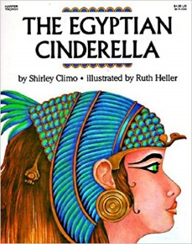  Retell & descriptive narrative  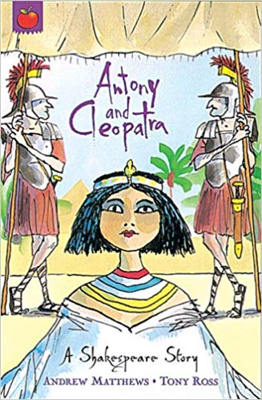 | 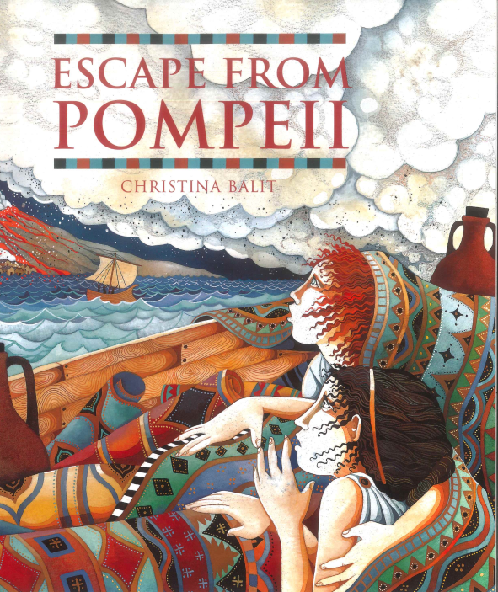  Diary Entry | Write non-fiction text | 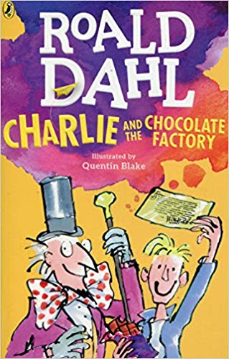  Persuasive | 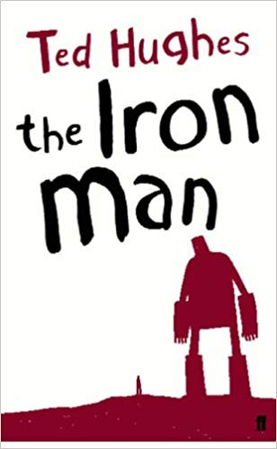 | 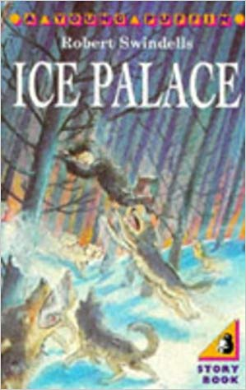  Non-fiction text
Non-Fiction texts |  |  |  |  | 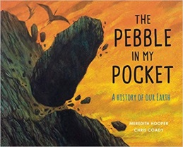
Poetry | Descriptive Poetry | Rhyming Poetry | Performance Poetry | Visual Poetry
Maths links | Place value  Addition  Subtraction | Multiplication  Division | Measure  Perimeter  Area | Fractions  Decimals | Money  Statistics – handling data  Time | Shape  Mass  Capacity  Position  Direction
Science | SC1 investigation | Light: light sources, light to see, darkness, reflection, sun danger, shadows | Electricity: common appliances, construct circuits, switches and lamps, conductors and insulators | State of matter: solids, liquids and gases, changes of state (heating, cooling…), evaporation and condensation | Forces and magnets: movement forces (twist, push, pull…), friction, attract or repel, grouping magnetic objects, magnets and movement | Living things and their habitats: grouping living things, classifying, livings things in local and wider environment, dangers to living things
History | Ancient Egypt | Roman empire and its impact on Britain  Local history - Cally tower |  | Mayan Civilisation
Geography | River Nile  North Africa | Roman Empire to Ancient Egypt  Conquest (Empires)  Roman Britain |  | Equator  Tropic of Cancer/Capricorn
Art | Hieroglyphic art/ Egyptian patterns  Making papyrus | Sculpture / clay of artefacts | Video art | Designing a chocolate wrapper – graphic designer  Screen printing | - About hot and cold colours  - About using different materials and techniques to represent a volcano  Animation | Artist focusing on land and sky – oil painting
DT
Artist/Designer |  |  |  |  | Writing through art artists | Luiza Visoli
Music | Specialist Music Curriculum following the National Curriculum – Specialist teacher
Now Press Play | Ancient Egypt | Bullying | Electricity | The Maya | Natural disasters | The five pillars
Computing
PE | Net and Wall games  (Core Activity 7 to 9) | Gymnastics  (Core Activities 5 to 10) | Yoga, Health and Wellbeing | Outdoor and Adventure  (Core Activities 4 to 8) | Athletics  (Core Activities 6 to 10) | Striking and Fielding  (Core Activities 1 to 5)  Invasion Games  (Core activities 8 to 10)
PHSE | Drug, alcohol and tobacco education: Tobacco  is a drug | Keeping safe and managing risk:  Bullying – see it, say it, stop it | Mental health and emotional wellbeing:  Strengths and challenges | Identity, society and equality:  Celebrating difference | Careers, financial capability and economic  - wellbeing: Saving, spending and budgeting | Physical health and wellbeing:  What helps me choose?
RSE (from Sept ember 2021) |  |  |  |  |  | Sex and relationship education:  Growing up and changing  - Puberty  - Wet dreams and periods  Relationships and different feelings
RE | Journey of Life | What does it mean to be a Christian in Britain today?  (Christmas) | Why is the Bible important for Christians today? | Why is Jesus inspiring to some people? |  | Why do people pray?  (Islam – Ramadan)

