Pakeman Primary School
Thematic Curriculum

Year 1/2 | Autumn 1 | Autumn 2 | Spring 1 | Spring 2 | Summer 1 | Summer 2
YEAR A | Whole school topic – Hope | Our World | Celebrations | Leaders | Growing -Plants | Minibeasts
Trips/ Workshops |  | Cinema | China town tasting trip | Tower of London  Drama/storytelling workshop | Drama/storytelling workshop | King Henry’s Walk garden
Key Events | Jeans for Genes Day  BHM  Roald Dahl Day  National Poetry Day  Peace week | Remembrance Day  Human Rights Day  International Day  Anti-bullying week  Remembrance Day lesson 10/11/20  11/11/20 11am silence | Holocaust Memorial Day  Internet safety day | World book day  World maths day  British science week  Mother’s Day Comic/sports relief | The Queen’s birthday  World refugee day  Spring | Father’s Day
Festivals | Rosh Hashanah  Harvest festival | Hanukah  Christmas  Inter Faith week  Diwali | Chinese New Year  Shrove Tuesday  Holi | Easter  St David’s day  St Patrick’s day | Ramadan  Eid  St George’s day
School Events | Cinema night | Christmas Fair | International evening | Easter Raffle | Cinema night | Eid Party  Summer Fair
Homework project |  | Recycling – junk modelling | Share pictures of celebrations from home | Make shields, swords and castles | Take care of bean plant over the holidays
Entry point | Supertato stole the fruit | Hunt for saving electricity | Cultural dress up | Now Press Play | Spring walk | Parent minibeast day
Key Fiction texts | 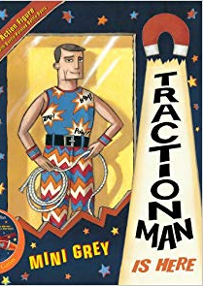  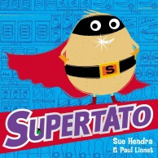  Beegu | 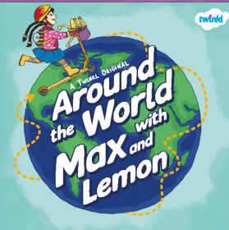  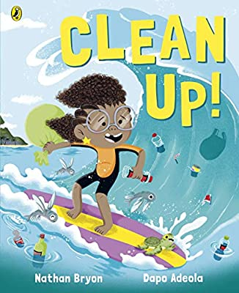  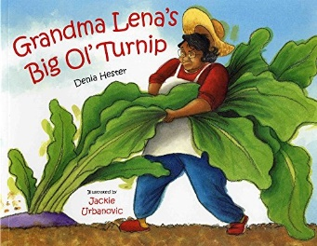  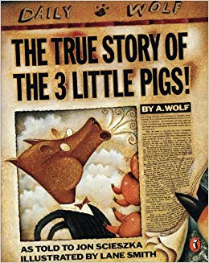 | 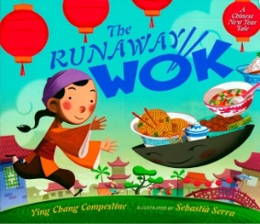  Celebrating Chinese new year  https://www.youtube.  com/watch?v=eVClAj8q_lY  Puppet cultural tale from Chinese new year  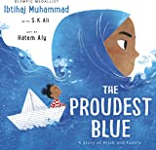  First Day Hijab  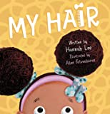  Birthday Celebration  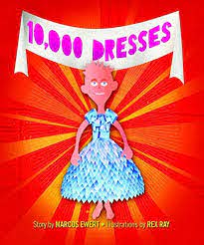  Celebrating gender freedom | 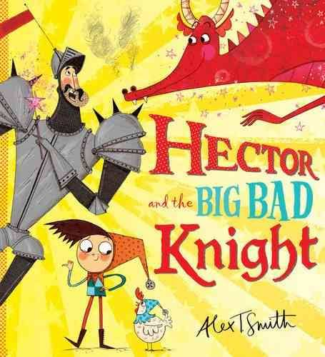  Sword in the stone (Different versions)  See Non Fiction Books | 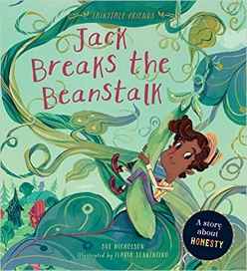Jack and the beanstalk (Comparing versions – Jack and the meanstalk – Jill and t he beanstalk)  See Non Fiction Books | 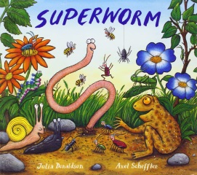  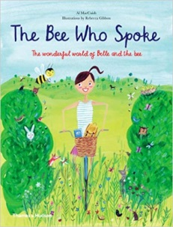  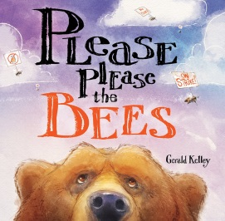  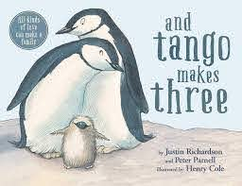  Intro to Pride  My Two Grannies  PSHE -Families
Fiction writing | Character description  Letter – personal writing using ‘I’  dialogue and speech bubbles  Comic strip  Postcard  Captions  Retell narrative - Rewriting a known story with a new ending | Retell narrative - Traditional tale  Retell narrative - Fairy tale  The snowman – dialogue and speech bubbles  Recount – energy walk  Retell – Giant turnip  Retell – Cinderella  Narrative – persuasive invitation  Character description  Setting description | Retell Narrative - Cultural tale  Letter – to the wok  Description – characters feelings  Comparing stories  Personal response – wish | Retell Narrative - Sword and stone  Diary entry - Hector  Character description | Alternative endings in narratives  Setting description | Character description  Letter - to use questions
Non-Fiction texts |  |  | Carnival | 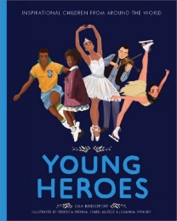  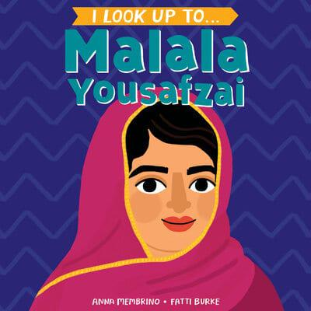 | Life cycle of a bean plant  How wheat becomes bread  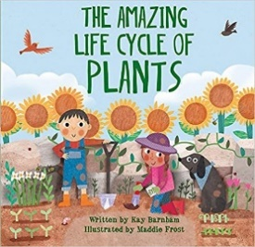 | Year 2 - Persuasive letter writing
Non Fiction writing | Diagrams and labels – traction man suit | Persuasive posters – energy saving  Explanation text – sources of energy  Report - recycling  Diagrams and labels – carriage | Diagrams and labels and descriptive narrative – Carnival float  Instructions – recipe for a stir fry | Recount - trip to Tower of London  Information text - Knight fact file  Fiction based instructions - Hector’s big bad plan | Explanation text - life cycle of a bean  Information text - How wheat becomes bread
Poetry |  | Silly poem with rhyme – Don’t …  Acrostic Winter poems |  |  |  | Riddles
Maths links | Place value  Addition | Addition and Subtraction  Y2: Money  Y1: Shape, Place Value | Y1: Addition  Subtraction, Place Value  Y2: Multiplication, Division, Statistics, | Y1: Length, Height, Weight, Volume  Y2: shape and fractions | Y1: Multiplication, Division, Fractions, Position and Direction  Y2: Length, Height, Position and Direction | Y1: Place Value, Time, Money  Y2: Time, Mass, Capacity, Temperature
Science | Healthy eating and exercise | Materials and their properties.  Best suit for traction man. |  |  | Plants: Seeds and growing  Seasons – Spring and summer – naming flowers and observations | All living things and their habitats: describing habitats for minibeasts (microhabitats)
History | Interpretation – Fairy tales “Who did it?” | Remembrance Day – How is it celebrated? | History of Chinese new year – London yearly event | Events beyond living memory – significant leaders from around the world  A day in the life of a leader.  Tower of London – historical landmark |  | Events in living memory – heroes in our lives  Significant Black British Women
Geography |  | Birds eye view of our locality – Google Earth/Maps  Now Press Play – directional language  Locational knowledge -Continents, Countries, Cities | Seasonal and daily weather patterns |  | Farming focus  Human and physical geography  Key Vocab - soil, valley, vegetation, factory, farm,
Art | Self-portraits | Art using natural materials  Aboriginal art  Firework chalk art | Straw painting for Holi  Print making – vegetables | Historical art inspired by Tower of London – Castle shape tracing | Watercolour – water lilies  Oil pastels – Van Gogh | Paper mache sculptures  Snail abstract collage
DT |  |  | Chinese lanterns  Design a dragon using egg boxes  Make a piñata | Model making - castle building  Make a drawbridge (pulleys and levers)  Crown making |  | Design an observation container for a minibeast  Design a product to sell to minibeast
Artist/Designer |  |  |  | Paul Klee | Monet  Van Gogh | Matisse
Music | Specialist Music Curriculum following the National Curriculum – Specialist teacher
Now Press Play | Superheroes | Maps | Online Safety | Castles | Plants | Habitats
Computing | Online Safety  Computer Art | Online Safety  Word Processing Skills | Online Safety  Presentation Skills | Online Safety  Using and Applying | Online Safety  Programming Toys | Online Safety  Programming Turtle Logo and Scratch
PE | Net and Wall games  (Core Activity 1 to 6) | Gymnastics  (Core Activities 1 to 8) | Yoga, Health and Wellbeing | Outdoor and Adventure  (Core Activities 1 to 5) | Athletics  (Core Activities 1 to 7) | Games  (Core activities 1 to 7)  Striking and Fielding  (Core Activities 1 to 3)
PHSE | Physical health  and wellbeing  Fun times | Keeping safe and managing risk:  Feeling safe | Identity, society and equality:  Me and others | Drug, alcohol and tobacco education:  What do we put into and on to bodies? | Mental health and emotional wellbeing:  Feelings  Boys and Girls, Families | Careers, financial capability and economic  wellbeing: My money
RE | What makes some places sacred? | Diwali – How is it celebrated? Rangoli Patterns.  Who is Jewish and what do they believe?  (Hanukah)  How should we care for others and the world, and why does it  matter? | How & why do we celebrate special and sacred times  Easter  Passover  Holi  Eid |  |  | Who is a Muslim and what do they believe?  (Eid)

Year 1/2 | Autumn 1 | Autumn 2 | Spring 1 | Spring 2 | Summer 1 | Summer 2
YEAR B | This is Me!  Whole school topic – TBC | Dinosaurs | Animals | Great fire of London | Holidays | The Circus
Trips/ Workshops | Drama/storytelling workshop | Cinema | Gillespie ecology centre | Drama/Storytelling workshop | Seaside | Circus skills workshop
Key Events | Jeans for Genes Day  BHM  Roald Dahl Day  National Poetry Day  Peace week | Remembrance Day Human Rights Day  International Day  Anti-bullying week | Holocaust Memorial Day  Internet safety day | World book day  World maths day  British science week  Mother’s Day Comic/sports relief | The Queen’s birthday  World refugee day | Father’s Day
Festivals | Diwali  Rosh Hashanah  Harvest festival | Hanukah  Christmas  Inter Faith week | Chinese New Year  Shrove Tuesday  Holi | Easter  St David’s day  St Patrick’s day  Eid | Ramadan  St George’s day
School Events | Cinema night | Christmas Fair | International evening | Easter Raffle | Cinema night | Eid Party  Summer Fair
Homework project | Peg Doll project |  | Research project book – Animal | Tudor houses
Entry point | Share a photo of you doing or wearing something that makes you feel proud! | Excavation or  The egg? | Habitat classroom | Now Press Play  Museum of London – check websites | Beach day or  Airport – travelling to different countries | Circus school dress up day
Key Fiction texts | Week 1  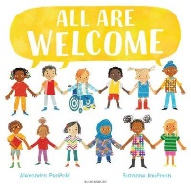  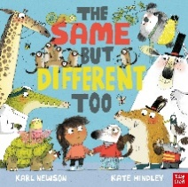  Week 2-3  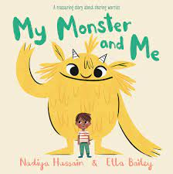  week 4-5  Week 6  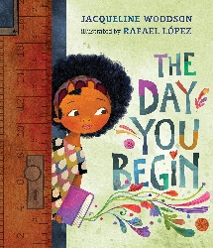  PSHE/Topic  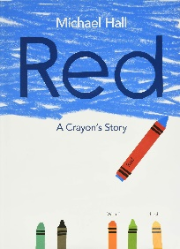  Feeling different inside | 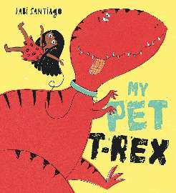  Check with ¾  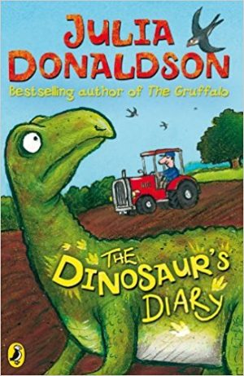  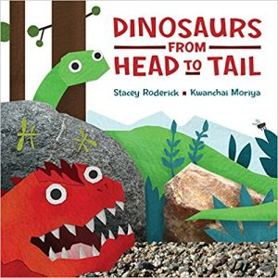  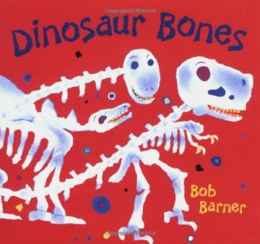  Ask the red boxes  Non-fiction dinosaur book? Check the last two.  PSHE and ART  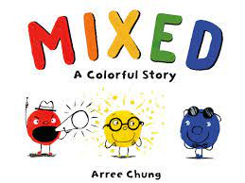 | 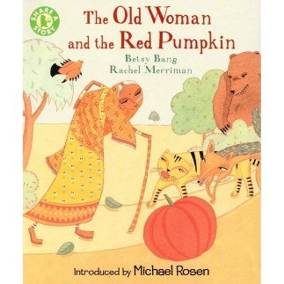  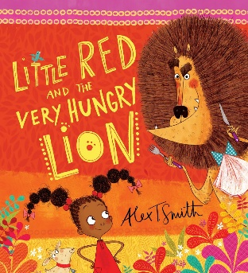  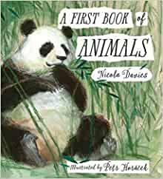  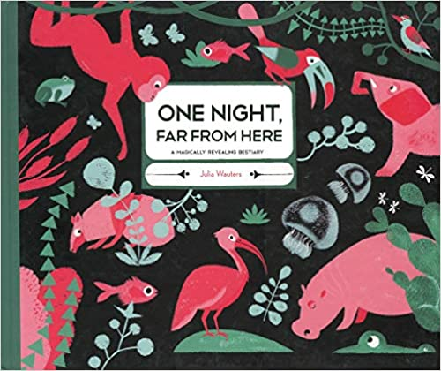  Ask the red boxes | 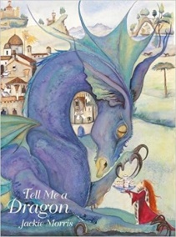Non- Fiction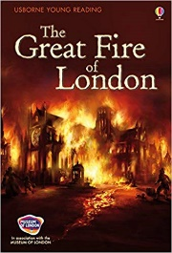Texts  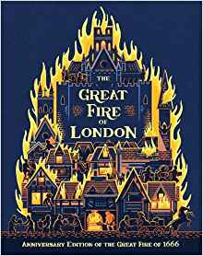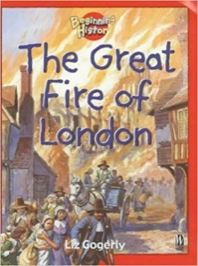  Research books – remove two find Tudor times book  RE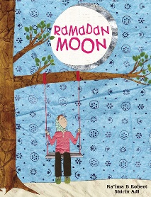 | 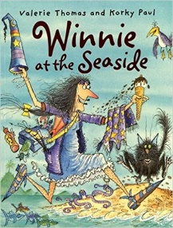  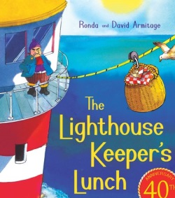  Windrush Day  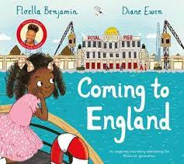  Tata Story Time  PSHE  Overcoming Fears  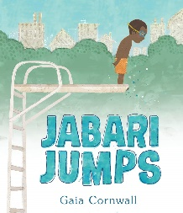 | 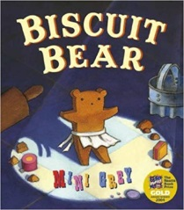  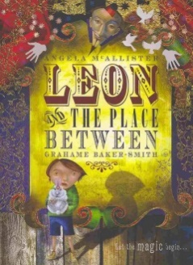  PSHE  Pride Month  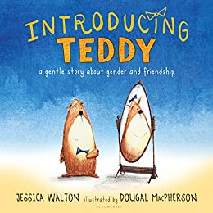  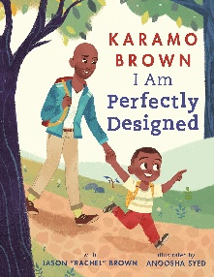  Growing up and getting older
Fiction and Non-fiction writing | Sentence writing – I am… I can…  Adjectives  Conjunctions  Antonyms – lots of opposites in “The Same but Different”  Recount – My News  Letter – Write a letter to the character to tell them about themselves | Letter - Advice to the character  Narrative – retell of story (more able can change part of the story)  Information text - Fact file Dinosaurs  Procedural -Instructions – salt dough dinosaur bones | Character description – Old Lady and The Very Hungry Lion  Narrative Traditional tale – alternative ending narrative (change escape)  Recount – Trip  Character description – wanted poster | Recount – diary entry in first person events of the great fire  Explanation – Build a House  Information - Missing Poster (e.g. Dragon) | Narrative – Alternative character  Book Review  Letter – Windrush day – comparing countries  Information -Summer activities in Islington. | Explanation – Circus invention  Instructions - making biscuits  Book Review
Poetry | Poetry – Rhyming poems, repetition and opposites (Word of the week – use reception flip) |  | Animal poems
Maths links  - Year 1 | Number: Place Value  (within 20)  Number:  Addition and Subtraction  (within 20) | Number:  Addition and Subtraction  (within 20)  Continued  Measurement: Money  Number: Place Value (within 50)  Number: Multiplication | Number: Division  Number: Place Value (within 100)  Measurement: Length and Height | Geometry: Shape  Number: Fractions | Geometry: Position and Direction  Measurement: Time  Number: Place Value (within 100) RECAP | Measurement: Weight and Volume  Number: Four Operations Recap
Maths links  - Year 2 | Number: Place Value (within 100)  Number: Addition and Subtraction (within 100) | Number: Addition and Subtraction (within 100) Continued  Measurement: Money  Number: Multiplication | Number: Division  Statistics  Measurement: Length and Height | Geometry: Properties of Shape  Number: Fractions | Geometry: Position and Direction  Measurement: Time  Problem solving | Measurement: Mass, Capacity and Temperature  Number: Four operations recap and investigations
Science | Healthy eating and exercise  Seasons – Autumn and winter | All living things and their habitats: describing habitats | Animals including Humans: basic needs, classifying animals and babies | Seasons – Spring  Working scientifically – Practical investigations | Summer – focus on clothing  Climates | Materials – best material for a circus tent – properties
History | Questioning –  Significant – Inspirational Figures –  Malala – Everyone should go to school  Comparing-  Paralympian – Determination and not giving up  e.g  Dillon Labrooy  Vanessa Wallace | Chronology – Timeline  Prediction - What could we find buried underneath?  Link to book with layers (Maria)  App – Dinosaur in the room |  | Historical Association Scheme  Questioning – Investigating how the fire started.  Interpretation –evidence eye witness (hot seat) Events beyond living memory  Life in Tudor Times  Samuel Pepys – significant people  Artefacts from today and the past  Comparing- of houses from today and the past  Timeline  Historical landmark – Monument |  | Significant people – Joseph Grimaldi  Website: Extraordinary bodies – look up disabled circus performers
Geography |  |  | Countries and capitals in the UK  Continents and oceans |  | Comparing seasides – contrasting locations  Basic geographical vocabulary – physical features | Weather patterns  Basic geographical vocabulary – physical and human features
Art | Collage self portrait  Animal’s in clothes drawing | Fossil Sculptures or dino bones  Painting Colour mixing basics  ‘Mud painting’ –Tate kids  Emily Willoughby – Paleo art (Dinos with feathers) | Animal printing  Sketching  Oil Pastel – animal illustrations | Oil painting  Samuel Pepys portrait - How to compare a photograph and a painting  Pointillism  Casts of house- concrete | Layered water colours  Seaside postcards  Found art | Close observational sketches
DT | Soup making – cooking | Barbara Hepworth – sculpture for a dinosaur park | Habitat shoe box | Make a model of the bakery | Cooking - rock cakes | Circus puppet making
Music
Artist/Designer | 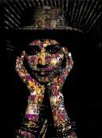  Chila Kumari Singh Burman | Jean Dubuffet – Mud painting | Chris Ofili –art with elephant dung | Rachel Whiteread  Menguy  Seurat | Martin Parr - seaside photography  Eileen Agar – found art | Kandinsky
Now Press Play | Healthy Living | Online safety | Animals  Humans | Great Fire of London | Bullying | Number bonds  Punctuation
Computing | Online Safety  Painting | Online Safety  Using and applying  Animation – Recording video | Online Safety  Computer Skills | Online Safety  Using the Internet | Online Safety  Scratch Junior Programming | Online Safety  Preparing for Turtle Logo
PE | Net and Wall games  (Core Activity 1 to 6) | Gymnastics  (Core Activities 1 to 8) | Yoga, Health and Wellbeing | Outdoor and Adventure  (Core Activities 1 to 5) | Athletics  (Core Activities 1 to 7) | Games  (Core activities 1 to 7)  Striking and Fielding  (Core Activities 1 to 3)
PHSE | Physical health  and wellbeing  Fun times | Mental health and emotional wellbeing:  Friendship | Drug, alcohol and tobacco education:  Medicines and me | Keeping safe and managing risk:  Indoors and outdoors | Sex and relationship education:  Boys and girls, families  - respect and differences  - differences between males and females animals  - different types of families  - Differences between people  - Young to old  - Care  - Families (foster/aunt/uncle/cousins)
RE | What does it mean to belong to a faith community? | Who is a Christian and what do they believe? (Christmas)  Creation stories |  | How should we care for others and the world and why does it matter? |  | Who is Jewish and what do they believe.

