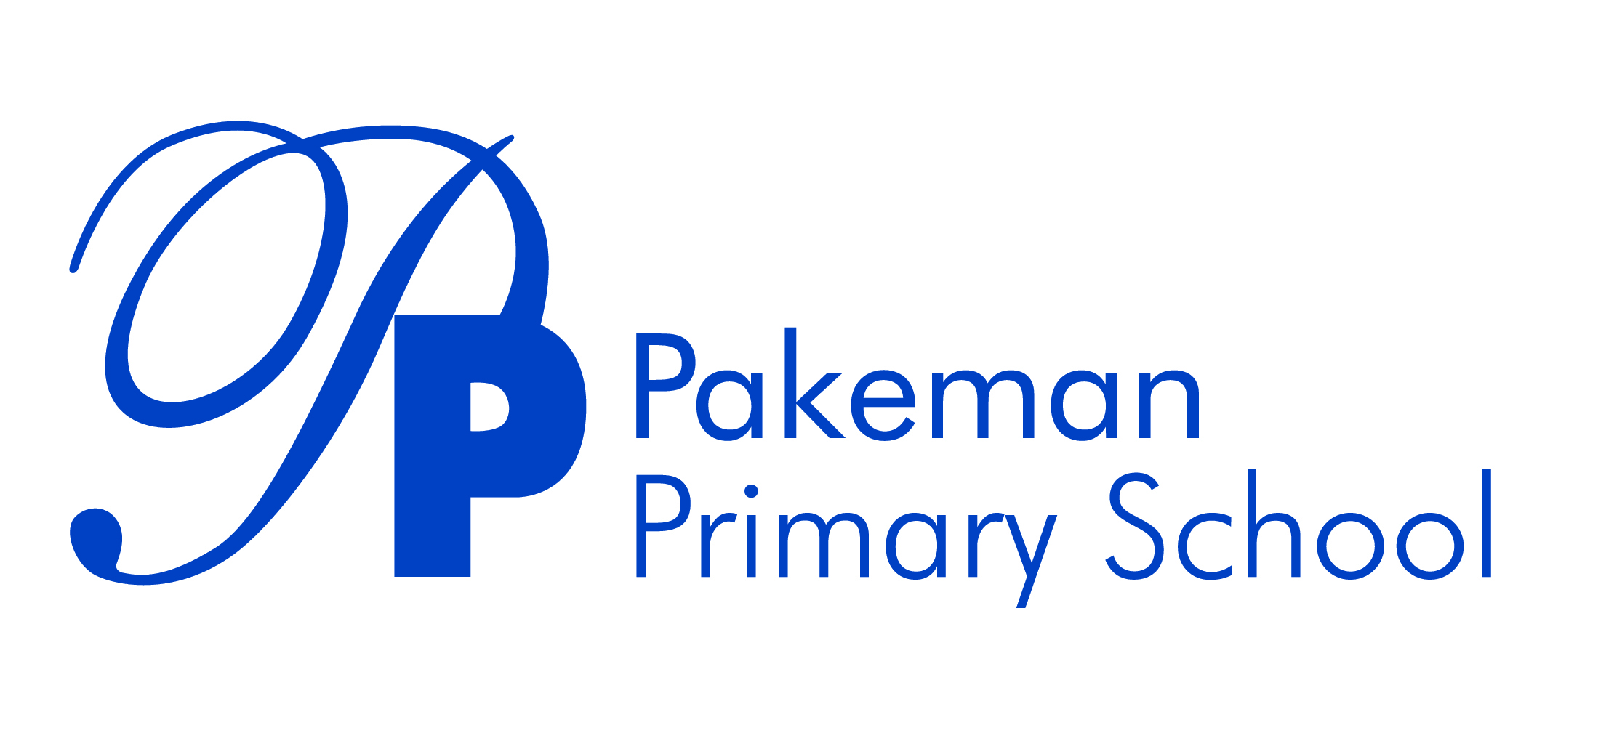

**Equality Objectives**

Approved by

|  |  |  |
| --- | --- | --- |
| Emma Bonnin | Headteacher | September 2021 |
| Janet Convery | Chair of governors | September 2021 |

**Ethos Statement**

Pakeman School offers a positive, safe learning environment for its community, in which everyone has equal and individual recognition and respect. We celebrate success and are committed to the continuous improvement and fulfilment of potential in every child. We encourage increasing independence and self-discipline amongst the pupils. Everyone within the school has an important role to play in sharing responsibility for this policy.

**Equality Objectives**

We aim to provide the highest possible education for all at Pakeman Primary School. The ethos of our school states that ‘Pakeman School offers a positive, safe learning environment for its community, in which everyone has equal and individual recognition and respect.’

**We have set ourselves the following objectives for 2021 - 22:**

|  |  |  |
| --- | --- | --- |
| **Objective** | **Focus area** | **Evaluation** |
| To ensure our school environment and curriculum is reflective of our families, and develops positive identities for all members of our community. | All protected characteristics |  |
| To ensure that our revised curriculum and wider provision effectively supports the needs of all children, in particular disadvantaged pupils and those with SEND. | Disability  Disadvantaged and non-disadvantaged |  |
| To ensure we are closing the in-school attainment gap between disadvantaged pupils and others post Covid, focusing on combined attainment in all of Reading, Writing and Maths at KS1 and KS2. | Disadvantaged and non-disadvantaged |  |
| To ensure we are improving the poor attendance of persistent absentees (disadvantaged pupils). | Disadvantagedand non-disadvantaged |  |
| To close the attainment gap between boys and girls in Reading and Maths – in EYFS and KS1 | Gender |  |
| Raise achievement of White UK disadvantaged and Black Caribbean pupils | Ethnicity |  |
| Increase the impact of parental engagement in children’s learning – especially children with SEND | All protected characteristics |  |

We strive to make our school a model for equality. These objectives will be reviewed throughout the year using pupil voice, data analysis, book looks and staff/parent/carer surveys.