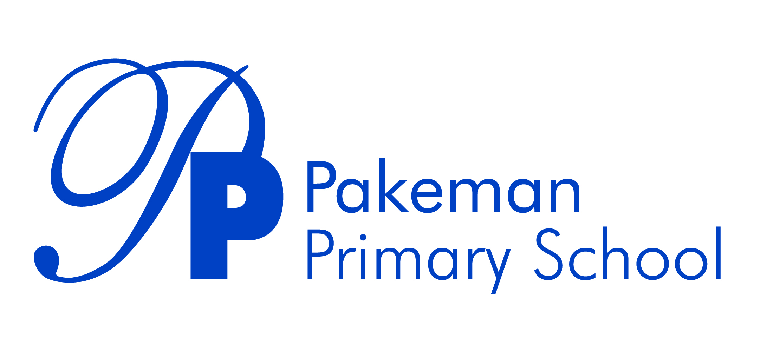

**Equality Statement and Objectives**

**Review Date: December 2021**

**Next Review Date: December 2022**

Approved by

|  |  |  |
| --- | --- | --- |
| Emma Bonnin | Headteacher | December 2021 |
| Janet Convery | Chair of governors | December 2021 |

**Ethos Statement**

Pakeman School offers a positive, safe learning environment for its community, in which everyone has equal and individual recognition and respect. We celebrate success and are committed to the continuous improvement and fulfilment of potential in every child. We encourage increasing independence and self-discipline amongst the pupils. Everyone within the school has an important role to play in sharing responsibility for this policy.

**Equality Information**

At Pakeman Primary School we promote a culture of equality and ensure that people are protected under the Equality Act. This includes equality linked to race, disability, gender, age, pregnancy and maternity, marital status, religion and belief and sexual orientation.

The public sector equality duty has three aims and they are to:

* eliminate unlawful discrimination, harassment and victimisation and other conduct under the Equality Act 2010.
* advance equality of opportunity between people who share a protected characteristic and those who do not
* foster or encourage good relations between people who have a shared characteristic and those who do not

**Contextual data**

Pakeman Primary School is a one and a half form London primary school in the borough of Islington. We offer provision for children from the ages of 2 to 11. The current number on role is 329.

We have a wonderful mix of nationalities with 34 languages spoken by the children in our community. Of these, English, Somali, Bengali, Arabic and Turkish are the most widely used. 63% of our pupils have English as an additional language.

Holloway Ward has a very high deprivation factor, approximately double the national average. Islington is one of the most deprived boroughs in London (6th out of 32 in 2019) and the most deprived for income deprivation affecting children (IDACI). The school has an Income Deprivation Affecting Children Index (IDACI) of 0.41. Currently, 46% of our pupils are eligible for free school meals and 40% are pupil premium. There are an additional 20% of working poor families.

Mobility at the school is very high.  Islington had an average IMD score of 27.5 which was higher than both London and England averages at 21.3 and 19.3 respectively.​

22% children have Special Educational Needs, including 5 with Education Health and Care Plans.

Over the last twelve months, 2 children have been excluded for one fixed term each.

**Equality Objectives**

We aim to provide the highest possible education for all at Pakeman Primary School. The ethos of our school states that ‘Pakeman School offers a positive, safe learning environment for its community, in which everyone has equal and individual recognition and respect.’

**We have set ourselves the following objectives for 2021 - 22:**

**Objective 1** To ensure our school environment and curriculum is reflective of our families, and develops positive identities for all members of our community.

**Objective 2** To ensure that our revised curriculum and wider provision effectively supports the needs of all children, in particular disadvantaged pupils and those with SEND.

**Objective 3** To ensure we are closing the in-school attainment gap between disadvantaged pupils and others post Covid, focusing on combined attainment in all of Reading, Writing and Maths at KS1 and KS2.

**Objective 4** To ensure we are improving the poor attendance of persistent absentees (disadvantaged pupils).

We strive to make our school a model for equality. These objectives will be reviewed throughout the year using pupil voice, data analysis, book looks and staff/parent/carer surveys.