Pupil premium strategy report 2021/2022

This statement details our school’s use of pupil premium (and recovery premium for the 2021 to 2022 academic year) funding to help improve the attainment of our disadvantaged pupils.

It outlines our pupil premium strategy, how we intend to spend the funding in this academic year and the effect that last year’s spending of pupil premium had within our school.

School overview

Detail | Data
School name | Pakeman Primary School
Number of pupils in school | 329
Proportion (%) of pupil premium eligible pupils | 40%
Academic year/years that our current pupil premium strategy plan covers (3 year plans are recommended) | 2021 – 2022  2022 – 2023  2023 - 2024
Date this statement was published | 15th October 2021
Date on which it will be reviewed | October 2022
Statement authorised by | Emma Bonnin (Headteacher)  Janet Convery  (Chair of governors)
Pupil premium lead | Tracey Gulliford
Governor / Trustee lead | Janet Convery

Funding overview

Detail | Amount
Pupil premium funding allocation this academic year | £190,990
Recovery premium funding allocation this academic year | £10,513
Pupil premium funding carried forward from previous years (enter £0 if not applicable) | £0
Total budget for this academic year | £201,503
Total spent | £219295.48

Part A: Pupil premium strategy plan

Statement of intent

Our aim is to use the pupil premium funding to counter disadvantage and to ensure greater equity through:
- Ensuring and supporting great teaching
- Providing targeted academic interventions
- Using a wider range of strategies to overcome barriers to learning

Ensuring and supporting great teaching

We recognise the importance of ensuring all pupils, whatever their background or circumstance, are provided with an education of the highest quality. This will ensure that all our pupils are equipped with the knowledge and skills they will need to succeed in, and beyond school. Strategies to close achievement gaps between groups and individuals are an integral part of every lesson and evident across the curriculum. Within the classroom there is a clear focus on well planned and differentiated lessons that challenge and stretch all pupils. A programme of training supports staff to continually expand and experiment with a full range of teaching strategies and techniques to ensure the achievement gap is closed rapidly through the use of timely and appropriate interventions.
This will include:
- extensive gap analysis used to further inform teaching
- 1:1 and small support within the class
- TA support in class
- the employment of specialist teachers
- CPD for staff and collaborative practice, including team teaching, modelled lessons and best practice visits

Providing targeted academic interventions

For some children, high quality teaching in itself may not be enough and there is a need for additional, time-limited provision outside of normal classroom activities. There is extensive evidence supporting the impact of high quality one to one and small group tuition as a catch-up strategy. Programmes are likely to have the greatest impact where they meet a specific need, include regular sessions maintained over a sustained period and are carefully timetabled to enable consistent delivery. Effective interventions follow assessment, which can then be used to ensure that support is well-targeted and to monitor pupil progress.
This will include:
- 1:1 / small groups in English and maths
- additional learning time
- online 1:1 tutoring
- additional phonics
- speech and language support
- SEND / EAL support groups

Using a wider range of strategies to overcome barriers to learning

In addition to the strategies above, a range of other strategies can contribute to children’s success in school, such as improving attendance, supporting positive behaviour, social and emotional skills and building parental engagement. Parents/carers play a key role in supporting children to learn at home and it is important for us to work together to support this.
This will include:
- a focus on improving attendance
- providing curriculum enrichment opportunities
- support for wellbeing and mental health
- interventions to increase parental engagement and to ensure there is equity for pupils

Challenges

This details the key challenges to achievement that we have identified among our disadvantaged pupils.

Challenge number | Detail of challenge
1 | Lack of parental engagement, understanding of support systems and aspirations
2 | Mental health issues for the parents/carers and the child
3 | Lack of cultural capital and experiences
4 | Communication and social skills - Speech and language difficulties
5 | Exposure to gangs, crime, drug and alcohol abuse
6 | Housing issues, lack of space and overcrowding
7 | Financial issues
8 | Low attainment on entry

Intended outcomes

This explains the outcomes we are aiming for by the end of our current strategy plan, and how we will measure whether they have been achieved.

End of year data intended outcomes
EYFS Good Level of Development to be 60% for pupil premium children | Regular assessment weeks, data points and data tracking  Monitoring through observations, learning reviews, book looks, pupil voice and pupil progress meetings  Attendance and punctuality monitoring weekly with the headteacher and half termly with parents/ carers
To be broadly in line with expected standards at Year 1 phonics, KS1 cumulative phonics, KS1 and KS2 reading, writing and Maths for pupil premium children
Attendance to be 96% or above for pupil premium children

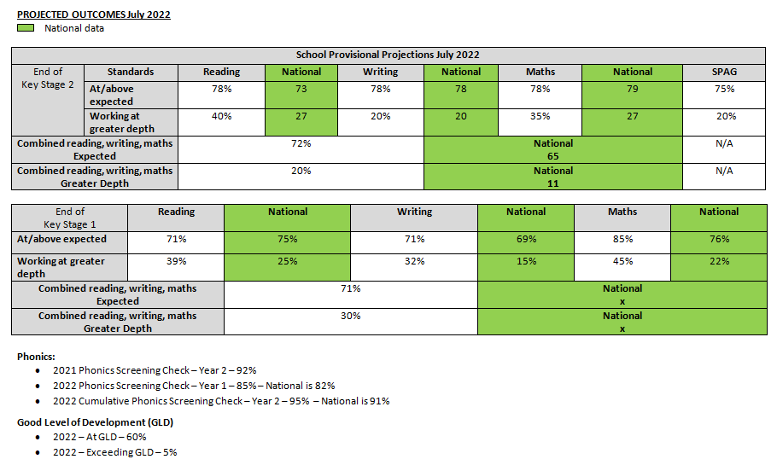

Intended outcome | Monitoring | Link to aim:  - Great teaching  - Targeted interventions  - Wider strategies
Teaching is consistently good or better for pupil premium children | Monitoring through observations  Evaluation of regular CPD  Intervention observations and book looks  Feedback from trips using pupil voice  Monitoring in pupil progress meetings  Systematic catch-up monitoring in interventions  Pupil voice monitoring for SEMH interventions | 1
Pupil premium pupils are supported through interventions in all core subjects |  | 2
Pupil premium children have benefit from a range of activities and experiences to broaden their experiences and curriculum |  | 3
Pupil premium children are supported emotionally and socially in order to fully access the curriculum – SEMH support |  | 2
Evidence
EFF Report on the Impact of school closures on the attainment gap
EFF Guide to Supporting School Planning: A Tiered Approach to 2020-21

Activity in this academic year

This details how we intend to spend our pupil premium (and recovery premium funding) this academic year to address the challenges listed above.

- Lack of parental engagement, understanding of support systems and aspirations
- Mental health issues for the parents/carers and the child
- Lack of cultural capital and experiences
- Communication and social skills - Speech and language difficulties
- Exposure to gangs, crime, drug and alcohol abuse
- Housing issues, lack of space and overcrowding
- Financial issues
- Low attainment on entry

Ensuring and supporting great teaching

Budgeted cost: £113927

Activity | Cost | Challenge number(s) addressed
Teaching monitoring and support – collaborative work – gap analysis – lesson study and best practice | Team leader TLR – 40% of TLR for 4 people  £6666.40 | All
Leadership development training – middle leaders’ work | Cost of Middle leader training  £4100 | All
External validation | Local authority and writing consultant support  £600  LA funded by project group | All
Extensive gap analysis used to further inform teaching | Teaching assistant release time – 40% of 12 days a year for 9 people  £4818.80 | All
The employment of specialist teachers | Music, PE, Spanish and Drama/Movement  40% of all  £26401.20 | 3
Recruitment of new teachers and support staff | Advertising costs  £275 | 1 and 7
1:1 and small group support within the class and TA support in class | TA support  40% of 9 staff  £69465.60 | 1
CPD for staff and collaborative practice, including team teaching, modelled lessons and best practice visits | 40% of Future zone membership cost for training and networking  £1600 | 1 and 4

Providing targeted academic interventions

Budgeted cost: £65756.20

Activity | Evidence that supports this approach | Challenge number(s) addressed
1:1 / small groups in English and maths | 40% of additional teacher cost in Year 5/6  £20271.60 | 1
Additional learning time – boosters | Funded by Richard Reeves | X
Online 1:1 tutoring | Funded by Richard Reeves | X
Additional phonics group work | 40% of phonics TLR - £345.60  40% of 4 hours a week cost (included in SEND funding) | 1
Speech and language support | Funded by local authority | 1 and 4
SEND / EAL support groups | 40% of SEND and EAL teacher cost  40% of bilingual support workers  £26620 | 1 and 4
CGP books for homework and differentiation | 40% of cost of books  £3125 | 1
Pupil progress interventions | 3 hours a week of AH, DH and H cost  £15394

Using a wider range of strategies to overcome barriers to learning

Budgeted cost: £39612.28

Activity | Evidence that supports this approach | Challenge number(s) addressed
Focus on improving attendance | 40% of 5 hours a week of attendance and punctuality lead  40% of 2H of our Child and Family Support worker’s time  £4480.28  £2078 | 1
Providing curriculum enrichment opportunities and targeted financial support | 40% of residential trip costs for the year  Bringing literacy to life experiences – funded by Richard Reeves  School funded place for 2 pupil premium children on school journey  40% of Young Shakespeare company  40% of Now Press Play  £1536  £2395 | 3
SEMH interventions for children who are not accessing the curriculum to their full potential | 40% of SEMH interventions (5 days between both CFSW)  £12468 | 2
Support for wellbeing and mental health | Training for staff to support in class throughout the day  Funded by local authority | 2
Interventions to increase parental engagement and to ensure there is equity for pupils | 40% of 1/10 of our Child and Family Support worker’s time for coffee mornings and workshops  Funded by Richard Reeves | All
Weekly pastoral care meetings | 40% of 2 hours of H, DH, AH and 2 CFSW  £16655 | 1

Total budgeted cost: £ £219295.48

Part B: Review of outcomes in the previous academic year

Pupil premium strategy outcomes

This details the impact that our pupil premium activity had on pupils in the 2020 to 2021 academic year considering the impact of the pandemic.

Pakeman Primary School
During 2019/20 and 2020/21, all children spent 6 ½ months in lockdown with home learning provision.

Year 2 cohort 2020-21

27 pupils (out of 39) in our Year 2 2020-21 cohort joined Pakeman at the start of Reception (or earlier). We have tracked the attainment of these children at the end of Reception (GLD data) and their Year 2 SATs. We have also measured their progress between the two stages.

Attainment in Year 2 (2020-21) | Working at | Greater depth
Reading | 20/27 (74%) | 4/27 (15%)
Writing | 19/27 (70%) | 4/27 (15%)
Maths | 19/27 (70%) | 5/27 (19%)

Attainment in Reception  (2018-19) | Working at | Greater depth
Reading | 18/27 (67%) | 0/27 (0%)
Writing | 17/27 (63%) | 1/27 (4%)
Maths | 19/27 (70%) | 1/27 (4%)

Progress from Reception (2018-19)  to Year 2 (2020-21) | Good or better progress | Exceeding progress
Reading | 24/27 (89%) | 9/27 (33%)
Writing | 26/27 (96%) | 6/27 (22%)
Maths | 25/27 (93%) | 6/27 (22%)

Comparing the Reception and Year 2 data for this cohort, the percentage of children working at age related expectation increased from Reception to Year 2 in both reading (up 7%) and writing (up 7%). The number of children working at age related expectation in maths remained consistent between Reception and Year 2, with 70% of children achieving this.

There was an increase in the percentage of children working at greater depth in reading, writing or maths. This went up from a very low percentage of children achieving greater depth in Reception, up to 15% in writing and 15% in reading and 19% maths by the time the children were in Year 2.

A number of pupils made exceeding progress between Reception and Year 2 (33% in reading, 22% in writing and 22% in maths).

Year 6 cohort 2020-21

32 pupils (out of 44) in our Year 6 2020-21 cohort joined Pakeman at the start of Year 2 (or earlier). We have tracked the attainment of these children in their Year 2 and Year 6 SATs. We have also measured their progress between the two stages.

Attainment in Year 6 (2020-21) | Working at | Greater depth
Reading | 24/32 (75%) | 8/32 (25%)
Writing | 25/32 (78%) | 7/32 (22%)
Maths | 20/32 (63%) | 8/32 (25%)

Attainment in Year 2 (2016-17) | Working at | Greater depth
Reading | 22/32 (69%) | 3/32 (9%)
Writing | 22/32 (69%) | 1/32 (3%)
Maths | 21/32 (66%) | 3/32 (9%)

Progress from Year 2 (2016-17)  to Year 6 (2020-21) | Good or better progress | Exceeding progress
Reading | 32/32 (100%) | 11/32 (34%)
Writing | 31/32 (97%) | 15/32 (47%)
Maths | 29/32 (91%) | 7/32 (22%)

Comparing the Year 2 and Year 6 data for this cohort, the percentage of children working at age related expectation increased from Year 2 to Year 6 in both reading (up 6%) and writing (up 9%). There was a slight dip in the percentage of children working at age related expectation in Year 6 (down 3%). Lockdown and home learning impacted Maths attainment and progress more than other subjects due to the need for manipulatives and the number of different skills that the pupils need to master.

There was a significant increase in the percentage of children working at greater depth in reading, writing or maths. This went up from single digit percentages in all of the core subjects in Year 2, up to 22% in writing and 25% in reading and maths by the time the children were in Year 6.

A high number of pupils made an exceeding level of progress between the end of the two key stages (34% in reading, 47% in writing and 22% in maths).

End of year data outcomes for 2020/2021
Year 2

 | National At KS1 | National Above KS1 | PP  20
Reading | 75% | 25% | 70%
Writing | 69% | 15% | 55%
Maths | 76% | 22% | 70%
Combined | x | x | 45%

Year 6

 | National At KS2 | National Above KS2 | PP  27
Reading | 73% | 27% | 82%
Writing | 78% | 20% | 82%
Maths | 79% | 27% | 70%
Combined | 65% | 11% | 63%

Attendance for the Summer term 2021 – 94% (including 2+ and Nursery)

Externally provided programmes

Please include the names of any non-DfE programmes that you purchased in the previous academic year. This will help the Department for Education identify which ones are popular in England

Programme | Provider
1:1 reading programme | Beanstalk  Bookmark  Tutormate
Specialist drama, music and language focused teaching | Artis
Year 5 and 6 maths and reading tuition | Action tutoring
Cultural experience and language development | Young Shakespeare Company
Immersive curriculum/ cultural experience | Now Press Play

Further information

Covid 19 has had an enormous impact on the education of our children. It has resulted in unprecedented challenges and has brought intense pressure, high levels of stress and anxiety and radical changes to the way in which we work and live.

The closure of schools has had a considerable impact for all pupils, but the largest impact is likely to fall on those from the poorest families.

Every child’s experience has been different and some children have been impacted far more than others. It is clear that children have had access to different levels of learning during the lockdown. Some children have parents/carers who have been able to take on the role of ‘teacher’ and oversee the home learning. For many others, a whole range of issues have impacted on their ability to learn at home:
- Space to work
- Overcrowding
- Parents/Carers having the time / skills to commit to home learning
- Lack of access to online facilities

The health of some children has been impacted by poor nutrition and a lack of physical exercise or access to the outdoors. Many families have experienced serious illness and bereavement and there are ongoing anxieties for children, parents/carers and staff about getting back to “normality”.

