FEDERATION
BUSINESS CONTINUITY PLAN
COVID-19: Tiers 1–4

Pakeman Primary School

Plan Owner / Author: | Emma Bonnin
Date of Implementation: | 5th March 2021
Review: | June 2021
Version Number: | 2

Document Change History

Version | Author | Date | Change Details
1 | Lynne Gavin | 5th October 2020 | Return to school after winter lockdown

Purpose
The objective of this plan is to maintain or recover the critical services and activities at Pakeman Primary School in the event of having to implement Tiers 1-4.

All schools and settings are currently operating at Tier 4. Tier 4 was implemented on the 4th January 2021.

All schools and settings are already familiar with Tiers 1 – 4 as they have reflected the various levels of educational provision since March 2020.

This plan complements (and does not replace) all other plans schools and settings might have in place and should be read in light of the school risk assessment.

This plan includes:

List of critical services/activities

List of possible disruptions

Incident Management Plan

Generic Actions – example

Action Cards (for each high risk disruption)

Appendix 1. Contact List
Appendix 2. Remote Learning Policy

CRITICAL SERVICES OR ACTIVITIES
Critical Service/Activity | Recovery Time Objective | Service Details  In particular – what should be maintained or recovered in the event of disruption. | Responsible Person
Emergency Management | 1 day | Management of Covid/non-Covid-related emergency  - remote learning  - printed learning packs for those without digital access  - provision for vulnerable children and children of key workers  - extended day provision, where staffing allows  - Process in place when positive case occurs: Following meeting with the DFE - 0800 046 8687 – also include inform the following: CIPHAdmin@islington.gov.uk; fis@isongton.gov.uk; Anthony.doudle@islington.gov.uk; Jeff.cole@islington.gov.uk; Candy.holder@islington.gov.uk  - log of key decisions | HT  DH  AH
Safeguarding, including attendance | 1 day | Child protection, CIN, otherwise vulnerable  - creating ‘live’ RAG-rated list of vulnerable pupils and assigning key person to each – pastoral care meeting to organise  - agreeing methods and timescales for communications for any times children aren’t attending school  Attendance  - all pupil details are current and up to date – missing information is obtained as a priority | AH/DSL  Attendance Lead/ Office staff
Communications | - day | All mass internal and external communications  - Staff Briefings (Wimi)  - Newsletter / Website  - Emails/Class Dojo for parents  - LA/DfE returns | HT  DH  AH  Office staff  A.S
Site Security | 1 day | Site access and security | School Premises Manager
IT/data Security | 2-3 days | Securing critical hardware, enabling remote access and tech support  - Wimi, CPOMS, SIMS, server access for staff, device support for children of key workers to access remote learning | HT  Turn it on consultant Anna Fitzgerald  07498989707  anna.fitzgerald@turniton.co.uk
Health & Safety (sites/ buildings/ premises) | 1 day | Oversight of school buildings, facilities, repairs/maintenance and cleaning  - cleaning (including deep cleaning)  - building risk assessments  - planned and reactive maintenance and statutory testing (e.g. legionella)  - termly fire evacuation drills (tested according to current building usage) | School Premises Manager  SOS - cleaning
Health & Safety (risk assessments, business continuity and related processes) | 1 day | Covid-related risk assessments and associated documents  - regular SLT reviews  - when appropriate, with governors and LA | HT  DH  AH  SLT
Supply Chain Management | 1 week | Management of stocks and ordering of critical supplies  - PPE  - cleaning and hygiene stocks  - resources that support remote or in-school learning | School Admin Officer
Mass Staff Absence | 1 day | Cover arrangements and partial/full closures  - SLT and other staff may need to be deployed to cover absences  - all staff details and recorded absences are current and up to date – missing information is obtained as a priority | HT  DH  SBM
Provision of Meals (for FSM) | 2-3 days | Food provision  - in school for children of key workers – 1 day  - vouchers for FSM – 2-3 days (if EdenRed system) - 1 week if schools have to purchase and distribute  - hampers – fortnight lead time on orders through Caterlink | School Admin Officer  HT  DH  AH

POSSIBLE DISRUPTIONS
Possible Disruption | Impact  (A) | Likelihood  (B) | Risk Rating  (A x B)
Tier 1 | 3 | 2 | 6
More than 2 positive cases of COVID-19 | 3 | 2 | 6
Tier 2 | 3 | 3 | 9
Tier 3 | 3 | 3 | 9
Tier 4 | 4 | 3 | 12
Attendance | 3 | 3 | 9
Communication to school community | 2 | 2 | 4

The purpose of this list is to identify the disruptions that should have action cards (higher risk rating) and those which do not (lower risk rating).

Impact – how serious the disruption might be as a result of this threat.
1 – Insignificant
2 – Minor
3 – Moderate
4 – Major
5 – Catastrophic

Likelihood – the chances of this threat happening.
1 – Rare
2 – Unlikely
3 – Possible
4 – Likely
5 – Almost Certain

INCIDENT MANAGEMENT PLAN
The purpose of the Incident Management Plan is to make sure the right people come together in the right place at the right time to take control of the organisation’s response to the disruption.

Overall Responsibility

The following will take overall responsibility of the school’s response to an incident and bring together the Incident Management Team.

Name | Role | Contact Details | Deputy | Contact Details
Emma Bonnin | Head Teacher | ebonnin@pakeman.islington.sch.uk  07709 496 711 | Ben Sadler | bsadler@pakeman.islington.sch.uk  07950 349 993

Most Likely Key Players

The following should be contacted to form an Incident Management Team who will carry out the actions required to maintain or recover critical services/activities. This list should include some of those listed as Responsible Persons in the list of Critical Services/Activities.

Name | Role | Contact Details
Tracey Gulliford | Assistant Head  Designated Safeguarding Lead  Lead for pastoral care and inclusion | tgulliford@pakeman.islington.sch.uk  07789907017
Janet Convery | Chair of Governors | janetconvery@icloud.com  07779551645
As required:
Steve Wells | School Premises Manager | swells@pakeman.islington.sch.uk  07956355902
Marta Tildesley | Vice Chair of Governors | martatildesley@btinternet.com  07783441130
Gill Dukelow | School Business Manager | gdukelow@pakeman.islington.sch.uk  07815057206
Ann Dwyer | Senior Admin Officer | adwyer@pakeman.islington.sch.uk  07940343260
Arlene Scott | Communications and Wellbeing Lead | ascott@pakeman.islington.sch.uk  07810602103
Estelle Bevis-Murrain | Attendance | ebevis-murrain@pakeman.islington.sch.uk  07810861731

Location

Incident Management Team will use Zoom for strategy meetings and Wimi for instant/live messaging and general communication.

KEY TEAMS
Staff will be organised into 5 teams:

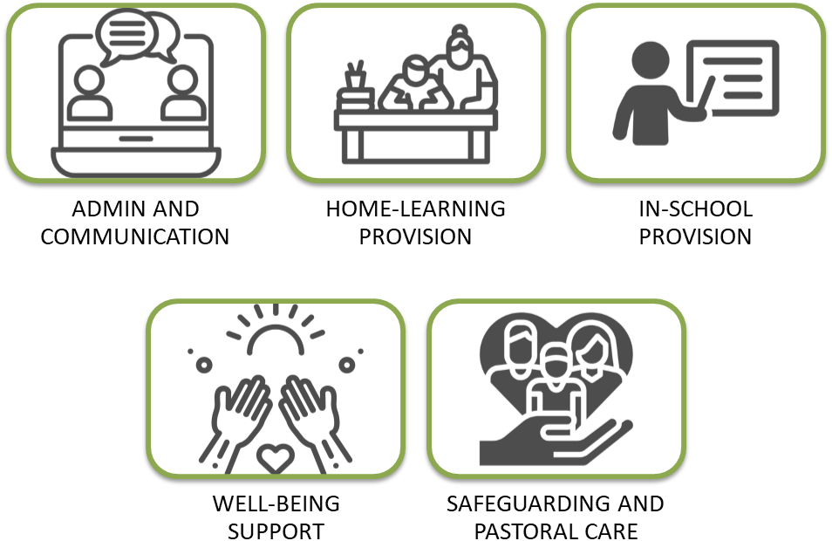

TEAM RESPONSIBILITIES
TEAM 1  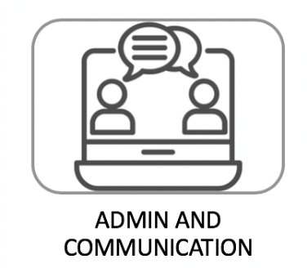 | - General communication  - Providing updates for staff  - Updating parents/carers  - Getting food to most needy families (hampers and vouchers)  - Purchasing and delivering necessary resources  - Weekly phone calls to check in (with all families)  - Responding to concerns raised in communications with parents/carers  - Communicating with volunteers/others who work in the school
TEAM 2  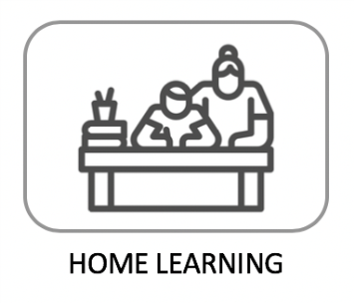 | - Setting home learning  - Ensuring delivery of a broad and balanced curriculum offer  - Supporting staff in developing effective remote working practices  - Ensuring online safety  - Establishing consistent and effective protocols for home learning  - Providing feedback and responding to messages from children and parents  - Approving, up-loading and sharing children’s working  - Developing innovative and creative ideas for engaging children  - Supporting children’s health and well-being needs
TEAM 3  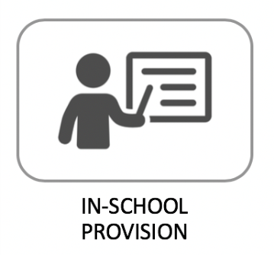 | - Setting in school learning  - Ensuring delivery of a broad and balanced curriculum offer  - Listening to concerns from staff and families, responding to their individual needs  - Timetabling / staffing  - Establishing new systems and practices  - Sharing children’s work and making links between them and children learning remotely  - Developing innovative and creative ideas for engaging children  - Supporting children’s health and well-being needs
TEAM 4  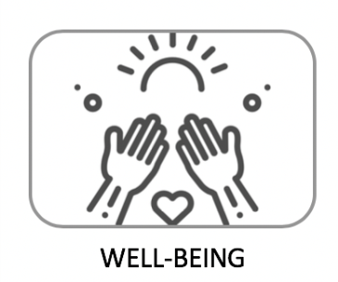 | - Providing wellbeing support – resources / activities / guidance  - Checking in with children and staff  - Weekly check-ins with all families  - Establishing lines of communication to identify and support families who are in need at this time  - Responding to needs arising  - Organisation of remote well-being support for staff and families
TEAM 5   | - Identification and monitoring of targeted / vulnerable children  - Follow up of concerns - safeguarding and pastoral  - Monitoring attendance / follow up of children not attending  - Signposting to other agencies where more specialised support is needed (e.g. bereavement, mental health concerns)  - Frequent communication with and referrals to other agencies  - Meeting with external professionals (CIN, CP and Families First)

GENERIC ACTIONS – example
Example Action Card | Actions
Assess the situation:  - Survey the scene – social distancing, staggered start/departure issues  - Morning break and lunchtimes are an issue and need reviewing  - Movement within the building needs reviewing  Assess the scale, severity, duration of the incident and its likely impact on the school’s critical services and activities. | SLT to review
Establish an Incident Management Team contact point for all personnel | One person allocated to lead and manage  Wimi group for incident management
Allocate specific roles as necessary. | 5 teams:  Communication  Learning – school and home  Wellbeing  Safeguarding
Ensure a log of key decisions and actions is started and maintained throughout the incident. | HT, DH and AH to maintain logs on Cpoms or other software depending on the incident
Notify the relevant stakeholders:  - Staff  - School governors  - Local authority | Notify them of your:  - Assessment  - Arrangements for keeping in contact
Agree with local authority who is making arrangements for:  - Communication to parents/carers  - Establishment of an internal and/or public helpline number  - Public communication and media handling  - Insurance  - Site security (incl. turning off of utilities) | Following meeting with the CELL – inform the following:  Anthony.doudle@islington.gov.uk  Jeff.cole@islington.gov.uk  Candy.holder@islington.gov.uk  Penny.kenway@islington.gov.uk  Mark.taylor@islington.gov.uk  Tom.Louvre@islington.gov.uk  Harjit.Roopray@islington.gov.uk
Agree with stakeholders date/times of future updates, meetings, progress reviews and communications. | SLT  Staff  Parents/ Carers  Governors

ACTION CARDS for all potential tiers following DFE guidance
Included here are prototype Action Cards for specific disruptions, they should be completed, extended and added to as required.

Tier 1 involves remaining fully open, as the government has been clear that ensuring schools and educational settings remain open should be prioritised over other areas when restrictions are considered. | Actions
Risk Assessment is reviewed on a regular basis | Reviews  SLT and governors weekly reviews/ evaluations  Risk committee meetings (SLT)  Submit to LA on request.  Additional measures (enhanced Tier 1) on standby, to deploy in emergency Covid-related situation (nationally or locally):  Staff identified by NHS as clinically extremely vulnerable  Action: Individual risk assessments undertaken. School to redeploy into roles that minimise interaction with staff and pupils, potentially working from home, if necessary  Operate in smaller bubbles  Action: schools to move into phase group bubbles of 90 pupils, plus staff (practicalities of this will mean minimal change, except in the playground and in lunch hall, as well as school-specific impact on phonics / interventions and extended day)  Reduce times Pakeman staff working across bubbles / phases  Action: staff are timetabled to particular phases where possible – staff take breaks with bubble / phase  Reduce non-Pakeman adults to only absolutely essential visits  Action: Volunteers / external professionals and other visitors to either be rescheduled or use video conferencing where possible  Action: minimise use of short term external agency staff  No off site trips  Action: No external trips / visits
Regular reminders are provided for staff – social distancing and hygiene | Pakeman communications via Wimi , Zoom and in small group meetings (as required - more frequent in emergency situations)  Individual communications with specific staff
Attendance figures do not decline and steadily improve | Attendance Team (Attendance Lead and HT) to meet weekly to monitor and follow up absence - to address individual cases  Communication with Parents/ Carers – Consistent approach and clear communication with parents/carers about the importance of attendance. Letters from LA are shared.
Website and other types of social media are kept current and up to date | Reduce channels of communication to ensure simple management of messages:  - Wimi for staff  - Class Dojo /Teachers 2 parents for parents/carers  - Email / phone for LA  Keep website homepage up-to-date with critical messages
Parents and staff are regularly updated in light of testing and transport arrangements | Wimi messages for staff / Letters to parents (as required – as above)
Safeguarding procedures are current and up to date. All staff understand their responsibility | All staff asked to read and sign as they understood the essential documents and accessed training – including new members of staff  New Safeguarding & Child Protection Policy written and approved by Governors in October 20 – this includes KSCIE 20 new info and all essential documents including AUP  Safeguarding Governor visit – October 2020
Remote Learning plans/policy are currently being developed. | Develop remote learning approach and policy:  - Publish on website  - Use LBI resources where possible  - Use Class Dojo to deliver and manage school-directed remote learning  - Paper packs to supplement

Tier 2 asks secondary schools to adopt a rota system and further education (FE) colleges to limit on-site attendance, whilst all other settings, including alternative provision (AP) and special schools, remain fully open. | Actions
In the event an area moves to tier 2 intervention, early years providers, primary schools, AP settings and special schools should continue to allow all children to attend full-time.
Whilst we recognise that tiers 2, 3 and 4 all require planning to operationalise and will present challenges for parents/carers, pupils, and staff

Risk Assessment is updated in light of moving to Tier 2 | Reviews  SLT and governors weekly reviews/ evaluations  Risk committee meetings (SLT)  Submit to LA on request.  Additional measures on standby, to deploy in emergency Covid-related situation (nationally or locally)  Staff identified by NHS as clinically extremely vulnerable  Action: Individual risk assessments undertaken. working from home, if necessary  Operate in smaller bubbles  Action: schools to move into phase group bubbles of 90 pupils, plus staff to move to allocated bubbles  Reduce times Pakeman staff working across bubbles / phases  Action: staff are timetabled to particular phases where possible – staff take breaks with bubble / phase  Reduce non-Pakeman adults to only absolutely essential visits  Action: Volunteers / external professionals and other visitors to either be rescheduled or use video conferencing where possible  Action: minimise use of short term external agency staff  No off site trips  Action: No external trips / visits
A rota system can be implemented within 1 working day following DFE guidance | HT and AT to put in place a rota for the 5 teams
Remote learning plan can be fully implemented within 1 – 2 working days | Develop remote learning approach and policy:  - Publish on website  - Use LBI resources where possible  - Use Class Dojo to deliver and manage school-directed remote learning  - Paper packs to supplement
Systems are in place to support the immediate implementation of face covering for adults and pupils. | All resources/ PPE in school – ready to use for staff
Children of critical workers and vulnerable children and young people will be able to continue to access full-time on-site provision. Systems and procedures are in place to implement within 1 - 2 working days | Remote learning and mirrored in school provision ready to be used as it is used weekly for homework
All staff are informed and can follow attendance procedure for tier 2 rota system including the attendance of vulnerable young people | Use of wimi to communicate about attendance
Systems and procedures are in place in regards to FSM | FSM procedures in place for vouchers (Edenred) and for food pick up from school (Kim)
Website and other types of social media are kept current and up to date | Reduce channels of communication to ensure simple management of messages:  - Wimi for staff  - Class Dojo /Teachers 2 parents for parents/carers  - Email / phone for LA  Keep website homepage up-to-date with critical messages
Parents and staff are regularly updated in light of testing and transport arrangements | Wimi messages for staff / Letters to parents (as required – as above)
Safeguarding procedures are current and up to date. All staff are understand their responsibility | All staff asked to read and sign as they understood the essential documents and accessed training – including new members of staff  New Safeguarding & Child Protection Policy written and approved by Governors in October 20 – this includes KSCIE 20 new info and all essential documents including AUP

Tier 3 requires secondary schools and FE colleges to limit on-site attendance to just vulnerable children and young people, the children of critical workers and selected year groups, other settings remain fully open. In the event of tier 3 local restrictions being implemented the Department for Education will issue operational guidance for the affected area that will confirm which year groups should be prioritised. | Actions
In the event an area moves to tier 3 intervention, early years providers, primary schools, AP settings and special schools should continue to allow all children to attend full-time.
Whilst we recognise that tiers 2, 3 and 4 all require planning to operationalise and will present challenges for parents/carers, pupils, and staff
Risk Assessment is updated in light of moving to Tier 3 | Pakeman to review on ongoing basis, potentially operating critical worker/vulnerable provision on site  Governing body reviews weekly via Zoom or visits
A rota system can be implemented within 1 working day following DFE guidance | HT and AT to put in place a rota for the 5 teams
Remote learning plan can be fully implemented within 1 – 2 working days | Class teachers and support staff – daily implementation during normal school term time  Team Leaders and DH - monitor weekly  See Remote Learning Policy
Systems are in place to support the immediate implementation of face covering for adults and pupils. | Face coverings for staff – encouraged in communal areas but not in classrooms
Children of critical workers and vulnerable children and young people will be able to continue to access full-time on-site provision. Systems and procedures are in place to implement within 1 working day | Remote learning and mirrored in school provision established  AH to ensure up to date list of key workers / vulnerable children is available  Booking system – DH / Inclusion Lead to manage organisation of daily attendance
All staff are informed and can follow attendance procedure for tier 2 rota system including the attendance of vulnerable young people | N/A for primary schools
Systems and procedures are in place in regards to FSM | SAO:  Kitchens open for all pupils in school (daily),  Food hampers/ pick up available from volunteers (Kim - weekly) for families who are isolating
Website and other types of social media are kept current and up to date | Wellbeing and Communication Lead to update website regularly  Covid 19 area developed on website
Parents/carers and staff are regularly updated in light of testing and transport arrangements | Parent letter fortnightly and additional letter if necessary
Safeguarding procedures are current and up to date. All staff are understand their responsibility | All vulnerable families are contacted by HT, AH or CFSW

Tier 4 goes further to limit attendance to just vulnerable children and young people and the children of critical workers at all settings, excluding AP and special schools. Where there are no local restrictions in place, education provision should continue to remain fully open to all, and these tiers do not apply. | Actions
Whilst we recognise that tiers 2, 3 and 4 all require planning to operationalise and will present challenges for parents/carers, pupils, and staff
Risk Assessment is updated in light of moving to Tier 4 | Pakeman to review on ongoing basis, operating critical worker/vulnerable provision on site  Governing body reviews weekly via Zoom or visits
A rota system can be implemented within 1 working day following DFE guidance | HT and AT to put in place a rota for the 5 teams
Remote learning plan can be fully implemented within 1 working day | Class teachers and support staff – daily implementation during normal school term time  Team Leaders and DH - monitor weekly  See Remote Learning Policy
Systems are in place to support the immediate implementation of face covering for adults and pupils. | Face coverings for staff – compulsory in communal areas but not in classrooms
Children of critical workers and vulnerable children and young people will be able to continue to access full-time on-site provision. Systems and procedures are in place to implement within 1 - 2 working days | Remote learning and mirrored in school provision established  AH to ensure up to date list of key workers / vulnerable children is available  HT, DH and AH - monitor and review weekly  Booking system – DH / Inclusion Lead to manage organisation of daily attendance
All staff are informed and can follow attendance procedure for tier 2 rota system including the attendance of vulnerable young people | N/A for primary schools
Systems and procedures are in place in regards to FSM | SAO:  kitchens open for pupils in school (daily),  e-vouchers for others where possible (issued as needed, for two weeks at a time),  food hampers/ pick up available from volunteers (Kim - weekly)
Website and other types of social media are kept current and up to date | Wellbeing and Communication Lead to update website regularly  Covid 19 area developed on website
Parents/carers and staff are regularly updated in light of testing and transport arrangements | Parent letter fortnightly and additional letter if necessary
Safeguarding procedures are current and up to date. All staff understand their responsibility. | All families are contacted weekly and all vulnerable families are contacted by HT, AH or CFSW

Appendix 1. Contact List

Telephones (handsets, voicemail) | Steve Wells | swells@pakeman.islington.sch.uk  07956355902
Fire Alarm | Leader Systems | 01788 542220
Electrician | Storm Electrics | 07943 118238
Plumbing | SOS | 02072811470  info@sosservices.co.uk
Heating (Boilers) | Commercial Gas System Ltd.  Himat Singh | 07834982055
General Maintenance (roof leaking etc.) | SOS | 02072811470  info@sosservices.co.uk
Cleaning (inc. Deep Cleaning) | SOS (cleaning) | 02072811470  info@sosservices.co.uk  07803 209550
Air condition | SOS | 0207281 1549
Intruder Alarm | Chubb 08448791710 | Jay engineer 07748 147551  0844 8791710
ID Badge Readers/Door Entry | R F M | John Facer 07775894553
CCTV | Chubb  Ray Webber/Jason Tann | 07785336133 (Ray)  Jason.Tann@chubbengineer.co.uk
Fire extinguishers | A class Protection | Neil Traynor 07557 380605
Emergency lighting | Nationwide Maintenance ltd | Simon 01895630526
IT System | Turn it On  Anna Fitzgerald | 079  Anna.Fitzgerald@turniton.co.uk
Catering | Caterlink – Cordelia  Margaret Shaw  Deirdre Vimpany | cobozua@caterlinkltd.co.uk  Margaret.Shaw@Islington.gov.uk  Deirdre.Vimpany@Islington.gov.uk
Kitchen Equipment | Syntonic | 02087787838
Health & Safety (LBI) | Sonia Sondhelm | Sonia.Sondhelm@Islington.gov.uk
Asset/Building Management | Tom Louvre | Tom.Louvre@Islington.gov.uk
 | Steve Wells | swells@pakeman.islington.sch.uk  07956355902
Staff Absence | Absence Line (HM) | Emma 07709496711

Appendix 2: Remote Learning Policy

Appendix 3: Decisions Log (Wimi and Cpoms)

