9th January 2019/168

Dear Parents/Carers

This Week

Saturday 12th January 2019 is the first day back of SHINE after the winter break.
We hope you all had a wonderful holiday and enjoyed your time off.

The children will be continuing with the theme of Aspirations for this final week.

The children enjoyed their last day of the term particularly decorating their gingerbread men in the style of their future profession.
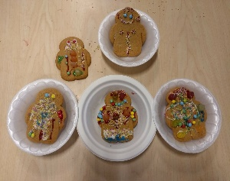
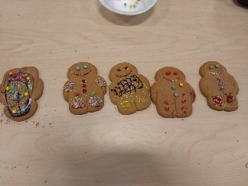
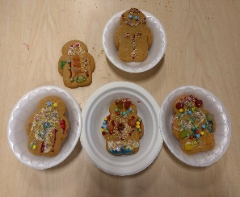
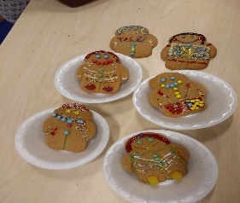
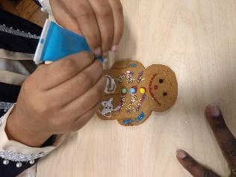

These are some photos of the children’s decorated gingerbread men

Reminder

SHINE is a wonderful provision and there is a waiting list to attend. Therefore, if your child misses two sessions without contacting the school they will be in danger of losing their place.
If your child is unable to attend a session please ring the SHINE team on 020 7607 2575.

Kind Regards

Eunice Burlingham
Shine Project Manager

