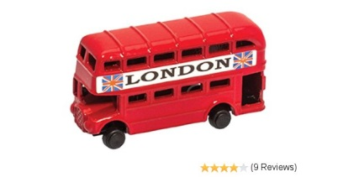****

**In Physical development…**

-Develop fine motor control through threading, cutting or playdough

-To begin to form recognisable letters

-To use the toilet independently

- To put on/take off jumpers, coats or shoes

- To take care of my possessions e.g. coat

**In Understanding the world…**

-Talk about families and special events

-Talk about their home and local environment e.g. Holloway or London

-To be able to use simple programmes on the iPads and on the classroom computers

**Reception Autumn 1**

**In Maths we are learning to…**

-Use mathematical names for 2D shapes and begin to talk about properties of shape

- To begin counting numbers and matching to objects 1-10 and beyond

- To use positional language

- To practise counting to 20 and backwards from 20.

**In Personal, social and emotional development…**

- To be aware of the classroom boundaries and follow the class rules

-To play co-operatively and talk about own needs i.e. ‘Please can I have that?’

-To demonstrate friendly behaviour forming relationships with peers and adults

**In Communication and language…**

- Concentrate and sit quietly during appropriate activity

- Respond appropriately to instructions

-To use talk to communicate feelings and ideas in play situations

**--**

**This half term we are learning all about…**

**London**

**In Literacy: Stories we are reading…**

Week 1: A variety of starting school books

Week 2: Hello London! – Marion Billet

Week 3: London calls! – Gabby Dawny/Topsy and Tim visit London – Jean and Gareth Adamson

Week 4: Peppa Pig visits London -

Week 5/6: Naughty Bus – Jan and Jerry Oke

Week 7: London Maps and the river Thames

**In Creative arts and design …**

- Construct with a purpose in mind using different materials e.g. a rocket with junk modelling or a zoo with blocks and animals.

-Play alongside other children introducing simple story language e.g. princess and dragon

**Reading**

- Understand that print carries meaning

- Link sounds to letters when reading books and words in the environment

-To begin to blend together individual sounds to read a word i.e. s-u-n or c-a-t

**Writing**

- Link sounds to letters when mark making

- To break down the letter sounds in each word and write down each sound heard i.e. c-a-t or d-o-g

- To write own names and names of family members

i.e. Mum or Dad