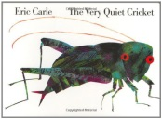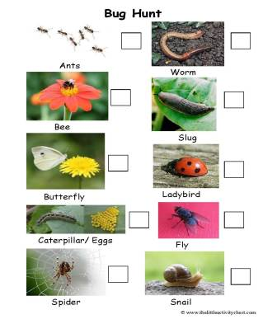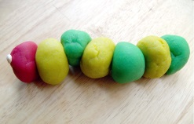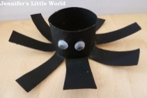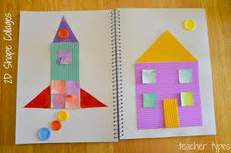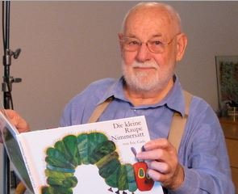****

**In Creative arts and design …**

-Draw caterpillars and butterflies

-Make play dough caterpillars

-Make a spider using a yogurt pot and string or toilet roll

**In Literacy: Stories we are reading…**

The Very Hungry Caterpillar (Week 1+2), The Very Busy Spider (Week 3+4), The Very Lazy Ladybird (Week 5), The Very Quiet Cricket (Week 6).

What to do at home?

-Visit the library and borrow Eric Carle books

-Watch Eric Carle stories on Youtube

-Draw insects with coloured pens, crayons or paints

**In Maths we are learning to…**

-Make pictures with 2D shapes cut out of paper e.g. rocket, house or caterpillar

**How can you get involved with our topic at home?**

This half term we are learning all about…

**‘The Amazing world of Eric Carle’**

**Don’t forget!**

To send photos of special family experiences or progress made at home to our new class email address:

**lilac@pakeman.islington.sch.uk**

**In Personal, social and emotional development…**

-Play turn taking games with the whole family at a table

or on the carpet e.g. board or cards game

**In Communication and language…**

-Ask your child how and why questions about insects e.g. “Why does the caterpillar stay inside the cocoon?” “How does the spider catch food?”

-Read two story books before bed!

**Nursery**

-Go on a bug hunt in the garden or local park. Keep a list of how many you find and compare numbers

-He is an American designer, illustrator, and writer of children's books.

**In Understanding the world…**

-Visit the ‘Sensational butterflies’ tunnel at the Natural History Museum

Prices and tickets here:

http://www.nhm.ac.uk/visit/exhibitions/sensational-butterflies.html

**In Physical development…**

-Try new healthy foods e.g. vegetables

-Explore climbing trees in the local park

-Practise swinging on the monkey bars

**Who is Eric Carle?**

-

-He is most famous for [The Very Hungry Caterpillar](https://en.wikipedia.org/wiki/The_Very_Hungry_Caterpillar), a [picture book](https://en.wikipedia.org/wiki/Picture_book) with few words that has been translated into more than 62 languages and sold more than 44 million copies!

-His style of illustration is very distinctive. He uses a [collage](https://en.wikipedia.org/wiki/Collage) technique, using hand-painted papers, which he cuts and layers to form bright and colourful images.

Check out his website! http://eric-carle.com/home.html